EDUAP
WordMath
Manual

Mikael Samsøe Sørensen
17/11-2025

Preface
WordMath is an add-in for Word that allows you to perform a wide range of mathematical operations directly from Word. It is targeted primary and secondary education, but can easily be applied to higher education.
WordMath core is free and released under the GNU General Public License.

It is possible to purchase a partnership that provides access to WordMath+, support and a number of additional services that make the work of getting WordMath running on many computers much easier.
At the same time, it is the partner schools that help to ensure that WordMath is continuously updated and further developed.
Read more about partnership here

Mikael Samsøe Sørensen

www.eduap.com

Content

Preface 2
Content 3
1. Quick intro 6
2. Math Fields (Equation Editor) 7
Overview of shortcuts in math fields 8
3. Keyboard shortcuts 9
4. Settings 10
CAS 10
Notation 15
Backup 17
Advanced 18
5. Calculation 21
Logarithms 21
Implied multiplication signs 22
Reduce 23
6. Equation solving 25
Trigonometric equations 28
Examples of equations that can be solved with WordMath: 29
Inequalities 31
Simultaneous equation solving 32
Test true/false 34
7. Definitions 36
Definition fields 36
Temporary definitions 39
Piecewise defined functions 40
Physical constants 41
Assumptions 42
8. Graphing 43
GeoGebra 43
GnuPlot 46
Graph 48
Excel 48
Slope field (directional field) 53
3D Graphs 55
Solid of revolution 57
Statistical charts 58
Data 58
Ungrouped observation set 59
Grouped Observation Set 60
GOF (Goodness of fit) 61
Histogram-fit 62
Normal plot and QQ plot 63
Comparing charts 64
9. Regression 65
Regression in Word 65
Excel Regression 66
Sinus regression 67
User defined regression 69
10. Probability 71
Combinatorics, binomial distribution and testing 71
Normal distribution 73
ꭓ² distribution and testing 75
χ² - Test 77
T-distribution 77
11. Calculus 78
Differential calculus 78
Integral calculus 81
Limit values 82
12. Differential equations 84
Numerical solution of differential equations 85
Coupled differential equations 86
13. Vectors 88
14. Matrices 91
15. Complex numbers 93
16. Formula collection 95
17. Lists 97
18. Sum signs and product signs 99
19. Triangle solver 101
20. Units 103
21. Special Functions 107
Lambert W Function 107
22. Programming / Code Fields 108
Programming language 109
23. Latex 111
Converting Math Fields to LaTeX 111
Latex template 112
Word as MikTex editor 113
24. Numbered equations 115
25. Word to HTML 117
26. Speed Tips 119
27. WordMath Mac and Windows 119
28. External programs 120
29. Debugging 121
30. Tips for the technician 121
Installation 121
Antivirus issues 122
Where is WordMath installed? 122

Quick intro
WordMath is an add-in for Word that makes it easy to perform many mathematical calculations directly in Word.
Typically, it works in the way that you insert a math field, via the menu, or with the keyboard shortcut Alt + M
$$Skriv ligningen her.$$
Then you write your calculation or equation in the field.
$$3^{2}+\frac{1}{2}-2$$
Once the phrase is written, you choose what happens to it. For instance, you can get it calculated with the keyboard shortcut Alt + B.
$$3^{2}+\frac{1}{2}-2=7,5$$
If you want to solve an equation, you can do it with Alt + L.
$$6x+2=2x+18$$
$⇕$ The equation is solved for x using WordMath.
$$x=4$$
All commands can be executed from the WordMath menu, but there are also a number of keyboard shortcuts for the most frequently used functions. In addition, there are shortcuts that make it easy to enter mathematics in the mathematics fields.
Note: The above are some simple examples. WordMath can also handle more complicated expressions.

Math Fields (Equation Editor)
The built-in equation editor in Word is really good because you can very quickly create mathematical expressions that look very nice. To get the full potential out of it, it is important that you learn the shortcuts that are built into it, so you do not have to click in the menu all the time. All mathematics can be entered with the keyboard.
You insert a new math field with the shortcut Alt + M
(Without WordMath, the shortcut is Alt + =, but it is somewhat more difficult)
When you type in a mathematics field, it is continuously transformed into a 'professional layout', where it looks like mathematics as you would write it on paper. The conversion is often automatic, but typically needs to be activated by pressing the space bar right after the expression. Examples:
2/3 Space → $\frac{2}{3}$
2^3 Space → $2^{3}$
x_1 Space → $x_{1}$
There are also special key shortcuts for mathematical symbols. They all start with the symbol backslash '\', i.e. a backslash. On Windows computers, you typically enter backslash by pressing 'alt-gr' (just to the right of the space bar) along with the button that is just to the left of z. On Mac computers, enter backslash with Option + shift + 7 (shift + 7 gives the normal slash).
Examples:
\pi Space → $π$
\sqrt Space → $√$space →
Notice here how two spaces can sometimes turn a symbol into a 'template' that you can fill in.
To make a fraction, it's easiest to just type in a regular slash followed by a space.
/ Space →
Then you can use the arrow keys to navigate into the fraction template and fill in the numerator and denominator.
These templates can be an advantage to use, as you avoid having to write parentheses.
In the WordMath menu on the right side, there is a button called 'Shortcuts'. It shows an overview of the keyboard shortcuts for WordMath and the most commonly used shortcuts for the math fields. You can also see these overviews on the following pages.

Overview of shortcuts in math fields

$$\frac{a}{b}$$ | a/b | $$→$$ | \to or -> | $$√$$ | \sqrt | $$α$$ | \alpha
$$a^{x}$$ | a^x | $$←$$ | \gets | $$\sqrt[p]{q}$$ | \sqrt(p&q) | $$π$$ | \pi
$$a_{x}$$ | a_x | $$⇒$$ | \Rightarrow | $$∛$$ | \cbrt | $$∆$$ | \inc
$$\vec{a}$$ | a\vec | $$⇐$$ | \Leftarrow |  | \int | $$∂$$ | \partial
$$\hat{a}$$ | a\hat | $$⇔$$ | \Leftrightarrow | $$\int_{a}^{b}{}$$ | \int_a^b | $$∣|│$$ | \mid \vert \vbar
$$·$$ | \cdot | $$⇕$$ | \Updownarrow | $$\frac{ⅆ}{ⅆx}$$ | \dd / \dd x  Differential d | $$∑Σ$$ | \sum \Sigma
$$±$$ | $$+ -$$ | $$⇋$$ | \lrhar |  | ( ) space ← enter | $$\overset{̳}{x=1}$$ | $(x=1)$\Ubar
$$≠$$ | \ne | $$\overset{←}{→}$$ | \to \above \leftarrow | $$∈$$ | \in | $$R$$ | \doubleR
$$≤$$ | < = | $$↗$$ | \nearrow | $$⊂$$ | \subset | $$×$$ | \times
$$≈$$ | \approx | $$↘$$ | \searrow | $$⊆$$ | \subseteq |  | {\close
$$∼$$ | \sim | $$∨$$ | \vee | $$∪$$ | \cup |  | \overbrace
$$≃$$ | \simeq | $$∧$$ | \wedge | $$∩$$ | \cap |  | \rect()
$$∝$$ | \propto | $$⊥$$ | \perp | $$∅$$ | \emptyset | $$a b$$ | a\emsp b
$$°$$ | \degree | $$∠$$ | \angle | $$∞$$ | \infty | $$□$$ | \box

Note: there are many more than these shortcuts and you can even create your own. You can create your own shortcuts here:
Open File > Options and select Proofing > AutoCorrect Options and finally the Mathematical AutoCorrect tab

Keyboard shortcuts
Note for Mac users:
In this manual, the 'Alt' key is always mentioned. On Mac, use the 'Option' key instead.
WordMath uses a series of keyboard shortcuts where you hold down the Alt key and press a letter. You can choose what the individual shortcuts should do, but there are some of the shortcuts that are set in advance. You can change keyboard shortcuts by clicking on 'Shortcuts' on the right side of the WordMath menu.

New field of mathematics Alt + M
Calculate Alt + B
Solve equation Alt + L
Plot Graph Alt + P
Formula collection Alt + F
Previous result(s) Alt + R
Define: Alt + D
Delete definitions: Alt + S
Rewrite Alt + O
Settings Alt + J
Insert degree Alt + Q
Convert LaTex Alt + T

Specifically about Alt + R
- With Alt + R, you can insert the result from previous math fields.
- If you press quickly several times, you jump further back in the series of results.
- If you take a short break, you start over from the latest result.
Once you have the right expression, you can easily convert it to professional layout by using the right arrow key and spacebar.

Settings
You can find WordMath's settings via the menu on the left side. Here you can quickly change the most frequently used settings, or you can click on the gear to see all options. The default shortcut to open the settings is Alt + J.
The following describes some of the settings you can make in WordMath, but not all. Many of the recommendations are described in the sections where they are relevant. The tabs Graph, Units, Num. Equation & Code each have their own section further down.

CAS
Most calculations in WordMath are done by an underlying mathematics program, a so-called CAS program (CAS stands for Computer Algebra System). This tab contains settings for which CAS program to use and settings for the CAS program.
Number of digits
You can specify directly in the menu whether WordMath should be counted on:
- A number of digits after the comma
- Significant figures
- Scientific notation
The number of digits can be set from 2 to 16.
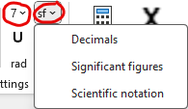
In the examples below, the number of digits is set to 4, and the calculation is made with each of the 3 settings:
Number of digits: $123,456789=123,4568$
Significant figures: $123,456789=123,5$
Scientific notation: $123,456789=1,235·{10}^{2}$

If you select significant figures, WordMath automatically switches to scientific notation when needed.

A typical misconception is to combine significant digits with a low number of digits.
For example, if you set the number of digits to 2, the result will be shown in scientific notation if it is greater than 100.
Example:
$$134+1≈1,4·{10}^{2}$$
If that is not your intention, increase the number of digits or switch to 'Number of decimal places'.
Exact or numeric
WordMath has three options for how results are displayed:
Numeric Always tries to enter the result as a decimal number. This is the default setting.
$$π·3^{2}=28,27433$$
Exact The result will be returned exactly. Calculations are made with fractions and irrational numbers, which are not rounded to decimals.
$$\frac{1+2}{4}·π=\frac{3·π}{4}$$
However, there are exceptions where decimal numbers can come into play. If decimal numbers are included in the expression that is being calculated, then the result will also be returned with decimal numbers.
$$1,2·\frac{3}{4}=0,9$$
Therefore, use fractions and irrational numbers, if you want to calculate exactly.
WordMath can also reduce exact expressions to decimal numbers for very complicated expressions that would otherwise take up a lot of space in the document.
Note: Exact performs a more advanced simplification of the expression than with auto and numeric. However, with the risk that in rare cases the calculation takes a very long time. Then press stop and try with auto or numeric.
Auto With this setting, WordMath behaves slightly differently depending on whether you press Calculate or Solve equation.
When calculating, both the exact and numerical results are generally stated, unless the two results are identical.
$$π·{3,1}^{2}=9,61·π≈30,19071$$In the case of equation solving, the exact result is generally stated, but the tolerance for how large an expression is accepted before being reduced to decimal numbers is lower than for the setting - exact. Likewise, if decimal numbers are included in the expression, the result is returned as a decimal number.

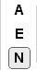 | You can change between the three output forms directly in the menu.  A - Auto  E - Exact  N - Numeric

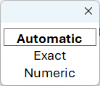 | It is also possible to set a keyboard shortcut that can switch between the three output forms. Click on shortcuts in the menu and set e.g. Alt + N to 'Change number/exact'. By repeatedly pressing Alt+N, the cycle will then cycle between the three settings. It will briefly appear in the middle of the screen what the setting is.

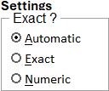 | When solving equations, there will be a window where on the right side there is the option to change some settings, including switching between exact and numeric. If the Setting is changed here, the change applies only to the current equation solution. The recommendation will therefore not be permanently changed.

Unit of Angle (Radians/Degrees)
WordMath can calculate in both degrees and radians. It is controlled via this button in the menu:
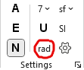 | As a starting point, it is calculated in degrees, but if the button is pressed, the setting is changed to radians. The button thus determines how the trigonometric functions are defined.
WordMath understands degree signs (°). If WordMath is set to radians, you can calculate the following
$$180°=π≈3,141593$$
If WordMath is set to calculate in degrees, the degree sign is completely ignored. You can therefore choose whether you want to write it or not.
The degree sign can be entered with "\degree". But there is also a default keyboard shortcut for inserting degree characters which is Alt + Q. (If this does not work, you can change it yourself in the menu under shortcuts)
Regardless of whether you have turned on radians or not, you will get the same solution for this trigonometric equation if you use degree signs.
$$\sin\left(34°\right)=\frac{a}{9}$$
$⇕$ The equation is solved using WordMath.
$$a=5,032736$$
To avoid problems with forgetting to switch between radians and degrees, it is therefore a good idea to always put degree signs on when entering numbers in degrees. However, you should still be aware that WordMath does not write a degree sign in output.
$$Delete definitions:$$
Very High Precision
This option can be found on the CAS tab. It increases the number of decimal digits in internal calculations. This can be an advantage for certain calculations where many calculations are included, as the uncertainty otherwise accumulates and will be visible in the result.
Example: (do not calculate the following with setting exact, as WordMath locks)
At first without high precision:
$${\left(1+\frac{1}{{10}^{12}}\right)}^{{10}^{12}}≈2,718523$$
The red numbers are not correct. Here with high precision:
$${\left(1+\frac{1}{{10}^{12}}\right)}^{{10}^{12}}≈2,718282$$
The disadvantage is that it is not thoroughly tested, as it uses a completely different number type in Maxima, and it will slow down the speed of calculations. Only turn this setting on if you have a specific problem you need to solve, where necessary.
CAS engine
Most calculations in WordMath are made by an underlying mathematical program, a so-called CAS program (CAS stands for Computer Algebra System).
The default program is Maxima, which is the best choice in most cases. Here are the pros and cons:
CAS engine | Description
Maxima | Maxima is a CAS program with many strengths. The downside of Maxima is that at the annual update of the Mac OS operating system, there have been several years been problems with the new operating system not being backwards compatible with Maxima, and it has taken time to get it working again.
GeoGebra | Is actually introduced as a backup system for Maxima. However, the CAS system in GeoGebra works fine. There will be problems that Maxima solves better and vice versa, there are problems that GeoGebra solves better.  On Mac computers, Safari requires a specific checkmark to be used as a CAS engine. This check mark is located in different places depending on the MacOS version. However, there is a help description in settings and a link to a video in the settings tab. https://www.eduap.com/geogebra-as-cas-engine-on-mac/
GeoGebra browser | Use only in emergencies. If none of the other CAS engines work, it may be that this one works, as it is much simpler. It sends the calculation to GeoGebra, which displays the result in a browser (does not use internet). Then you have to handle it yourself from there, and possibly copy back to Word.
VBACAS | VBACAS is Eduap's proprietary CAS system. It is not as advanced as the above, but is being developed continuously. If enabled, WordMath will first try VBACAS, and if it can't do the calculation, it will be passed on to Maxima or GeoGebra.  The advantages of VBACAS are that it does not require the calculation to be sent out of Word and back. This provides significantly increased speed of calculations, fewer technical problems, and better feedback on incorrect entries.  VBACAS is only available to schools with partnerships.

If Maxima does not work on Windows, there may be help available under the 'advanced' tab, as Word can connect to Maxima in two different ways.
The normal use of the program with calculations and equation solution works largely the same regardless of whether you use Maxima or GeoGebra, but there are differences.
Via WordMath, you can access the built-in functions in Maxima and GeoGebra, and they have different syntax
Here's an example of a built-in feature, but it's the same in Maxima and GeoGebra:
$$binomial\left(5; 2\right)=10$$
Check the documentation for the respective programs to see what built-in features are available or in Chapter 21 Special Features p. 98.

Insert explanation
When you use CAS functions in WordMath, a short explanation is automatically inserted documenting how the calculation was made. This is especially important for exams, where you are required to show your methodology.
Example of equation solution:
$$x^{2}=9$$
$⇕$ The equation is solved for x using the CAS tool WordMath.
$$x=-3 ∨ x=3$$

Purpose of the explanation: The explanation makes it clear how the solution has been found. In this way, both you and your teacher or examiner can see that you have used the correct method.

'Insert explanation' is turned on by default for the above reason, but there is an option to turn it off.

Show solution conditions
If this check mark is set, the equation solution states which conditions there are for the solution. The setting is on by default.
Example:
$$a·x^{2}=b$$
$⇕$ The equation is solved for x by WordMath. with the following assumptions/conditions: $a≠0 ;b·a≥0$

$$x=-\sqrt{\frac{b}{a}} ∨ x=\sqrt{\frac{b}{a}}$$

Notation
Notation tab
Separators
Under Settings > Notation you can change the list separator and decimal separator.
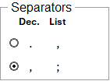
By default, commas are used as decimal separators and semicolons for list separators
Examples:
12,345 (2; 4) 12.345 (2,4)
However, with the default setting you can use both a comma and punctuation as decimal separators and both comma and semicolon as listseparators, if it cannot be misunderstood based on the context. WordMath tries to read from the context whether a comma is a decimal separator or a list separator. If the comma is surrounded by numbers on both sides, then it is understood as decimal separator or list separator. That is, you can easily make a comma act as a list separator if you just make a space on one side of the comma.
Example:
f(a,b) 1,23 Here, both places use commas, but they are translated differently.
Be especially careful with functions of several variables, such as K(n,r). It's very easy to get to writing
$K\left(5,2\right)$ in lieu of $K(5, 2)$
Two examples where a semicolon or comma is used as a decimal separator:
f(1,2; 3,4) f(1,2 , 3,4)
If you always want comma to be a list separator, then change this setting.
Index / subscript
It is possible to use subscript to give variables and functions more meaningful names. Examples:
$a_{1}$ $f_{a}\left(x\right)$ ${hi}_{there}(x)$
The easiest way to enter subscript text is by using underscore: a_1 $→a_{1}$
In mathematical notation, subscript is also used to refer to elements in lists, vectors, and matrices. Therefore, in some cases, it can be context-dependent whether subscript is part of the name or part of the notation. There is an option where you can choose the meaning of subscript under Settings > Notation
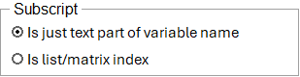
By default, the setting is set to 'Is just text that is part of variable name'. You cannot, by default, use subscript to refer to list items, etc. Let's see what is possible if the setting is set to 'Is list/matrix index':
$$Delete definitions:$$
$$Define: l=[4 , 7 , 12]$$
Now you can retrieve an item from the list using index:
$$l_{2}=7$$
$$Define: \overline{M}=\left[\begin{matrix}2 & 4 \\ 6 & 8 \\ 9 & 1\end{matrix}\right]$$
In an array, two indices are required. The first index is the row, the second is the column.
$${\overline{M}}_{3 ,2}=1$$
Vectors are considered nx1 matrices, so the second index must also be specified
$$Define: \vec{v}=\left(\begin{aligned}1 \\ 3 \\ 6\end{aligned}\right)$$
$${\vec{v}}_{3 , 1}=6$$
Be careful with commas as a list separator! Above there are spaces around commas everywhere.
Indexes can also be variables or expressions. Here all the items in the list l are added together
$$\sum_{i=1}^{3}{l_{i}}=23$$
Even with index turned on, you can use subscript to give variables and functions more meaningful names. However, it can cause problems in some cases. Defining x can cause problems with the variable x, as x now becomes a list. Here's another problem illustrated: $x_{1}$
$$Define: x_{a}=2 , a=1$$
$$x_{a}=x_{1}$$
Here, the a in the index was set to 1, so the variable name changed. $x_{a}$ cannot be accessed then.
So: Do not use the option: ''Subscript is list/matrix index" unless you need to use it.
Even if the index is not turned on, you can access items in lists etc. However, the notation will be a little different.
$$\vec{v}\left[3 , 1\right]=6$$
This way of approaching sub-elements can be used, for example, when calculating the mean value. The following is taken directly from the formula collection. The idea is that you change the lists yourself to the probability field you are dealing with.
$$Delete definitions:$$
$$x≔[1;2;3]$$
$$p≔[0,3;0,3;0,4]$$
$$n≔length(x)$$
$$μ=\sum_{i=1}^{n}{x\left[i\right]·p\left[i\right]}=2,1$$
$$Delete definitions:$$
Output color
Under Settings > Notation, you can choose which output color for calculations, so you can more easily see what you have written and what has been calculated.
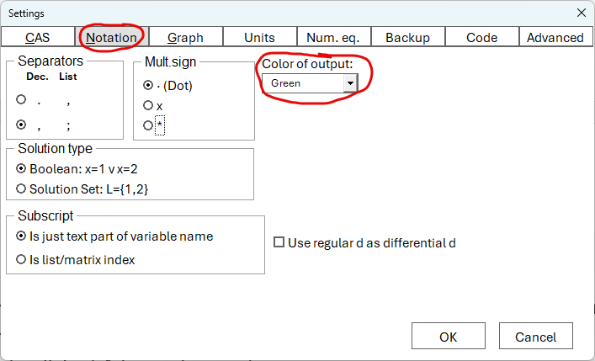
Example, where the color is set to green, which is the default:
$$2+\frac{3}{4}=\frac{11}{4}=2,75$$
It is only when calculating that the output is colored. This does not happen by solving equations etc.

Backup
WordMath has its own backup feature because Word's built-in backup only stores recovery data and not real backup files. With WordMath, entire backup files of your document are automatically saved in the folder 'documents/WordMat backup'.
Here's how it works:
- Every time you make a new calculation, WordMath saves a backup – but only if at least 5 minutes have passed since the last backup (you can change this time interval).
- By default, WordMath stores the most recent 20 backup files. When there are 20, the oldest ones are overwritten, so you always have the latest backups lying around.
- Automatic backup is not turned on from the start. You can turn it on or off yourself in Settings > Backup.

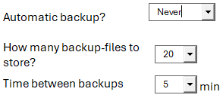 | If you select the 'Ask' option, WordMath will ask you the first time you make a calculation if you want to enable automatic backup.

If you need the backup files, you can always open the backup folder directly via a button in the settings.
Note: When automatic backup is turned on, WordMath may slow down a bit because it takes time to save backup files.

Advanced
On the 'Advanced' tab, there are the following options:
Automatically check for updates
check for updates is turned on by default, unless WordMath is installed with MSI files. When automatic updating is turned on, WordMath will check for new updates at the first calculation (however, it is checked no more than once a week). Automatic updating is disabled in May and June for exams.
WordMath version numbers consist of 3 numbers separated by periods:
Major.Minor.Patch
Ex. 1.36.2
Automatic updates occur if the Major or Minor number increases, but not if it is only the patch number that changes. If you click on the update button in the WordMath's menu, it will also be checked for changes in the Patch number. Patches are typically minor changes that do not affect all users and typically come in the wake of a change to the Minor number.
If you have WordMath+, WordMath will automatically download and update. You will simply be prompted to save your document and close Word during the update. Otherwise, you will be redirected to the website.
Language
By default, language is set to 'Auto'. This means that WordMath detects the language in Word and sets WordMath's language to the same. If the language in Word is not supported by WordMath, English is used. Alternatively, you can set the language to one of the 17 options, independent of the language in Word.
Repair keyboard shortcuts
In rare cases, problems may arise where WordMath's keyboard shortcuts do not work. The 'Repair Keyboard Shortcuts' button tries to fix the problem. However, it will not always work. In that case, deleting the normal.dotm file and restarting Word will most likely work.
On Windows, the normal.dotm file is located in the folder: "%AppData%\Microsoft\Templates"
On Mac, the normal.dotm file is located in: "~/Library/Application Support/Microsoft/Office/User Templates/"
Restart WordMath
On Windows, there is always an open instance of Maxima running in the background. This button will restart Maxima. You shouldn't need it, as WordMath should restart Maxima automatically in case of errors, but in case of unexplained errors, this button can be tried.
The button is only available for Windows, as it is not applicable on Mac. On Mac, Maxima opens and closes with each calculation.
Export/Import settings
Under Settings > advanced there is a button to export WordMath's settings to a file. This can be used for support, or if you want to ensure that all students have the same settings, as you can also import a settings file.
On Mac, you are not asked where you want to place the file and where you want to import from. It will always be the "Documents/settings.txt" file that will be exported and imported.
The Settings file can also be used if you want to ensure that WordMath starts with the same settings every time, so that they are reset at every start of WordMath. In that case, the file 'settings.txt' should be placed in the "%appdata%/WordMath" or "Program Files(x86)/WordMath" folder. This requires that WordMath is installed via an MSI file with the parameter RSF=2 or RSF=3 depending on where the file is located. See more on the admin partnership page: www.eduap.com/adm
Maxima connection method
WordMath can connect to Maxima on Windows in 2 different ways. Usually connected via an external library written in c# .Net, which ensures fast communication between Word and Maxima. If there are problems with the connection to Maxima, you can try the WSH method, which uses a simpler method. The disadvantage is that it is slower and you will see a black screen flashing at every calculation.

Customize Menu
Under Settings > Advanced, you will find the Customize Menu button. Here you can choose exactly which menu items should be displayed in the WordMath menu.
The setting is only available for partnership schools.
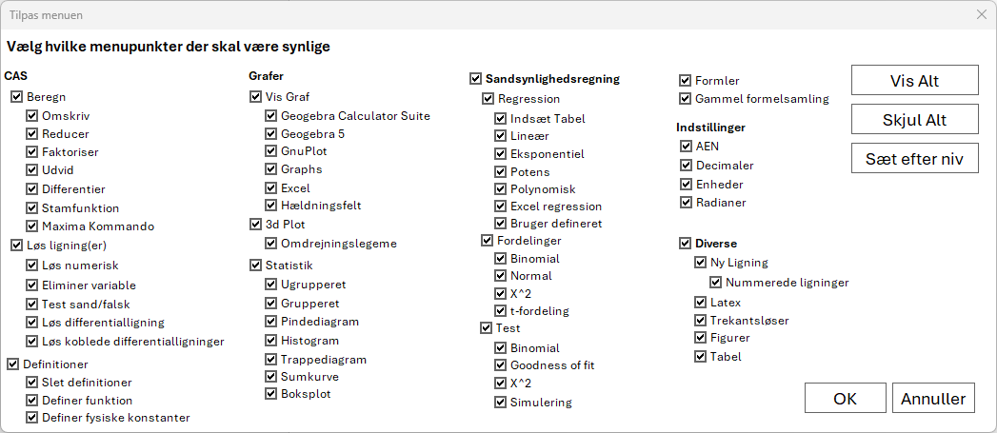
The button after Set by level is used to indicate which programme you are enrolled in, and WordMath then automatically adjusts the visible menus so that you only see the features that normally suit your level.

Calculation
A calculation is an evaluation of an expression and most often results in a number
$$3+5=8$$
There are two ways to calculate:
- Use the default keyboard shortcut: Alt + B
- Click Calculate in the WordMath menu
The expression you want to calculate must be in a math field. Just place the cursor somewhere in the box.
Example:
$$\frac{4+8}{2}=6$$
If there is an equal sign (=) in the expression, only the one to the right of the last equal sign is calculated.
Example:
$$a=b+c=2+5=7$$
If the expression can't be calculated into a number, WordMath tries to simplify it.
Example:
$$-2a·b-b^{2}+{\left(a+b\right)}^{2}=a^{2}$$
The result is inserted directly after the expression with an equal sign in between. How the result is displayed depends on your settings (e.g. exact or numeric. Read more about exact/numeric in section Settings > CAS on p. 10.)
Note: There are many ways to reduce a mathematical expression, but the reduction done by calculation is not the most advanced. There are more advanced methods for reducing under Calculate > Reduce in the menu (See the section on Reduce a little further down).
Here are a few more examples of calculations with WordMath:
$$\frac{4+8}{9}=\frac{4}{3}≈1,333333$$
$$\int_{1}^{4}{x^{2}}dx=21$$

Logarithms
WordMath interprets $\log{(x)}$ as the base 10 logarithm and $\ln{(x)}$ as the natural logarithm.
By default, the output is written with the same type of logarithm that you have used in your input. If no logarithm is specified in the Input, and the result has a logarithm, ln(x) is used by default.
Examples:
$$\log\left(a\right)=\log\left(a\right)$$
$$\ln\left(a\right)=\ln\left(a\right)$$
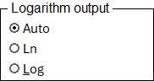 | Under Settings > CAS, you can force the output to either log(x) or ln(x).
WordMath also supports arbitrary base logarithms in inputs:
Examples:
$$\log_{2}\left(8\right)=3$$
$$\log_{a}\left(a^{4}\right)=4$$

Implied multiplication signs
WordMath automatically inserts implied multiplication signs where it is not ambiguous. Examples:
$$2x→2·x$$
$$3\left(a+3\right)→3·(a+3)$$
$$\left(a+b\right)\left(x-2\right) → \left(a+b\right)·\left(x-2\right)$$
WordMath supports variables with multiple characters, and variables can contain numbers. This can cause problems in relation to how some mathematics books write mathematics.
In the following situations, WordMath does not insert multiplication characters
- $x2$ is not interpreted as $x·2$, as it is perceived as the variable x2.
- $ab$ is not interpreted as $a·b$, as it is perceived as the variable ab.
Another problem is that mathematical texts are not always consistent with how variables and functions are written:
- $f(b+2)$ is function f with parameter b+2. Everyone agrees on that.
- $a(b+2)$ will probably most often be interpreted as $a·(b+2)$, but in reality it says the same as in the previous example. Except that f has been replaced with a, and there should be nothing to prevent calling a function a and a variable f. We just often call functions f and variables a. If it is to be consistent, we must distinguish between
$a(b+2)$ where a is a function
$a·(b+2)$ where a is a variable.
In WordMath $a\left(2+x\right)$ is not interpreted as $a·(b+2)$.
a is interpreted as a function a(x).

Reduce
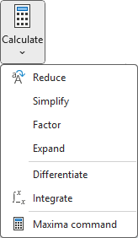 | Under the Calculate button in the WordMath menu, there are various functions for reducing or rewriting a mathematical expression.
For normal calculations, WordMath performs a simple reduction.
Reduce tries to reduce the expression with more advanced methods than the simple one.
Factorize tries to factor the expression, i.e. put outside parentheses.
Expand on the other hand, tries to expand all parentheses.
Rewrite opens a window giving you even more options for combining different methods, including ‘complete the square’.
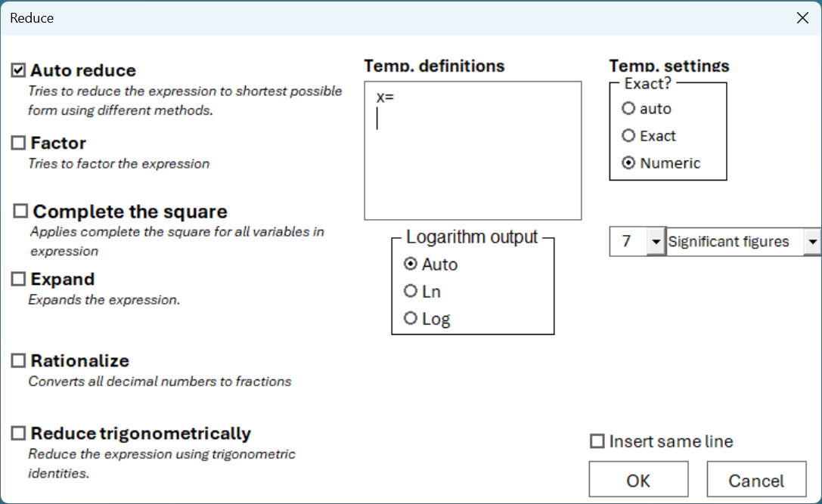
By default, 'Automatic reduction' is checked. It can be combined with the other methods.
Example of factorization:
$$x^{2}-x-6$$
The expression is factored by WordMat.
$$\left(x-3\right)·\left(x+2\right)$$
Example of expand:
$${\left(x-3\right)}^{2}+{\left(y+2\right)}^{2}-9=0$$
The expression is expanded by WordMat.
$$y^{2}+4·y+x^{2}-6·x+4=0$$
Example of square completion:
Square completion is typically used when transliterating to the equation of the circle
$$x^{2}-6·x+y^{2}+4·y+13=9$$
The expression is simplified by WordMat using the methods: Automatic simplify, Complete the square
$${\left(y+2\right)}^{2}+{\left(x-3\right)}^{2}-9=0$$
Example of Rationalize:
$$3,24$$
The expression is simplified by WordMat using the methods: Automatic simplify, Rationalize,
$$\frac{81}{25}$$
Example of Reduce Trigonometric:
If this is checked, trigonometric identities are used in the reduction.
$$\sin^{2}\left(x\right)+\cos^{2}\left(x\right)$$
The expression is simplified by WordMat using the methods: Automatic simplify, Trigonometric identities
$$1$$

Equation solving
To solve an equation, the equation must first be entered into a math field.
$$2x+3=6x-5$$
You now have two ways to solve the equation. The cursor must be somewhere in the mathematics field.
- Use the default keyboard shortcut Alt + L
- Click Solve in the menu
Next, a window will open with a number of options, but in most cases, you can just hit enter and the equation will be solved.
Example output:
$$2x+3=6x-5$$
$⇕$ The equation is solved for x by WordMath.
$$x=2$$
Equations with multiple variables
Let's look at another well-known equation to dive a little more into the possibilities in the window that opens:
$$a^{2}+b^{2}=c^{2}$$
Again, we press Alt + L to solve the equation.
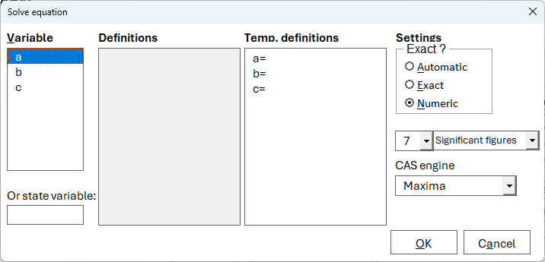
Because the equation contains multiple variables, you can choose from the 3 variables to solve the equation for on the left side of the dialog box.
Definitions shows any definitions that are already in the document (see section 7 Definitions > Temporary definitions p.36). Temporary definitions are definitions that will apply only to this calculation. You don't need to type anything here. On the right are some settings that may be relevant for equation solving. The changes you make here will only apply to this calculation.
Let's try to solve the equation for b, and change the setting from numeric to exact:
$$a^{2}+b^{2}=c^{2}$$
$⇕$ The equation is solved for b.
$$b=-\sqrt{c^{2}-a^{2}} ∨ b=\sqrt{c^{2}-a^{2}}$$
This gives us the general solution to the equation. Strictly speaking, it is not necessary to set the setting to exact, but the expression often becomes "nicer".
If the task is about finding sides in a specific triangle, you can insert the numbers into the equation or use the textbox with temporary definitions.
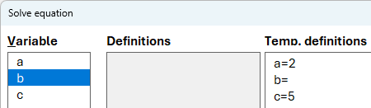
$$a^{2}+b^{2}=c^{2}$$
$⇕$ The equation is solved for b by WordMat. with the following assumptions/conditions:$a=2;c=5$
$$b=-4,582576 ∨ b=4,582576$$
Note that WordMath writes in the document which definitions have been used.

Analytical and numerical solution
WordMath solves equations analytically by default. However, not all equations can be solved analytically. If WordMath is set to use Maxima as the CAS engine (default), then WordMath will automatically solve the equation numerically if necessary. However, it is only possible to solve an equation numerically if there is only one variable in the equation. WordMath will write a note after the equation has been solved that numerical methods have been used. Example:

$$x^{2}-5=\ln\left(x\right)$$

$⇕$ The equation is solved for x by WordMat.
$$x=0,006738253 ∨ x=2,426173$$
Numerical methods were applied when solving the equation. More solutions may exist.
If numerical methods have been used, the solutions are a little more uncertain and there may well be more solutions.

In rare cases, it can take a long time to solve an equation, and WordMath will show this:
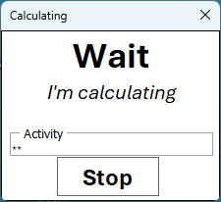 | WordMath will automatically stop after 30s, and you can always press Stop.

This does not mean that it is then impossible to solve the equation. You can try these options:
- Actively select that the equation should be solved numerically in the menu. The equation will not be solved analytically first.
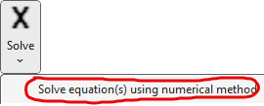
- Try switching the CAS engine to GeoGebra. Perhaps GeoGebra is better at solving this particular equation.
- Numerical and Graphical solution with GeoGebra: Make sure that GeoGebra is set as the CAS engine. Then select 'Solve equation(s) using numerical method' in the menu in the same way as in 1. GeoGebra will open and the two sides of the equation will be plotted, and any intersections marked.
Example:
This equation cannot be solved analytically. WordMath will attempt to solve it for a long time. You must use one of the methods above.
$$2^{x^{3}-x^{2}-1}=2x+3$$
The equation is solved numerically for x by WordMat.
$$x≈-1,494752 ∨ x≈1,974169$$

Graphically using GeoGebra:
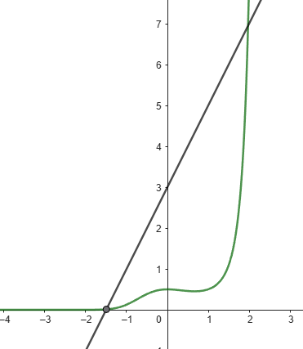

State variable manually
In the window where you have to choose a variable to solve for, there is a field at the bottom where you can write a variable yourself. There are two cases where it may be relevant to use this field:
- If the equation includes a variable or function defined earlier in the document (See Section 7 Definitions) and that definition includes another variable, that variable will not be included in the list. In that case, you can specify it yourself. Example:
$$Define: f\left(x\right)=a·x+b$$
$$f\left(x\right)=5$$
$⇕$ The equation is solved for x by WordMat. with the following assumptions/conditions: $a≠0$
$$x=\frac{5-b}{a}$$
- Equations can also be solved for partial expressions. For example, you can solve a cosine relation for cos(C) instead of just C (requires angle set to radians). Or solve the this equation for 1+r.
$$K_{n}=K_{0}·{\left(1+r\right)}^{n}$$
$⇕$ The equation is solved for 1+r by WordMat. with the following assumptions/conditions: $K_{0}≠0 ;K_{0}·K_{n}>0$
$$r+1={\left(\frac{K_{n}}{K_{0}}\right)}^{\frac{1}{n}}$$

Trigonometric equations
Let's look at the equation
$$\sin\left(x\right)=\frac{1}{2}$$
$⇕$ The equation is solved for x using WordMath.
$$x=30$$
WordMath shows only one solution to the equation by default, but in fact there are an infinite number of solutions. In most cases, however, it is only the first solution larger than 0 you are interested in.
In WordMath's settings, you can choose whether you want only one solution or all solutions for trigonometric equations. By default, it is set to one solution, as this is where you typically start in mathematics teaching. You will find the option on the CAS tab.
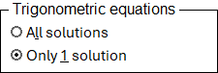
Let's see what happens when we change the setting:
$$\sin\left(x\right)=\frac{1}{2}$$
$⇕$ The equation is solved for x by WordMath.
$$x=360·Z+30 ∨ x=360·Z+150$$
$Z$ here represents an integer (..., -2, -1, 0, 1, 2, ...)
Typically, however, you do not need an infinite number of solutions, but solutions within a certain area. Here you can use assumptions that are explained in more detail in section 7 Definitions / Assumptions p. 40.
$$Define: 0≤x≤180$$
$$\sin\left(x\right)=\frac{1}{2}$$
$⇕$ The equation is solved for x by WordMat.
$$x=30 ∨ x=150$$

Again: it is important to remember to delete assumptions.
$$Delete definitions:$$
See also section 4 Settings / Angular for radians/degrees.

Examples of equations that can be solved with WordMath:
Here are some examples that show how WordMath can solve different types of equations and how complicated they can be.
Example with general solution of cosine relation
$$c^{2}=a^{2}+b^{2}-2a·b·\cos\left(C\right)$$
$⇕$ The equation is solved for C by WordMath. with the following assumptions/conditions: $b≠0 ; a≠0$
$C=\cos^{-1}\left(\frac{a^{2}+b^{2}-c^{2}}{2·b·a}\right)$
Here is an example of a higher-order polynomial. WordMath has algorithms to find all solutions for polynomials.
$$x^{4}-2x^{2}+3x-2=0$$
$⇕$ The equation is solved for x by WordMath.
$$x=-2 ∨ x=1$$

$$x·e^{2x}+e^{2x}=0$$
$⇕$ The equation is solved for x by WordMath.
$$x=-1$$

$$40=72·e^{\left(\frac{0,619}{0,22}∙\left(e^{22}-e^{0,22t}\right)\right)}$$
$⇕$ The equation is solved fot t by WordMath.
$$t=100$$
Here is an example where the two-point formula exists:
$$\frac{y_{2}}{y_{1}}={\left(\frac{x_{2}}{x_{1}}\right)}^{a}$$
$⇕$ The equation is solved for a by WordMath. with the following assumptions/conditions: $y_{1}·y_{2}>0;x_{1}·x_{2}>0$

$$a=\frac{\ln\left(\frac{y_{2}}{y_{1}}\right)}{\ln\left(\frac{x_{2}}{x_{1}}\right)}$$
Here is an example where a definite integral is included in the equation. The equation is solved for a.
$$\int_{0}^{2}{a·x·{\left(x-2\right)}^{2}}dx=20$$
$⇕$ The equation is solved for a by WordMath.
$$a=15$$
An example of a very complicated equation, where WordMath automatically applies the numerical solver:
$$\sqrt{x^{2}+\frac{40000}{x^{4}}}+x·\frac{2·x-\frac{160000}{x^{5}}}{2·\sqrt{x^{2}+\frac{40000}{x^{4}}}}+2·x-\frac{400}{x^{2}}=0$$
$⇕$ The equation is solved for x by WordMat.
$$x=5,520396$$
Numerical methods were applied when solving the equation. More solutions may exist.

Inequalities
You solve inequalities in the same way as equations.
Example:
$$x^{2}≥9$$
$⇕$ The inequality is solved for x by WordMat.
$$x≤-3 ∨ x≥3$$
More complex example:
$${\left(x-1\right)}^{2}⋅\left(x+1\right)≥ 1+x$$
$⇕$ The inequality is solved for x by WordMat.
$$\left(x≥-1 ∧ x≤0\right) ∨ x≥2$$
Note:
- Simultaneous equation with inequalities is not supported.
- WordMath is not always as good at solving inequalities as equations. If it is not possible to solve an inequality, the following can be tried:
- Change the CAS engine to GeoGebra, which is often better for inequalities.
- Solve the inequality as an equation and show a graph of both the right and left sides in a coordinate system, so you can see which side is highest between the solutions.
- GeoGebra and Graph can display the solution graphically. Select the inequality and press Show Graph (Alt + P)– then the solution will be shown graphically.
Example: graphical solution of $x^{2}≥9$ solutions are in the purple range.
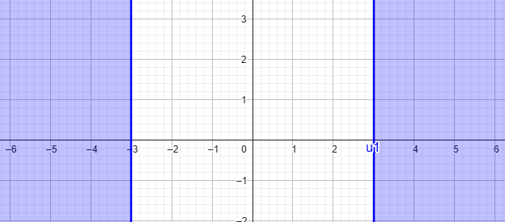
Using Graph:

Simultaneous equation solving
How to solve simultaneous equations (multiple equations with multiple unknowns)
- Write the equations in their respective math fields, right after each other.
- Select all the fields with the equations.
- Click the top of the button Solve in the menu or use the shortcut key Alt + L.
Example:
$$x+y=2$$
$$x-y=6$$
$⇕$ The system of equations is solved for x,y by WordMat's 'solve equation' function,
$$x=4 ∧ y=-2$$
You can also write all the equations in one math field, separated by ∧ (enter \wedge)
Example:
$$x+y=2 ∧ x-y=6$$
When solving an simultaneous equations, the same window appears as when solving a single equation. The only difference is that you now have to select several variables to solve for.
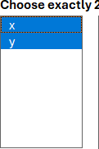 | You need to choose the same number of variables as there are equations. WordMath will automatically select the right number, and if the number of variables matches the number of equations, just press OK.  If there are more variables than equations, it is important that you select the variables that you want to isolate, and not just click OK for the variables that WordMath has selected.
It is possible to enter overdetermined systems of equations. That is, systems of equations where there are more equations than variables. It will most often be a mistake and not provide any solutions and WordMath will therefore write a warning:
Example:
$$2x=0$$
$$3x-5=9$$
$⇕$ The equation system is solved for x by WordMath's 'Solve Equation' function,
$$\left[x\right]∈∅$$
Warning: There were more equations than variables in the system of equations. Was that the intention?
In general, be careful with overdetermined systems of equations, as even small internal rounding can mean that the solutions are not specified.
Note: The order of the equations can in some cases be decisive for whether WordMath succeeds in solving simultaneous equations. Try to swap equations order if you don't succeed.
Also note the Solve > Eliminate variables feature in the menu. That function can be used to reduce an underdetermined system of equations to fewer equations, with certain variables eliminated.

Examples of simultaneous equations that WordMath can solve:
Derivation of formula for a and b in power function (Important that you choose to solve for a and b. There are 6 variables here)
$$y_{2}=b·a^{x_{2}}$$
$$y_{1}=b·a^{x_{1}}$$
$⇕$ The system of equations is solved for b,a by WordMat's 'solve equation' function, with the following assumptions/conditions: $a≠0 ; y_{1}≠0 ;y_{1}·y_{2}>0$

$$b=\frac{y_{1}}{{\left({\left(\frac{y_{2}}{y_{1}}\right)}^{\frac{1}{x_{2}-x_{1}}}\right)}^{x_{1}}} ∧ a={\left(\frac{y_{2}}{y_{1}}\right)}^{\frac{1}{x_{2}-x_{1}}}$$
Circle and line intersection
$$x^{2}+y^{2}=1$$
$$y=x+\frac{1}{2}$$
$⇕$ The system of equations is solved for x,y by WordMat's 'solve equation' function,
$$\left(x=-\frac{\sqrt{7}+1}{4} ∧ y=-\frac{\sqrt{7}-1}{4}\right) ∨ \left(x=\frac{\sqrt{7}-1}{4} ∧ y=\frac{\sqrt{7}+1}{4}\right)$$
Intersection between two lines, one of which is written parametric. Parametric vectors are automatically converted to 2 equations (or more).
$$5x+2y-32=0$$
$$\left(\begin{aligned}x \\ y\end{aligned}\right)=\left(\begin{aligned}-1 \\ 5\end{aligned}\right)+t·\left(\begin{aligned}3 \\ -4\end{aligned}\right)$$
$⇕$ The system of equations is solved for x,y by WordMath's 'Solve Equation' function,
$$t=3,857143 ∧ y=-10,42857 ∧ x=10,57143$$
Intersection between two lines using parametric plot representations
$$\left(\begin{aligned}x \\ y\end{aligned}\right)=\left(\begin{aligned}3 \\ 2\end{aligned}\right)+t·\left(\begin{aligned}1 \\ -6\end{aligned}\right)$$
$$\left(\begin{aligned}x \\ y\end{aligned}\right)=\left(\begin{aligned}-2 \\ 1\end{aligned}\right)+s·\left(\begin{aligned}2 \\ 5\end{aligned}\right)$$
$⇕$ The system of equations is solved for x,y using WordMath's 'Solve Equations' function,
$$s=\frac{31}{17} ∧ t=-\frac{23}{17} ∧ y=\frac{172}{17} ∧ x=\frac{28}{17}$$

$$slet definitioner:$$

Test true/false
The Test true/false function can be found in the menu under Solve. It is used to test whether two mathematical expressions are identical. Enter an equation, place the cursor in the equation and click Test true/false. WordMath now assesses whether the equation is generally true.
Example 1:
$${\left(a+b\right)}^{2}=a^{2}+b^{2}+2·a·b$$
The truth value of the statement is determined by WordMath.
$$true$$
WordMath has identified that the expressions on the right and left sides are identical using algebraic rules.
WordMath first tries to use algebraic methods to determine if the two expressions are identical. If that doesn't work, it try numerical methods. The fact that numerical methods are used also means that you cannot be 100% sure of the result, as a certain amount of rounding is allowed. WordMath will indicate it after the result if numerical methods have been used (see example 6 below).
Example 2:
$$x^{2}=9$$
The truth value of the statement is determined by WordMath.
$$false$$
The expression is not generally true for all x-values, so the result will be false.
Example 3:
$$\sin^{2}{(x)}+\cos^{2}{(x)}=1$$
The truth value of the statement is determined by WordMath.
$$true$$
WordMath has identified that the expressions on the right and left sides are identical using algebraic paraphrasing.
Example 4:
$$\left|x\right|=\sqrt{x^{2}}$$
The truth value of the statement is determined by WordMath.
$$true$$
Example 5:
$$\frac{{\left({\left(x^{2}+1\right)}^{2}-{\left(x^{2}-1\right)}^{2}\right)}^{2}}{16x^{2}}=\left(\frac{x^{4}-1}{x^{2}-1}-1\right)·\frac{{\left(x^{3}-x\right)}^{2}}{x^{2}·{\left(x-1\right)}^{2}·{\left(x+1\right)}^{2}}$$
The truth value of the statement is determined by WordMath.
$$true$$
Both expressions above are identical to $x^{2}$
Example 6:
Here is an example where the numerical rounding comes into play
$$π=3,14$$
The truth value of the statement is determined by WordMath.
$$false$$
With several decimal places, the expression is accepted, but a warning is printed.
$$π=3,141$$
The truth value of the statement is determined by WordMat.
$$true$$
The result is based on numerical comparison (3 decimals)

Definitions
You can define variables and functions that you can use in your calculations. This is smart if you need to use the same variable or function several times or want to make it more manageable.

Definition fields
A definition field is a math field that starts with $Define:$
You can insert a definition field with the keyboard shortcut Alt + D or through the menu under "Def."
$$Define:$$
You enter your definition after the colon.
Example:
$$Define: a=2$$
Now a has the value 2, so if a is included in a calculation, it just corresponds to 2.
$$3·a=6$$
In the same way, you can define a function:
$$Define: f\left(x\right)=2·x+1$$
$$f\left(2\right)=5$$
You can enter more than one definition in a definition field by separating with semicolons or commas.
$$Define: a=2, b=3$$
$$a·b=6$$
You can also type "Define:" yourself, but it is recommended to use the keyboard shortcut, as it fails in case of spelling mistakes or, for example, spaces before colons.
There is also another type of definition field that uses a special definition equal sign instead of typing "Define:".
Example:
$$a≔2$$
The following 3 definition equal signs are supported:
≔ is just entered with a colon and an equal sign
≡ entered with \equiv
$≝$ entered with \defeq
As with define: you can also enter multiple definitions in a definition field when you apply definition equal signs:
$$a≔3 , b≡4$$
$$a·b=12$$
Notice how a and b have assumed new values, even though they are also defined above. If the same variable is defined twice, the most recent one will apply.
Deleting definitions
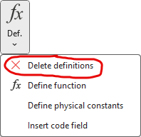 | You can delete definitions so that they are no longer valid in the rest of the document. This is done by inserting a 'Delete definitions' field  This can be done via the menu, but easiest with the default keyboard shortcut Alt + S

$$Delete definitions:$$
It deletes all definitions. Remember to use it when you no longer need the definitions, as you can easily end up having to use the same variable further down in the document where the variable should not be defined. Also note that the speed of calculations can be affected if you use definitions a lot. If you remember to use 'delete definitions:' you avoid significantly affecting the speed in large documents.
You can also delete individual variables and functions by writing which variables and functions should be deleted after the colon. Example:
$$Delete definitions:a, f$$
In this example, 2 of the 3 definitions are deleted and we can see in the calculation that only one definition is still valid:
$$Define: a=2,b=3,f\left(x\right)=x^{2}$$
$$Delete definitions:a, f$$
$$a+b+f\left(x\right)=f\left(x\right)+a+3$$
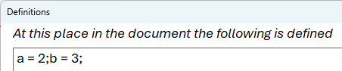 | In the WordMath menu, there is a Def button. If you press the top part of the button, it will display all the definitions that apply to the place where the cursor is located.

Variable names
Variables and functions in WordMath can be more than one letter and can contain numbers, but a name must not start with a number. A variable can also have subscript letters as part of the name.
Example:
$${car}_{1}≔200000, {car}_{2}≔300000$$
$$\frac{{car}_{1}+{car}_{2}}{2}=250000$$
Variable names with Greek characters are also supported.
$$β≔2, λ≔3$$
Example of entering Greek letters:
\beta -> $β$\lambda -> $λ$
\Lambda -> $Λ$

Important about definition fields
- You can't perform calculations in a definition field. The definitions are there so that they can be used in the calculations below the definitions.
- If there is an error in a definition, WordMath cannot perform calculations below that definition, as all calculations will fail. If this happens, WordMath will come up with an error message and mark the definition where the error is.
- It is allowed to place all the spaces you think are appropriate in the definition fields to make it more readable.
- When you make a calculation, WordMath searches up the document to find definitions written in definition fields. Only definitions that are listed before the calculation are used. If you define a variable or function multiple times, the most recent definition will apply.
- Note that a distinction is made between upper and lower case letters in variable and function names. I.e. f(x) and F(x) are not the same function.
One can also define vectors. See more about this in section 13 Vectors on p.86.
$$Delete definitions:$$
Definition of functions
As with variables, functions can be defined in different ways:
$$Define:f\left(x\right)=x^{2}+1$$
$$g\left(x\right)≔2x+3 ;h\left(t\right)≡t+1$$
The definitions can then be used to calculate, for example:
$$g\left(2\right)=7$$
$$g\left(3\right)+\frac{h\left(6\right)}{f\left(2\right)}=\frac{52}{5}=10,4$$
Definitions can also be included in equations
$$f\left(x\right)=h\left(x\right)+g(1)$$
$⇕$ The equation is solved for x by WordMath.
$$x=-\frac{\sqrt{21}-1}{2} ∨ x=\frac{\sqrt{21}+1}{2}$$

$$Delete definitions:$$
It is possible to define functions of several variables. You must then be aware of which list separator you have chosen.
$$Define: f\left(x;y\right)=x^{2}+y^{2}$$
$$f\left(2;3\right)=13$$
If semicolon (default) is set as listseparator you can also use comma, but WordMath determines the list separator based on context.
You can write f(x,y) but not f(2,3) unless you make space at either side of the comma: f(2, 3).
$$f\left(2, 3\right)=13$$
$$f\left(2,3\right)=syntax error$$
Here 2,3 is interpreted as the decimal number 2,3 and not as two numbers. Calculations fail as the function requires two numbers.
See also section 11 Infinitesimal calculus/Differential calculus on p. 74 for more on functions of two variables.
$$Delete definitions:$$

Temporary definitions
When you solve an equation, there is a textbox for temporary definitions where you can specify definitions that will apply only to that calculation.
Let's look at an example where you start by writing up Pythagoras, and then press Alt + L to solve the equation.
$$a^{2}+b^{2}=c^{2}$$
On the right side there is a textbox called Temp. definitions. The textbox will be pre-filled with the variables included in the expression. In the example, we know that side b is 4 and the hypotenuse c is 5. So we enter that in the textbox and choose to solve for a.
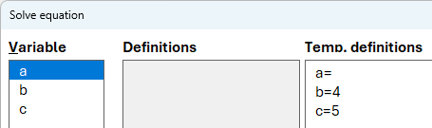
$⇕$ The equation is solved for a by WordMath. with the following assumptions/definitions: $b=4;c=5$
$$a=-3 ∨ a=3$$
Note that WordMath has written in the document what definitions we made, so it is documented.
In the example, we also got a negative solution. This can be avoided if you also specify that a>0 in the field
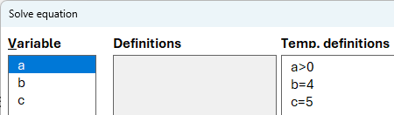
$⇕$ The equation is solved using WordMath. with the following assumptions/definitions: $a>0;b=4;c=5$
$$a=3$$
You can read more about assumptions in a later section.

Piecewise defined functions
WordMath can both make calculations and show graphs for piecemwise defined functions. Here's an example
$$Define: f\left(x\right)=\left\{\begin{aligned}-x ,x<0 \\ x^{2} ,x≥0 \end{aligned}\right.$$
It is important that it is entered correctly. The individual curly brackets are inserted via the "equation menu / Brackets / Examples and stacks". It is also important that a comma is used to separate the function and the scope of definition. Use spaces around the comma to avoid it being interpreted as part of a number.
With the above definition in the document, the following can be calculated
$$f\left(-1\right)=1$$
$$f\left(2\right)=4$$
You can use different spellings to specify definition quantities. You can use $∨$ and $∧$, but you can also use Boolean operators: OR, AND, or, and.
Here is an example, where it is applied in the 2nd definition
$$Define: f\left(x\right)=\left\{\begin{aligned}2x+2 , 0<x<3 \\ -x+3 , x≥3 ∧ x<5 \\ x^{2} ,x≥5\end{aligned}\right.$$
$$Delete definitions:$$
Piecewise functions can also be entered without definition, if it just needs to be plotted with GnuPlot or GeoGebra.
$$f\left(x\right)=\left\{\begin{aligned}x+6, x<-2 \\ x^{2}, -2≤x<1 \\ -x+2, x≥1\end{aligned}\right.$$
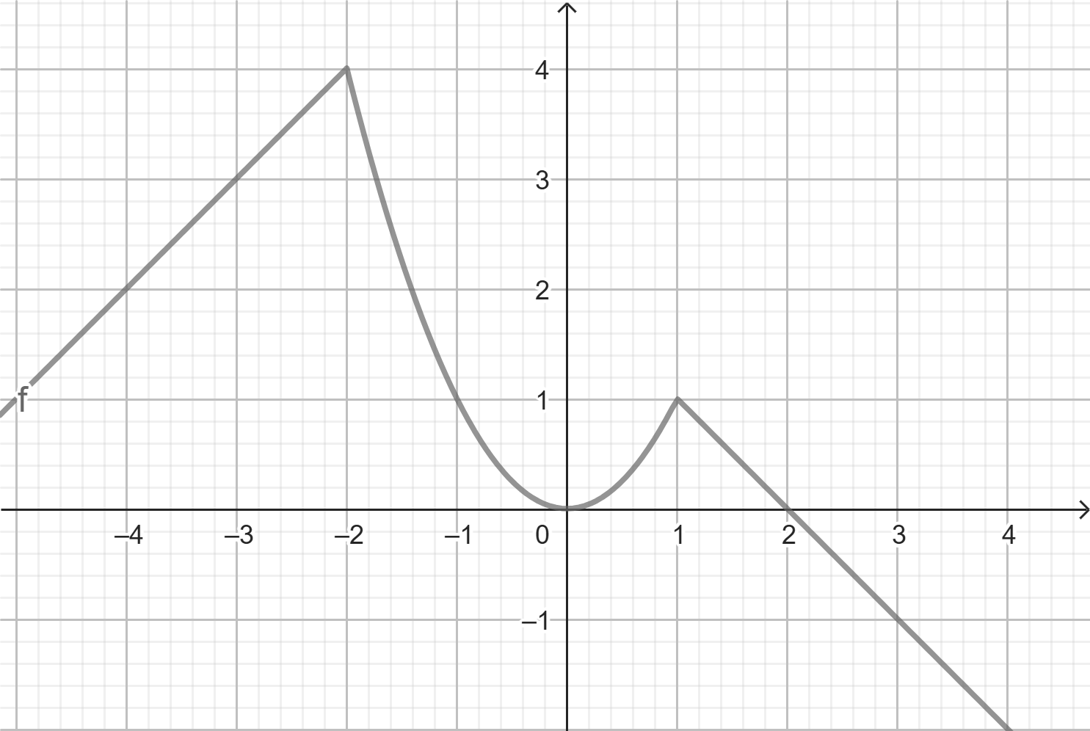
Typical mistakes are
- Forgetting the comma
- Forget space after the comma
- Use two curly brackets instead of one

Physical constants
Under the definitions menu, there is an item called Define physical constants. You can use this to insert definitions of the most common physical constants and most commonly used values of different physical properties . Select the constants to be used and press OK, then these will be inserted as definitions in the document.
Example:
$$Define: c=299792458 m·s^{-1};c_{vand}=4181 J·kg^{-1}·K^{-1};m_{sol}=1,98892·{10}^{30}kg$$
If you have WordMath+, you can find more physical constants and values in the physics formulae.

$$Delete definitions:$$

Assumptions
It is possible to limit solutions to equations by narrowing the set of definitions in advance
Example:
$$Define: x>0$$
$$x^{2}=9$$
$⇕$ The equation is solved for x using WordMath.
$$x=3$$
The above equation will usually give two solutions: $x=-3$ and $x=3$, but with the assumption, you will only get the positive solution.
Just like definitions, assumptions can be deleted with Alt + S
$$Delete definitions:$$
Examples of how assumptions can be stated:
$$Define: 0<x≤10 , a≠0$$
$$a·\left(a-1\right)=0$$
$⇕$ The equation is solved by WordMath.
$$a=1$$
$$x·\left(x-4\right)·\left(x-12\right)=0$$
$⇕$ The equation is solved for x by WordMath.
$$x=4$$

It is extra important to remember to delete assumptions. Assumptions will often be for x, and x is included in many expressions. If you have assumed x>0 at the start of the document, then that assumption will apply to all of the following calculations. Should an equation appear that you have to solve for x that has negative solutions, those solutions will not be returned.
Assumptions can also be entered in the temporary definitions/assumptions field when solving equations. Here, the # character is used as $≠$
See also section 6 about Trigonometric equations on p. 22 for a widely used example of assumptions.
$$Delete definitions:$$

Graphing
WordMath can draw graphs using various graphing programs, each of which has its own advantages. However, note that not all programs work on Mac.

At the bottom of the Show Graph button , you can choose from the available graphing programs. If you press Show Graph at the top or use the shortcut Alt + P, the default graph program opens.

In Settings → Graph, you can specify which graphing program should be the default. This program is then used when you select "Show Graph" or press Alt+P. By default, the GeoGebra Calculator Suite is selected by default.

In Word, select the mathematical expression (function, equation, etc.) that you want to display in a coordinate system. WordMath automatically sends the expression — along with relevant settings and notation (e.g. radians/degrees or log/ln) — to the selected graphing program.

To display bullet points, they must be entered in a table in Word. The cursor must be in the table, or the table must be part of the selection when the graph is displayed.

GeoGebra
WordMath can display graphs with both GeoGebra Calculator Suite and GeoGebra 5. GeoGebra works on both Windows and Mac. Calculator Suite is faster than GeoGebra 5 and is therefore the default graphing program.
GeoGebra 5 has some more advanced features, but starts significantly slower. Calculator Suite opens in a browser, and you might think that it is dependent on the internet, but this is not the case. Calculator Suite runs fully locally – you can see this by the local URL in the address bar.

Let's see how WordMath sends different types of expressions to GeoGebra. Select the following three expressions and click Show Graph:
$$x^{2}$$
$$y=4x-4$$
$$f\left(x\right)=-x^{2}+8$$
The graph for the three functions is now displayed in GeoGebra. If you would like to have an image of the graph displayed in the Word document, a screenshot must be taken.
In GeoGebra, you can copy the graph itself by pressing Ctrl + Shift + C, and paste into Word with Ctrl + V. (On Mac, it's ⌘ Command instead of Ctrl)
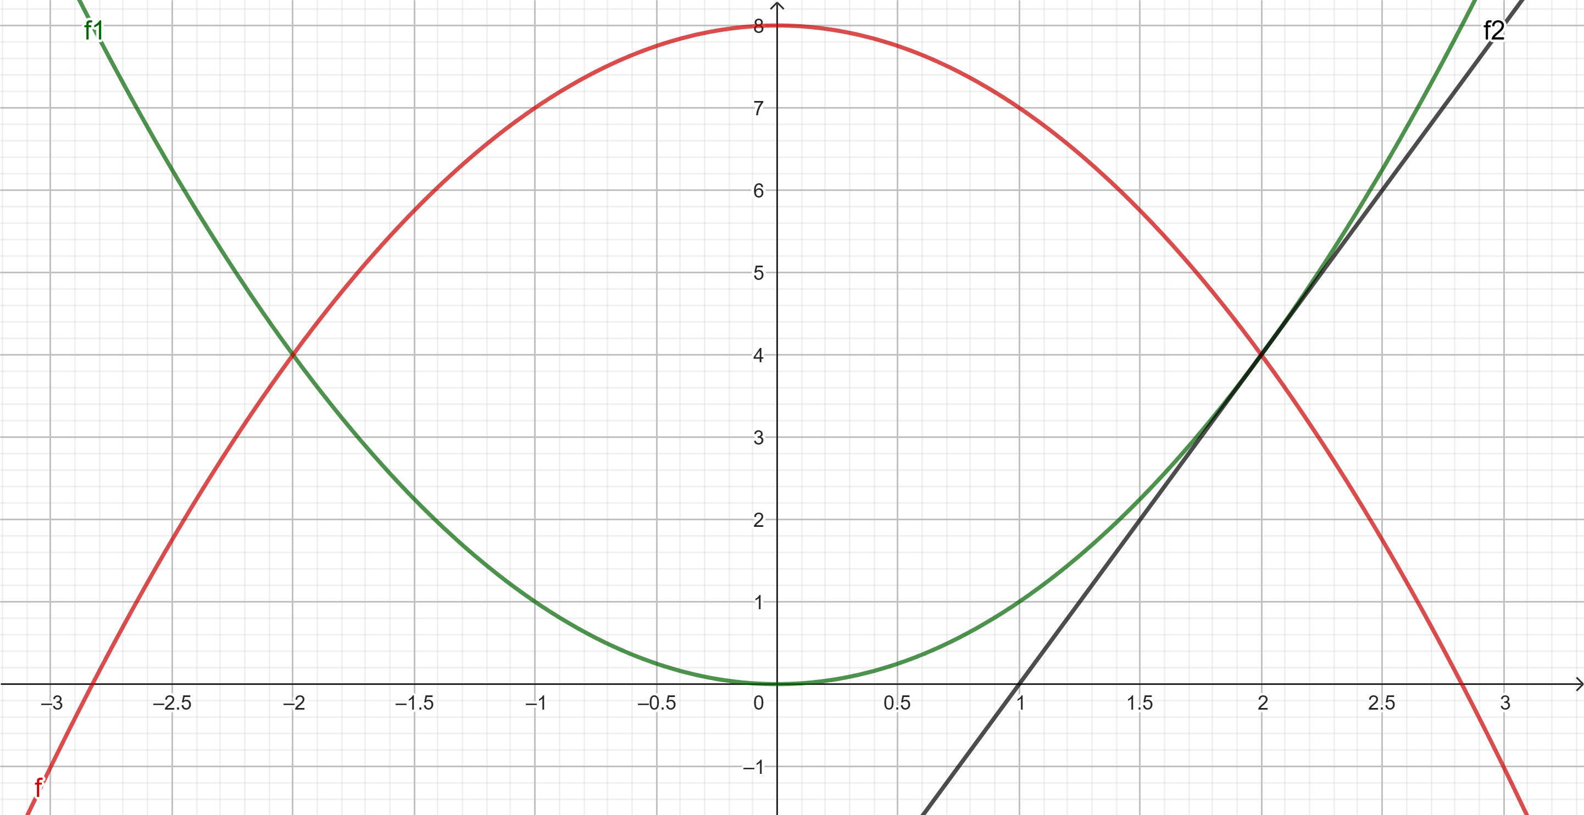
In the above graph, the axes are aligned. You do this in GeoGebra by clicking  and then placing the mouse over one of the axes, which you can then drag.

Graphing for subset of reel numbers
It is possible to view a graph for a function with a restriction on x. This is done by specifying the definition set after a comma.
Examples:
$$f_{1}\left(x\right)≔-x,x<0$$
$$f_{2}\left(x\right)≔x^{2},(0≤x<2)$$
$$f_{3}\left(x\right)≔-x+4,x≥2$$
NOTE:
- It may be necessary to put parentheses around the assumption as in $f_{2}\left(x\right)$
- It doesn't work in definition fields
- It only works for functions – not equations. You can't write $y=x^{2},x>0$
See also section 7 Definitions / Piecewise defined functions on p. 39

Variable names
GeoGebra can only show graphs for expressions where x is the independent variable and y is the dependent variable. However, WordMath tries to translate variables to x and y based on the context, so you can write the following:
$$f\left(u\right)=e^{u}+1$$
$$5s+1$$
$$Q=2·4000·T$$
$$Define: m=2, c=4186$$
$$Q=m·c·T$$
If t is included, then it automatically becomes the independent variable. If there is only one undefined variable, then that variable automatically becomes the independent variable. If there are several undefined variables, and none of them are x or t, then WordMath cannot determine which variable is the independent one and an error occurs.

If you enter an expression like this, which includes undefined variables, then it assumes that they are constants and they are set to 1. Sliders are created for each constant so that they can be easily changed in GeoGebra.
$$y=a·x+b$$

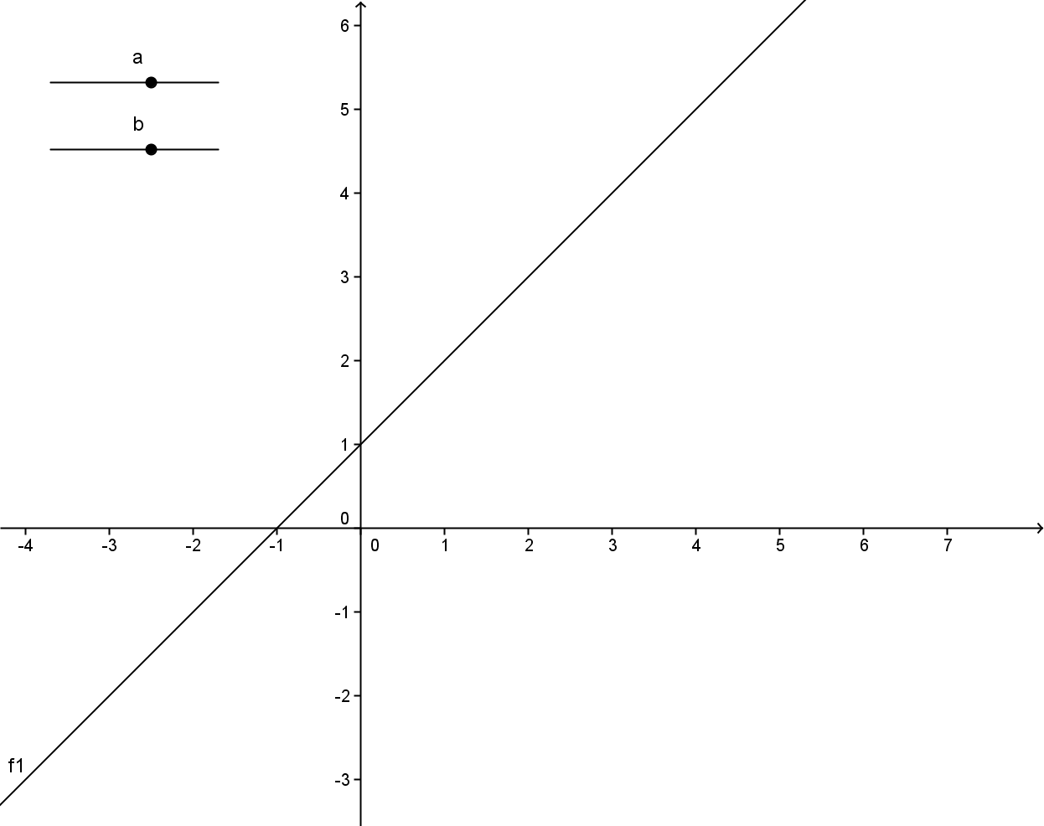 | Constants included in the expression are automatically inserted as sliders.

Displaying bullets
Here is an example where points and a function are plotted,
x | 0 | 1 | 2 | 3 | 4
y | 1 | 1,5 | 2,1 | 4,6 | 6,2

(Note: tables can be inserted both vertically and horizontally)
$$f\left(x\right)=1,5x+1$$
The table and the mathematics field are selected and Show graph is pressed.
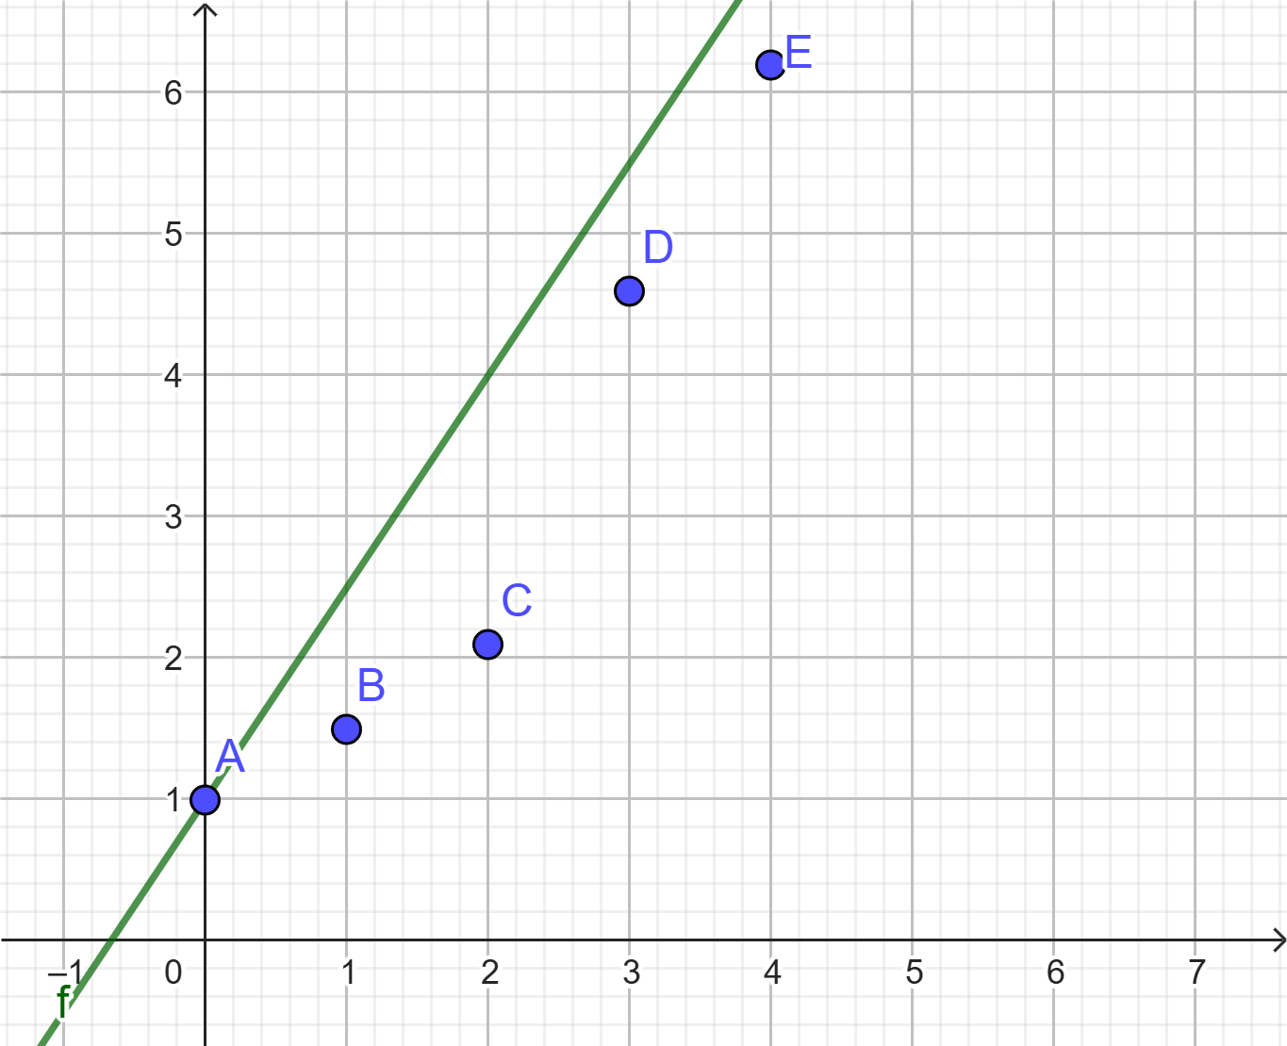

Expressions from geometry
Here are some examples of expressions from geometry that can be drawn using GeoGebra.
The equation of a line in this form: $2x-3y+7=0$
The equation of the circle: ${\left(x-2\right)}^{2}+{\left(y+3\right)}^{2}=5^{2}$
Paramettric plot: $\left(\begin{aligned}x \\ y\end{aligned}\right)=\left(\begin{aligned}2 \\ 3\end{aligned}\right)+t·\left(\begin{aligned}-1 \\ 2\end{aligned}\right)$
Vectors: $\vec{a}=\left(\begin{aligned}1 \\ 2\end{aligned}\right)$
NOTE:
- It is important that you use x and y as variables in the above examples.
- However, it is not important that you use t as a variable in parametric plot.
- Vectors are inserted with a starting point of (0, 0), but they can be manually moved with the mouse afterwards.
$$Delete definitions:$$

GnuPlot
GnuPlot is only supported on Windows. It is the only one of the graphing programs that is 100% compatible with Maxima.
Type a function in a math field and select Show Graph > GnuPlot
$$f\left(x\right)=x^{2}-1$$
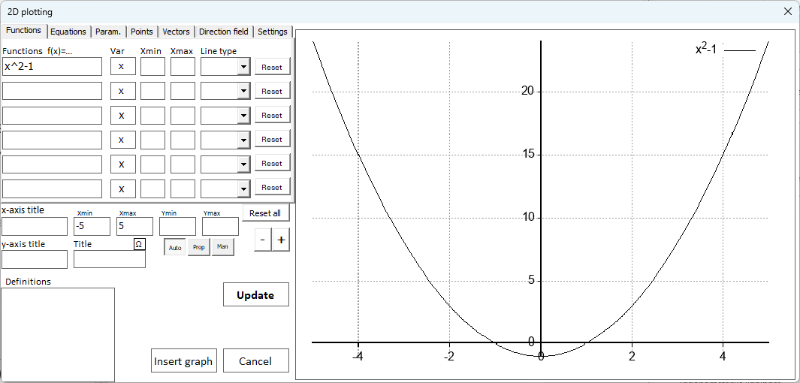
The graph on the right is only partially interactive. To zoom, drag a rectangle around the area you want to zoom in, or double-click to center and zoom. Otherwise, changes must be made on the left side of the window, where you can precisely set the boundaries of the coordinate system (x_{min}, x_{max}, y_{min}, y_{max}).

Click Insert Graph to add the graph as an image in the document. Double-click an existing GnuPlot graph in the document to reopen it and edit.
Below is a graph made with GnuPlot. Try double-clicking on it to open it.

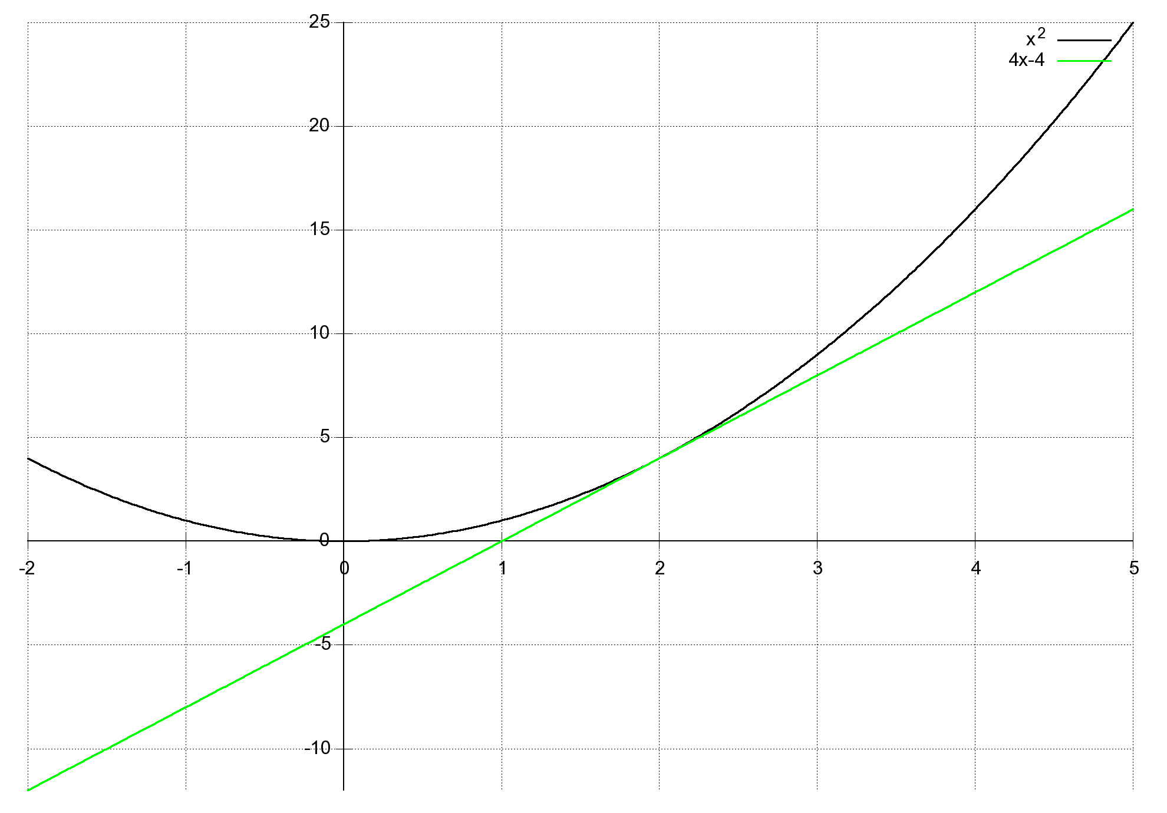
- It is possible to plot functions, equations, parametric plots, points, vectors, etc. See the menu at the top.
- To display points, they must be in a table in Word.
- Definitions from the document are automatically entered in the text field at the bottom left and can be used in functions, equations, etc.

The limitations in relation to GeoGebra are:
- Limited possibility of calculations directly in the graph (e.g. tangents).
- Zoom is not fluid.
- Interactivity is more limited.
A slightly more advanced option is that you can open the graph window in GnuPlot directly. You do this under 'Settings.' In the menu and then 'Show in GnuPlot'. It provides access to the following options:
- At the bottom, the coordinates of the mouse are constantly displayed in the coordinate system.
- To zoom, press the right mouse button, move the mouse to select a square, and press the right mouse button again.
- Press a or u to get back to the starting point.
- To copy image to Word: Right-click on the menu bar, select options and then 'copy to clipboard'. Now close the graph window and paste into Word.
- Press r for ruler and you can measure distances in the coordinate system
- Press g (grid) to turn dice on/off

Graph
Graph is an easy-to-use and fast program for drawing graphs. It has many features, but not quite as many as GeoGebra.
Advantages:
- Very fast
- Fully compatible with Word. The graph image is automatically inserted into Word and can subsequently be edited by double-clicking
- You can insert functions, points, differentiate, tangents, areas, solve inequalities, etc.
The only downside is that Graph is not supported on Mac.
If you double-click on the graph in the document, Graph opens again and you can continue editing. Try it out with this graph:
Defined functions are not plotted automatically. However, they have been transferred to Graph but will be on the list on the far left. Check the check mark next to the precept to show the graph. Defined constants and functions can be edited in the Graph by clicking on the small icon with f(t) in the middle of the toolbar.

Excel
WordMath has an Excel sheet that can show points, graphs and do regression in a more mathematical coordinate system than you immediately get in Excel.
The Excel sheet is opened by clicking Show Graph > Excel or Regression > Excel Regression. When the Excel sheet opens, you may be asked if you want to enable macros. It is important that you answer yes, as many of the features will not work otherwise.
If you selected a table and/or a function in a math field in Word, the points from the table and the function from the math field are transferred to the Excel sheet.
The Excel sheet only supports displaying functions – not implicit equations, vectors, or parametric plots.

The Excel sheet is not as advanced as the other graphing programs, but is quite easy to access, especially when it comes to displaying points and for regression. At the same time, it works on both Windows and Mac and does not depend on external programs. This is particularly suitable for large data sets if you already have data in Excel.
Example:
x | 0 | 1 | 2 | 3 | 4
y | 1 | 1,5 | 2,1 | 4,6 | 6,2

(Note: tables can be inserted both vertically and horizontally)
$$f\left(x\right)=1,5x+1$$
The table and field above are highlighted and there is press Show Graph > Excel. Below is a screenshot from the Excel sheet that appears.
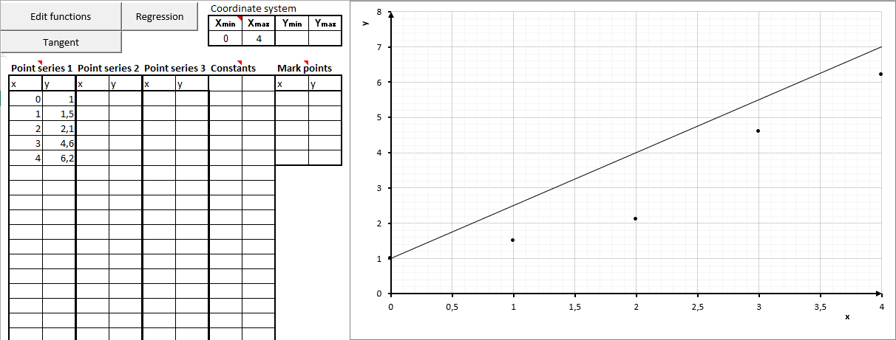

On the left side, the points from Word's table are inserted. You can see there are columns to insert two more data sets. The points from the 3 data sets will be inserted with different colors in the coordinate system.
Just to the left of the graph, there are 4 fields where you can insert the boundaries of the coordinate system.
Coordinate system
Xmin | Xmax | Ymin | Ymax
0 | 4
If the fields are empty, they will be aligned with the points, but if you have specified a function you must specify x_{min} and x_{max}, otherwise the graph will not be displayed. If you click Edit functions you can see the function that was transferred from Word, and you can add more functions here.
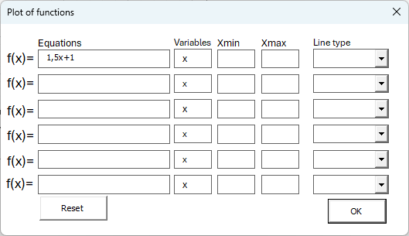
Note that it is possible to specify Xmin and Xmax for each function so that you can display piecewise defined functions, and that you can change the line type to consist of points or lines.
Example:
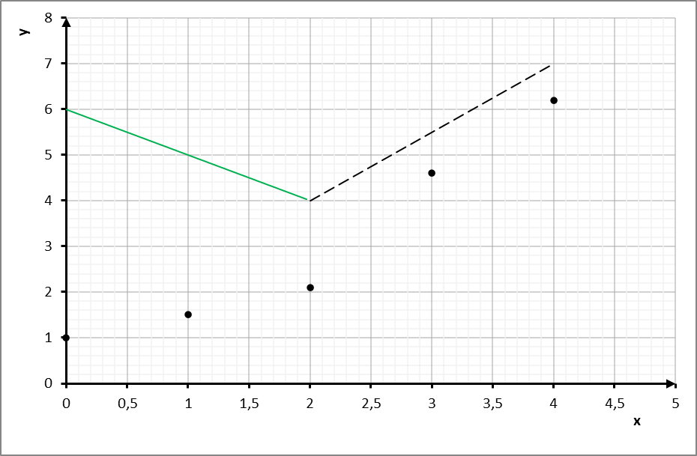

Constants in functions
There is a column called Constants. It can be used if you have inserted functions that include constants, then you can easily change the constants from that column.
Example:
$$f\left(x\right)=a·x+b$$
The field above is highlighted and Show graph > Excel is pressed
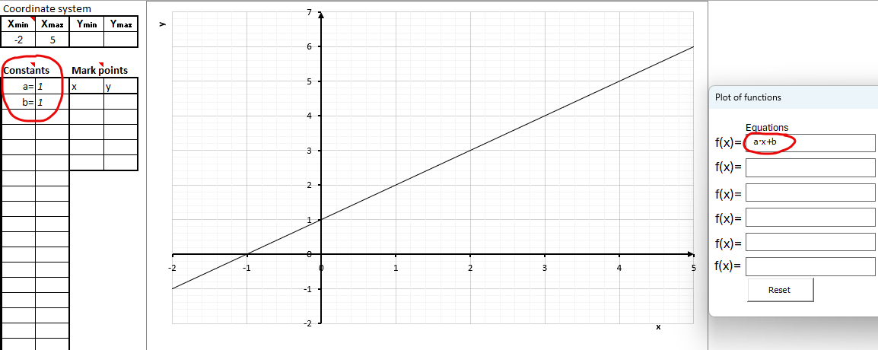

Notice that two constants a and b now appear in the constants column, and that they are both set to 1 by default. If you click Edit Functions, you can see the function is inserted with constants. If you change the values of the constants in the column, it will automatically show up on the graph.

Marking Points
There is a column called Mark Points. It can be used to highlight a specific point in the coordinate system with dotted lines from the x-axis to the y-axis.
In this example, the function $f\left(x\right)=x^{2}$ is inserted, and 2 is written in the first field below x. Next, WordMath automatically fills in the y-value to match the function. You can change this value yourself if you want.
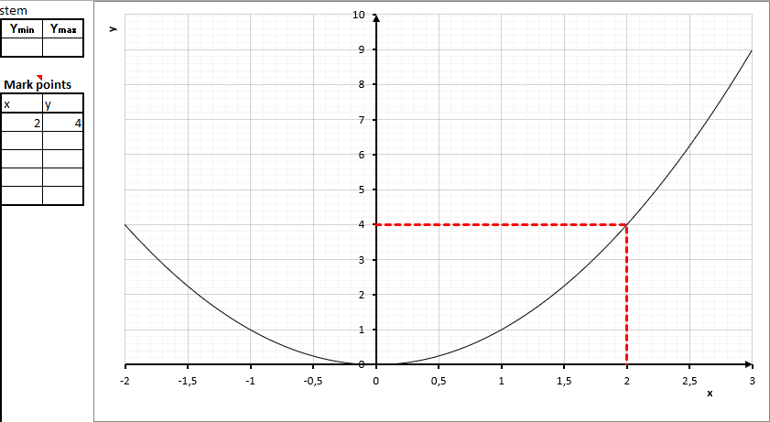
If there is no function in the coordinate system, the y-value is not automatically populated.

Other comments on the graph sheet
There are several different ways that functions can be entered in Word. Examples:
$$f\left(x\right)=2·x+1$$
$$y=\frac{1}{2}·x^{2}$$
$$f\left(d\right)=-d+3$$
$$\ln\left(x\right)$$

On the two axes, it says x and y, respectively. If you click on them, you can change the text. Since the coordinate system is just a customized chart, you can use all the normal Excel functions to customize the appearance. For example, add a chart title or legend by clicking on the chart, then clicking on the + in the top right corner.
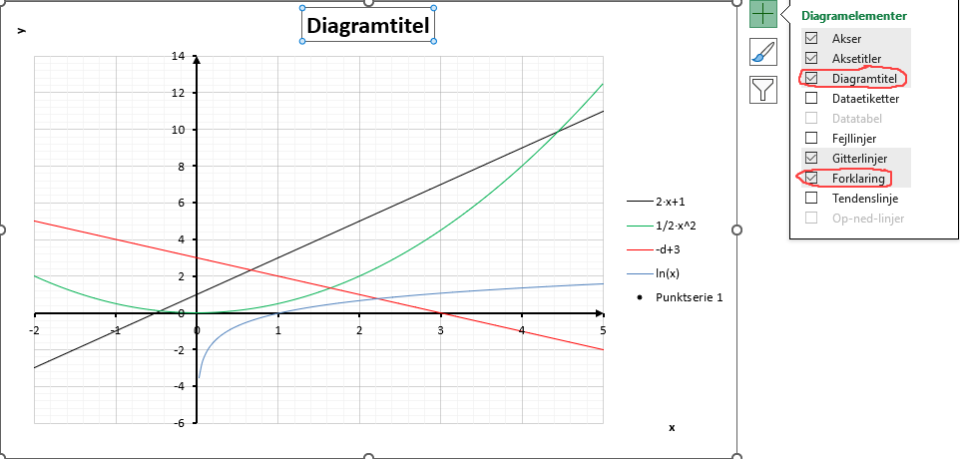
In relation to trigonometric functions, radians/degrees are used according to the setting in WordMath when the function is transferred from Word to Excel. If sin(x) is entered directly into Excel, radians are always assumed.

There is a Tangent button that can calculate and display the tangent to one of the functions displayed on the graph or a regression line. Just specify the x-value and which function number. The calculated keystroke is inserted as a function in Edit Functions.

Note that there is a separate sub-sheet called "Graph". It just shows the coordinate system with the graphs in large format.
There is also a sheet called "Residual Plot", which calculates the residuals for any regression lines inserted, and shows the residual plot.

There is a button to do regression on each of the point series. It is dealt with separately in sections 9 Excel Regression s. 52

How to save the graph sheet correctly
When you want to save a graph sheet as an Excel sheet (and not just take a screenshot for Word), pay attention to the file format:
- Always save as xlsm format (Excel workbook with active macros).
- If you save as xlsx format, many of the features in the sheet will not work.
- Choose Save, then usually the right format will be selected automatically.
- If you select Save As, you must ensure that the file is saved as xlsm.
That way, you avoid problems and all functions in the sheet will work as they should.

Embedded Excel sheets
The Excel sheet can be inserted embedded in Word instead of opening it separately in Excel. It is done by ticking Options > Graph > Insert Excel Sheet Embedded. However, it doesn’t work reliably.

$$Delete definitions:$$

Slope field (directional field)
You can draw the directional field and associated integral curves for a 1st order differential equation in the form:
$$y^{'}=F(x,y)$$
The slope field can be drawn with GeoGebra or GnuPlot (Windows only). Whether GeoGebra or GnuPlot is used depends on which graphing program is selected as the default graphing program in Settings > Graph
Note: GeoGebra 5 is not supported - only GeoGebra Calculator Suite.
Example:
$$y^{'}=x·y$$
Select the expression and press Show graph > Direction field.
In GeoGebra it looked like this:
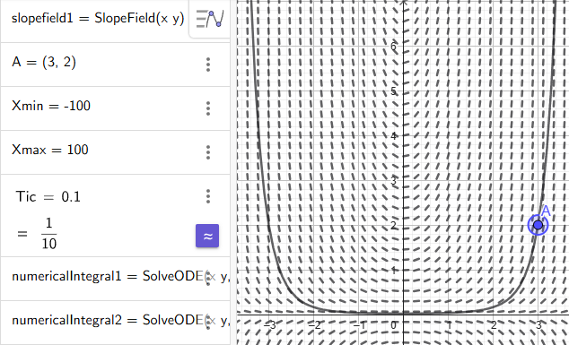
The slope field is shown along with an integral curve that goes through point A. You can drag the point A to see another integral curve, or change the coordinates on the left side. You can also change other settings:
Tic controls how precisely the integral curve is drawn. A lower value is better, but makes the graph slower to update.
Xmin and Xmax control the area in which the integral curve should be drawn.
Here's the same example with GnuPlot:
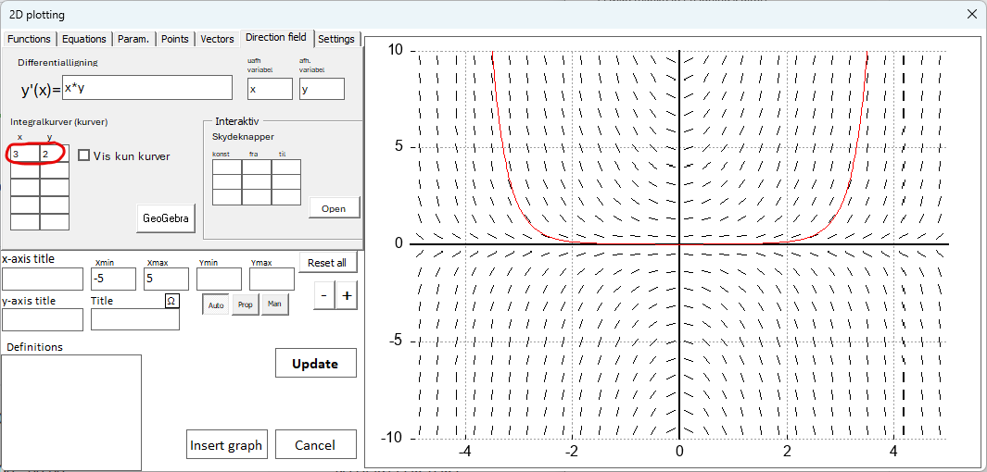
On the left side, enter the coordinates to the point where you want to see an integral curve, then click Update, and finally Insert Graph to get the graph into Word:
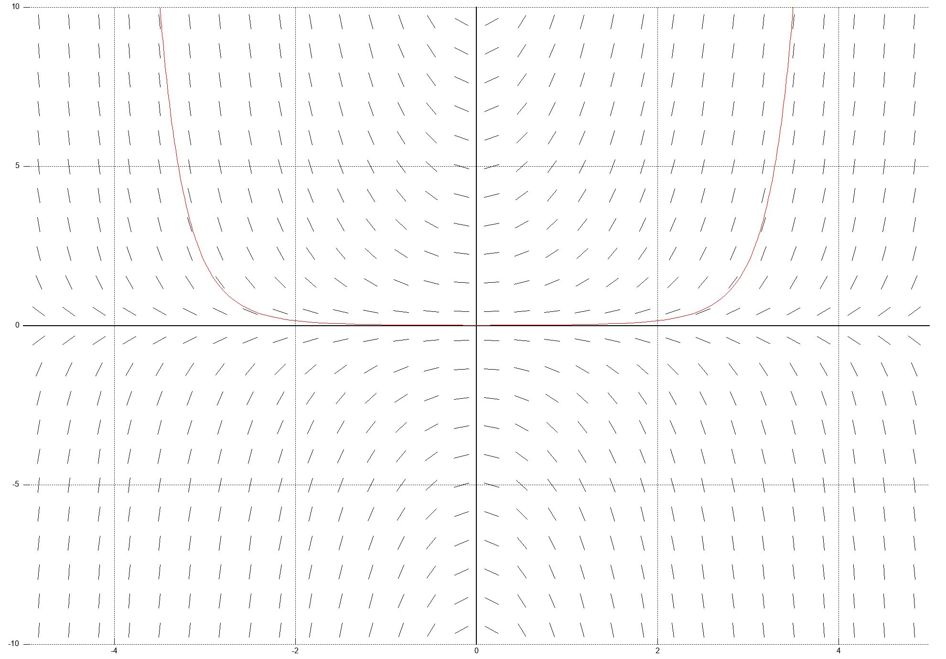
It is possible to plot all sorts of other objects in the same coordinate system, e.g. by filling in functions.
There is also the option to open an interactive window where you can tap on a point where integral curves are to be drawn. As well as inserting sliders that can dynamically change constants in the equation. (Click Open)

3D Graphs
WordMath can display functions, equations, vectors, parametric plots and points in 3D using GeoGebra or GnuPlot (Windows only).
For example, enter an equation in a math field and press the 3D plot button in the menu. You can select multiple math fields at once to display multiple objects at once.
Example:
The equation for a sphere: $x^{2}+y^{2}+z^{2}=1^{2}$
Parametric plot for a Line: $\left(\begin{matrix}x \\ y \\ z\end{matrix}\right)=\left(\begin{matrix}t \\ t \\ t\end{matrix}\right)$
The equation for a plane: $\left(x-0,577\right)+\left(y-0,577\right)+\left(z-0,577\right)=0$
Select the three terms and press 3D plot. The following window will appear:
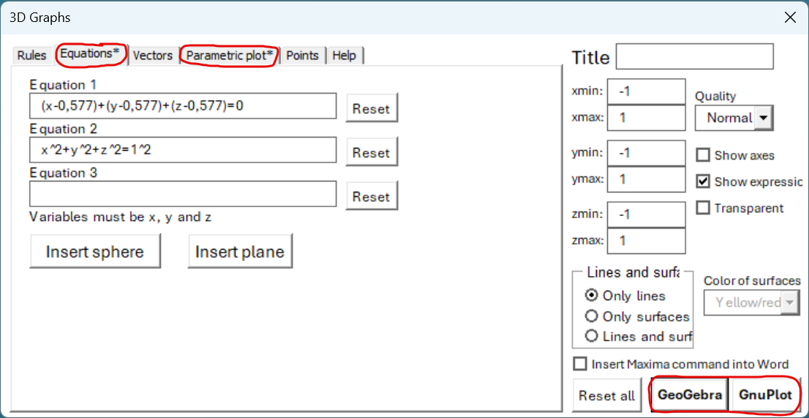 | Notice that there is an asterisk next to the tabs with equations and parametric plot tabs, as textboxes are now filled in on these tabs.  At the bottom right, select GeoGebra or GnuPlot to see the graphs.
The settings on the right side are settings that relate to GnuPlot, and not GeoGebra. In GeoGebra, you must change the axes and any other settings afterwards in GeoGebra.
Here's what the above looks like in GeoGebra, after the axes have been adjusted a bit:

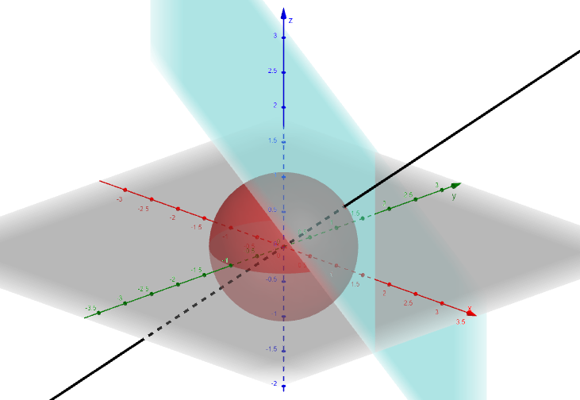
GnuPlot
Here is an example from GnuPlot
$$z=2·(y^{2}-x^{2})$$

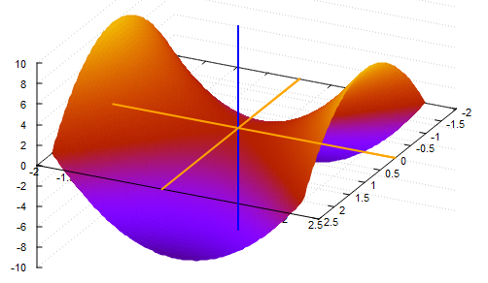
Once the 3D plot window is open, you can rotate the shape by dragging around with the left mouse button pressed inside. The image is copied to Word by right-clicking on the menu and selecting options and then Copy to clipboard. Now the 3D plot window can be closed and the image inserted.
The following Maxima command can also be used to make 3D graphs. However, only functions. Press calculate on the expressions and the GnuPlot window will open.
$$plot3d\left(2^{-x^{2} + y^{2}};\left[x;-3; 3\right]; \left[y; -2; 2\right]\right)$$
$$plot3d\left(x^{2}·y;\left[x;-3; 3\right];\left[y;-2; 2\right]\right)$$

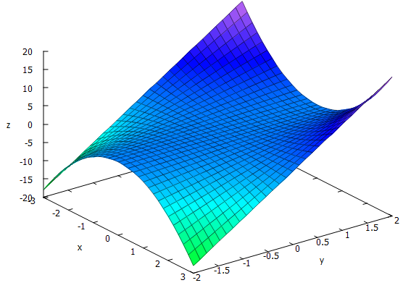

Solid of revolution
WordMath can draw solids of revolution around the x-axis for one or more functions at a time, using GeoGebra.
Example:
$$f\left(x\right)=x^{2}$$
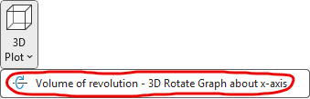 | Place the cursor in the math field, press the lower part of the 3D plot button and select Solid of revolution.
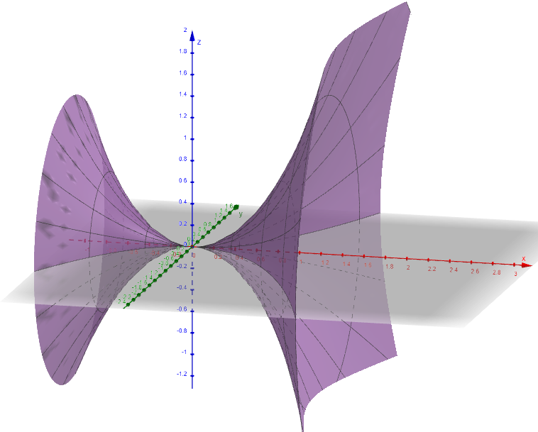
If you want to display multiple bodies in the same coordinate system, just select multiple math fields.
The formula collection has a formula for calculating the volume of a solid of revolution.
$$V=π·\int_{a}^{b}{{\left(f\left(x\right)\right)}^{2}}dx$$

Statistical charts
WordMath can generate all the statistical charts that are typically used in primary and secondary schools. This is done via an Excel sheet, which you open by pressing the statistics button in the menu at the top.
In this spreadsheet, there are several tabs at the bottom that are described in the next sections.

Data
The first tab is Data. Here you can enter your raw data, have it counted and the data grouped in intervals.
- Enter your raw data in the first column under "Raw data".
- WordMath automatically counts how many times each value occurs and displays it as a dot chart.
- If you want to group the data, you can type intervals under "grouped count". The intervals are written as ]a, b], where the starting number is not included, but the ending number is.
- You can quickly create intervals of the same length by using the fields above "grouped count".
- When you have entered and possibly grouped your data, click on Copy to other sheets. Then the data is transferred to the other tabs, where WordMath automatically calculates statistical descriptors and displays relevant charts.
- The next two tabs make complete calculations and charts for both ungrouped and grouped datasets.
- The Dataset 1 button lets you switch between up to 8 different datasets.
Example: Shoe sizes have been collected for 90 people. All 90 shoe sizes are entered in the first column under "raw data".
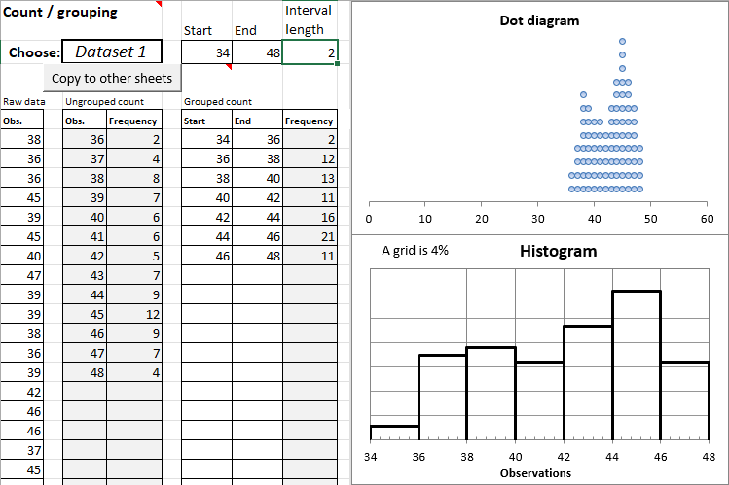
Note that the numbers in the first column 'Raw data' are unordered, while in the columns to the right they are arranged and counted. At the same time, the data is illustrated on the charts to the right.

Ungrouped observation set
On the Ungroup tab, data from the data sheet is automatically filled in when you click Copy to other sheets. You can also enter your observations and frequencies in the first two columns.
The sheet shows box and Whisker plot, dot diagram, bar chart, and staircase chart.
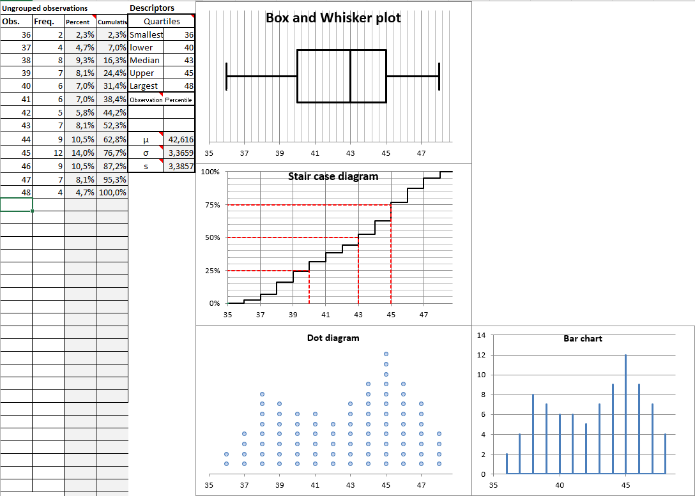
Frequency and cumulative frequency are calculated automatically. The following statistical descriptors are calculated:
smallest observation, lower quartile, Median, upper quartile and largest observation, mean value and standard deviation (also for a sample).
The quartiles are shown on the staircase diagram.
You can have an arbitrary percentile calculated and illustrated by entering either an observation or a percentage under "Percentile". It is possible to show two different percentiles at once.
If you want to align the axes on the graphs, do the following: Right-click on the x-axis and select Format Axis. On the right side, you can then adjust the minimum and maximum. Note that the axes are adjusted automatically when a number is changed on the sheet.

Grouped Observation Set
On the Group tab, data from the data sheet is automatically filled in when you click Copy to other sheets. You can also enter your intervals and frequencies yourself in the first three columns.
The sheet shows the Box and Whiskers Plot, Histogram, and Cumulative percentage diagram.
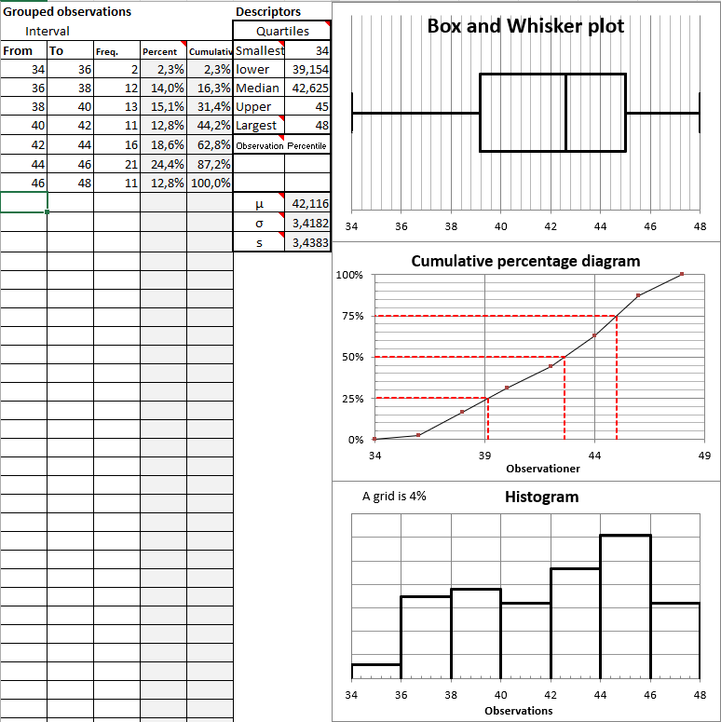
Frequency and cumulative frequency are calculated automatically. The following statistical descriptors are calculated:
smallest observation, lower quartile, Median, upper quartile and largest observation, mean value and standard deviation (also for a sample).
The quartiles appear on the Cumulative percentage diagram.
You can have an arbitrary percentile calculated and illustrated by entering either an observation or a percentage under "Percentiles". It is possible to show two different percentiles at once.
If you have intervals and frequencies, but not frequencies, you can just enter the frequency numbers under frequencies.

GOF (Goodness of fit)
The goodness of fit test is used to examine whether your observed data fits an expected distribution. Goodness of fit is calculated on the basis of a grouped data set. If you have entered data via the Data sheet and pressed Copy to other sheets, it will already be filled in. Otherwise, you can enter manually or copy from the Group sheet.
In addition to the dataset, enter an expected distribution (the 0 hypothesis). There are two buttons you can use to enter a symmetric distribution or a normal distribution as the expected distribution.
The test calculates the p-value and shows whether there is a basis for rejecting the null hypothesis.
Example:
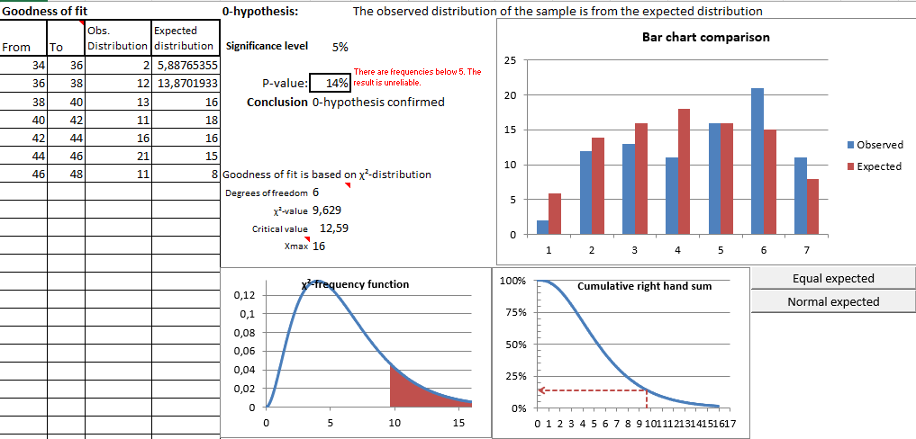
We can see that the p-value is 0,14 and with a significance level of 5%, we cannot reject the 0-hypothesis. We therefore have no evidence to say that the observed distribution is different from the expected one.
WordMath also shows how the P-value is calculated from the χ² distribution. You can see the calculated test size and critical value, and see it illustrated on the graphs.

Histogram-fit
Histogram-fit is used to find the normal distribution that best fits a grouped dataset.
Simply enter the grouped data – either manually or using Copy to other sheets on the data sheet.
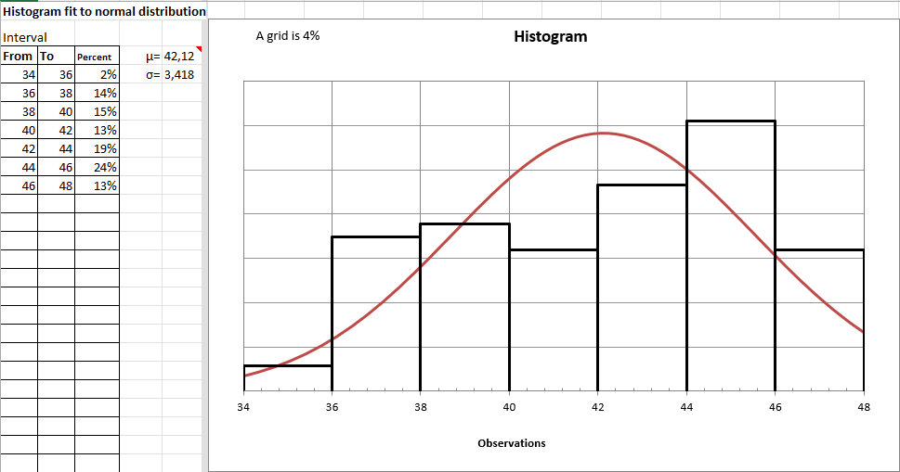
WordMath automatically calculates the mean and standard deviation and displays a histogram along with the normal distribution. The method for estimating the mean and the standard deviation is quite simple. You can manually adjust the mean and standard deviation yourself to see if you can produce a normal distribution that fits better with the distribution than the automatic one.
If you want a more accurate calculation of mean and standard deviation, you can use the "Normal plot" tab.

Normal plot and QQ plot
On this tab, you will find graphs that can help determine whether an ungrouped dataset is normally distributed. At the same time, estimates of mean value and spread are calculated using different methods.
Enter your raw data in the first column or transfer it from the data sheet using the Copy to Other Sheets button.
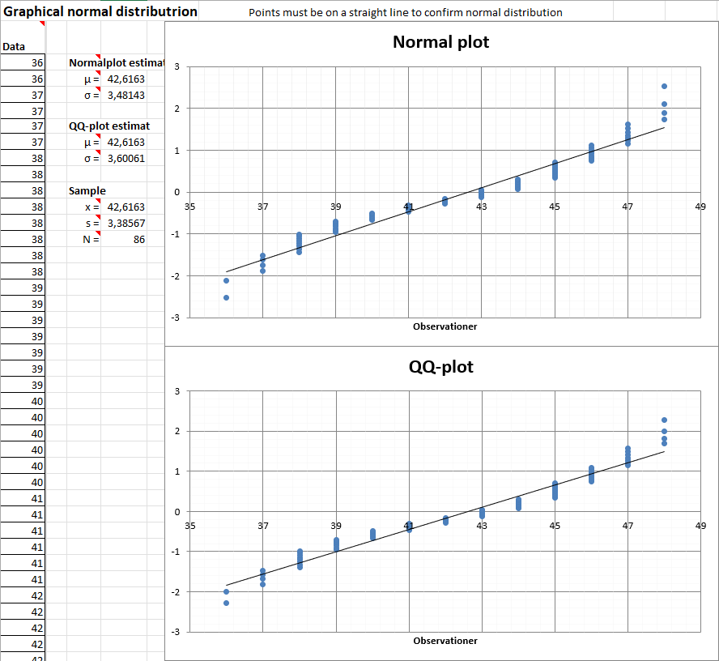
If the points are approximately on a straight line, without systematic deviations, there is evidence to say that the dataset is normally distributed.
There are two different graphs that use slightly different methods to draw the graphs. The top "normal-plot" uses the method described here: https://en.wikipedia.org/wiki/Normal_probability_plot
The QQ plot is a bit simpler but is a more common method.
It may be a good idea to adjust the axes on the graphs to get the best starting point for assessing the graphs. This is done by right-clicking on the x-axis and selecting "Format Axis". On the right side, you can then adjust the minimum and maximum.
WordMath calculates three different estimates for mean and dispersion, which can be read between the data and the graphs.
- Based on the normal plot
- Based on the QQ plot
- Calculated using standard formulas for mean and standard deviation for a data set

Comparing charts
The statistics sheet described above is good for processing one dataset.
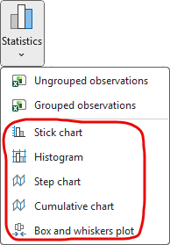 | If you want to compare different data sets using different charts so that they appear in the same chart, you can't use the Statistics sheet.  To that end, WordMath has a number of Excel sheets specifically for that purpose.  You can find them by clicking on the bottom part of the Statistics button.
Here's an example where the Box and Whiskers Plot is used to compare 3 plots:
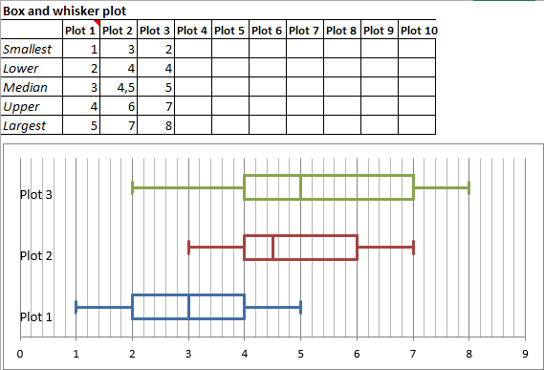
For the specific Excel sheets, you can select a subsheet at the bottom, where only the chart is shown in large format.

Regression
WordMath can perform 5 different regression forms: linear, exponential, power, polynomial, and Sine regression. However, there is also a custom regression form that can be used to approximate any function. There are basically two approaches. A method that uses only Word and a method that is Excel-based, which is discussed in a separate section below.

Regression in Word
- Click Regression > Insert Table in the WordMat menu
You will be asked how many points you want to insert and type e.g. 10. This table is then inserted
x
y
- Now fill in the table with the point coordinates
x | 1 | 2 | 3 | 4 | 5 | 6 | 7 | 8 | 9 | 10
y | 4,2 | 6,3 | 8,8 | 11 | 11,9 | 14,2 | 16,1 | 17,8 | 20 | 21,7
- Place the cursor somewhere in the table and click Regression > Linear in the WordMat menu.
Then you get the linear function that best fits with the points and the Coefficient of determination (R²).
Linear regression performed using WordMat: R2 = 0.9968176
$$f(x)=1,915152x+2,666667$$

If you want to see how the graph of the function fits with the points, select both the table and the function, and click Show Graph in the menu (Alt+P). It doesn't matter if there is text in between that is also selected.
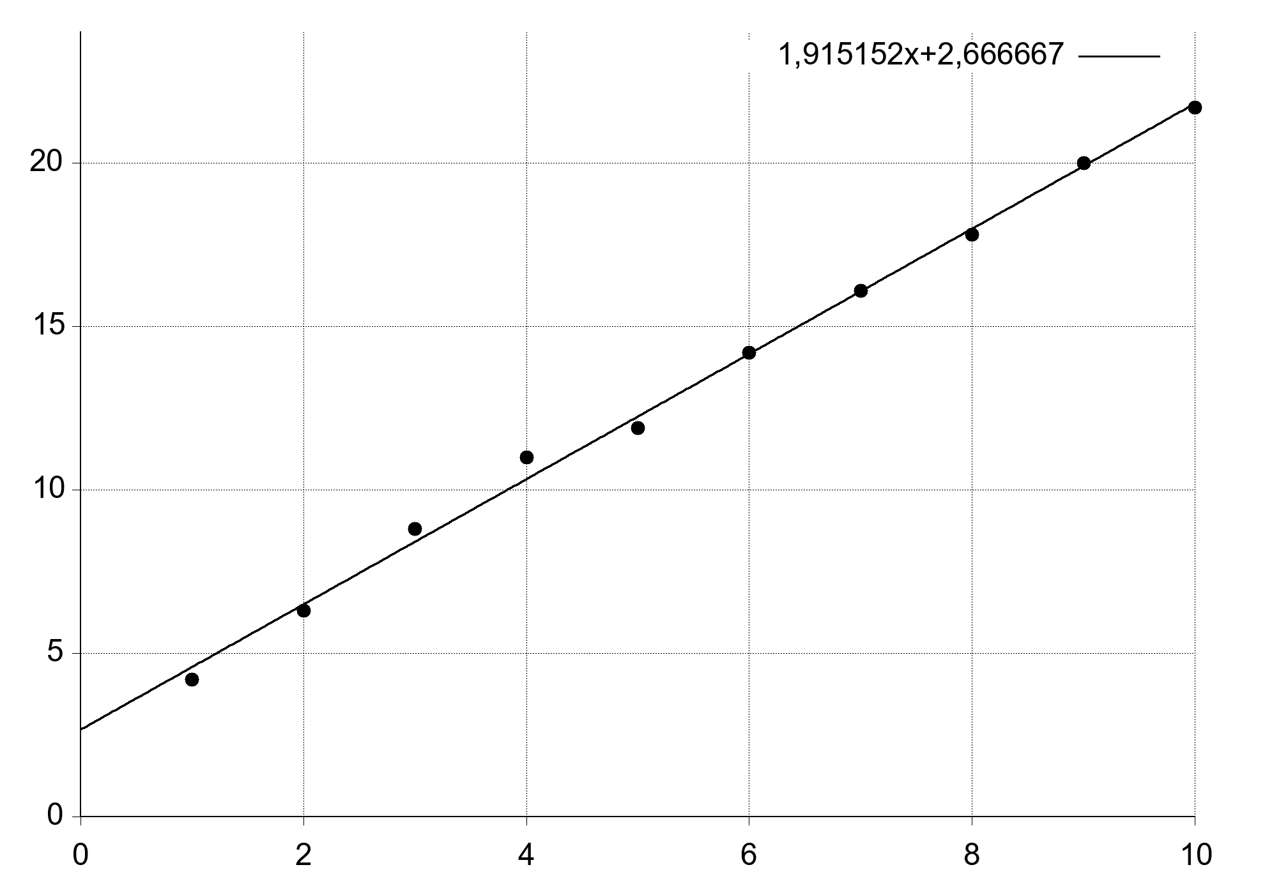

You can also insert your own table using Word's normal Insert>table or copy a table in from somewhere else. Both horizontal and vertical tables are supported. Regression > Insert Table will insert a horizontal table if 10 or fewer points are specified, otherwise a vertical table will be inserted. It is optional whether there should be "headings" in the first cells. Text is ignored.

A particular problem can arise if you only have two points and no heading is specified, as the direction of the table is ambiguous. The convention is that the table is vertical.
The following table is understood as points (1,2) and (3,4) not (1,3) and (2,4)
1 | 2
3 | 4
You can use both commas and periods as a decimal separator, and you can use scientific notation indicated by the following notation forms: 2.1*10^6 or 2.1E6
Letters in the table are ignored but do not cause errors.
Example of different approved ways of entering numbers in a table:
x | 1 | 2 | 3 | 4 | 5
y | 12,34 | 345.6 | 5.6E4 | 6.2*10^5 | 7E6

Mathematical fields may not be used in the table.

Instead of entering the points in a table, you can also enter a point set in a math field.
Example of entering point set, on which regression can also be performed:
$$\{(1,4;2),(3,2;5),(5,7)\}$$

Notice how both semicolons and commas have been used as list separators. List separator is identified based on the context. Graph display of the points is not supported using this format.

Excel Regression
Instead of performing the regression directly in Word, it can be done using a special Excel sheet. Excel already has features built in to perform regression, but WordMath's Excel sheet makes this easier, adding a number of features that Excel doesn't normally have:
- The Excel sheet makes a graph that looks like a real coordinate system, with arrows on the axes and a proper grid.
- The Excel sheet can write exponential functions in the form $y=b·a^{x}$
- The regression lines are continued so that they fill the entire coordinate system.
- Functions can be inserted in the diagram
The Excel sheet is particularly suitable if you have many points, or if you already have the points in Excel, and especially useful in science subjects.
The Excel sheet can be opened from two different places in the WordMath Menu. Under Show Graph > Excel and under Regression > Excel regression. It doesn't matter which button is clicked.
The Excel sheet's functions, except for regression, are described in Section 8 Graphing > Excel p. 38. It is recommended to read that section first. We continue here with an example from Section 8.

- Enter points under point series 1
- Click the Regression button
- Click on the regression type, e.g. linear.
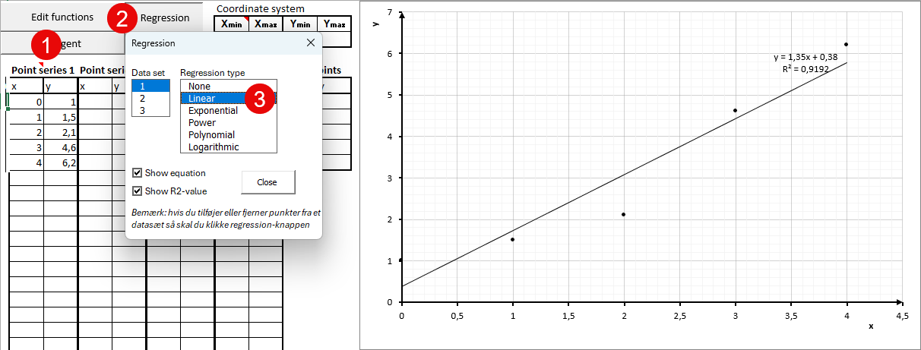
The equation and graph can now be seen in the coordinate system.
You can easily switch between the different types of regression to see how they fit with the points.
Especially for exponential regression, an extra text field appears where the equation is written in the form
$y=b·a^{x}$
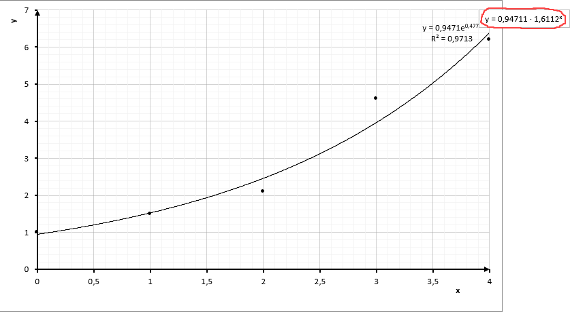
Note that in polynomial regression you have the option to specify the order (degree) of the polynomial from 2-6.
The "Mark Points" feature also works for regression lines. (see Section 8 Excel)

Sinus regression
In Sinus regression, the harmonic oscillation that best matches the points is found. The harmonic oscillation is this function:
$$y=A·\sin\left(ω·x+ϕ\right)+k$$
Sinus regression is a matter of determining the 4 constants that are included in the function.
A - the amplitude (vertical stretch)
$ω$ - the angular velocity (affects frequency and period/wavelength)
$ϕ$ - the phase shift (affects horizontal displacement)
k - vertical displacement.
As with the other regressions, you enter the coordinates of the points in a table, possibly via Insert table in the regression menu. Then you place the cursor in the table and select Sine regression from the WordMath menu.
Example:
x | 10 | 70 | 130 | 190 | 250
y | 7,2 | 11,5 | 16,2 | 17,5 | 13,4
Sine regression performed by WordMath(in radians): R² = 0,9991414
$$f\left(x\right)=5,43114·\sin\left(0,01695775·x-1,332785\right)+12,19906$$
You can view the graph by selecting the table and function at the same time, and click Show Graph (Alt + P)
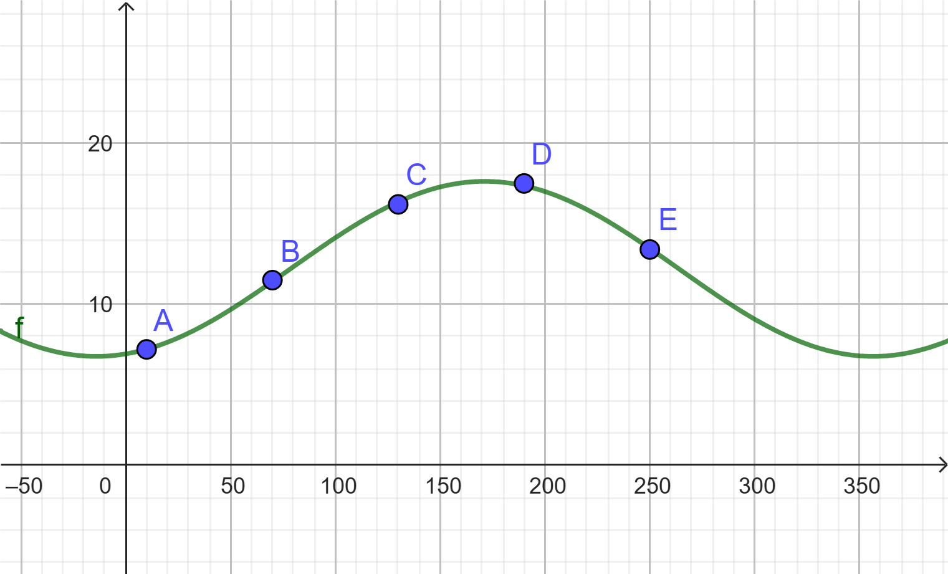
NOTE: In the vast majority of cases, the WordMath must be left to radians when performing Sinus Regression. If you perform regression while WordMath is about to be calculated in degrees, you will be warned. For example, if you have performed regression in degrees and subsequently show the graph with radians, the points and the graph will not fit together.
As an alternative to WordMath's sine regression, you can use GeoGebra
- Put the cursor in the table and press Show Graph > GeoGebra calculator suite or Show Graph > GeoGebra 5
(Or press Alt+P if you have GeoGebra as your default Graph program)
- Enter in the input field, depending on which GeoGebra is opened in.GeoGebra Calculator Suite: fitsin(l1)GeoGebra 5: fitsin(dots)
- Optionally increase the number of digits in Settings/Rounding

User defined regression
With custom regression, you can get any function adapted to a series of points. In addition to the independent variable, one or more variables must be included that must be determined. For example, this modification of the exponential function:
$$y=b⋅a^{x}+c$$
- Enter a table with points, possibly via Regression > Insert Table
- Enter the function with variables just below the table. The function must be entered in a math field.
(If you don't specify a function, you can also specify it afterwards)
- Select both the table and the function and click Regression > User defined Regression
Example:
x | 1 | 2 | 3 | 4 | 5 | 6 | 7 | 8 | 9 | 10
y | 82 | 75 | 66 | 59 | 51 | 50 | 44 | 37 | 37 | 33
$$y=b⋅a^{x}+c$$
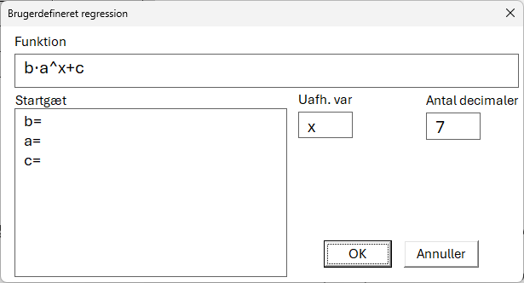 | Here you can see that the function that was marked has been inserted. WordMath identifies the three constants and is prepared to insert starting guesses.  In this case, no initial guess is entered, and WordMath still finds a good solution.
User defined regression with the function: $y=b⋅a^{x}+c$ performed by WordMath: R² = 0,9928024
$$80,84603·{0,8727893}^{x}+12,15958$$

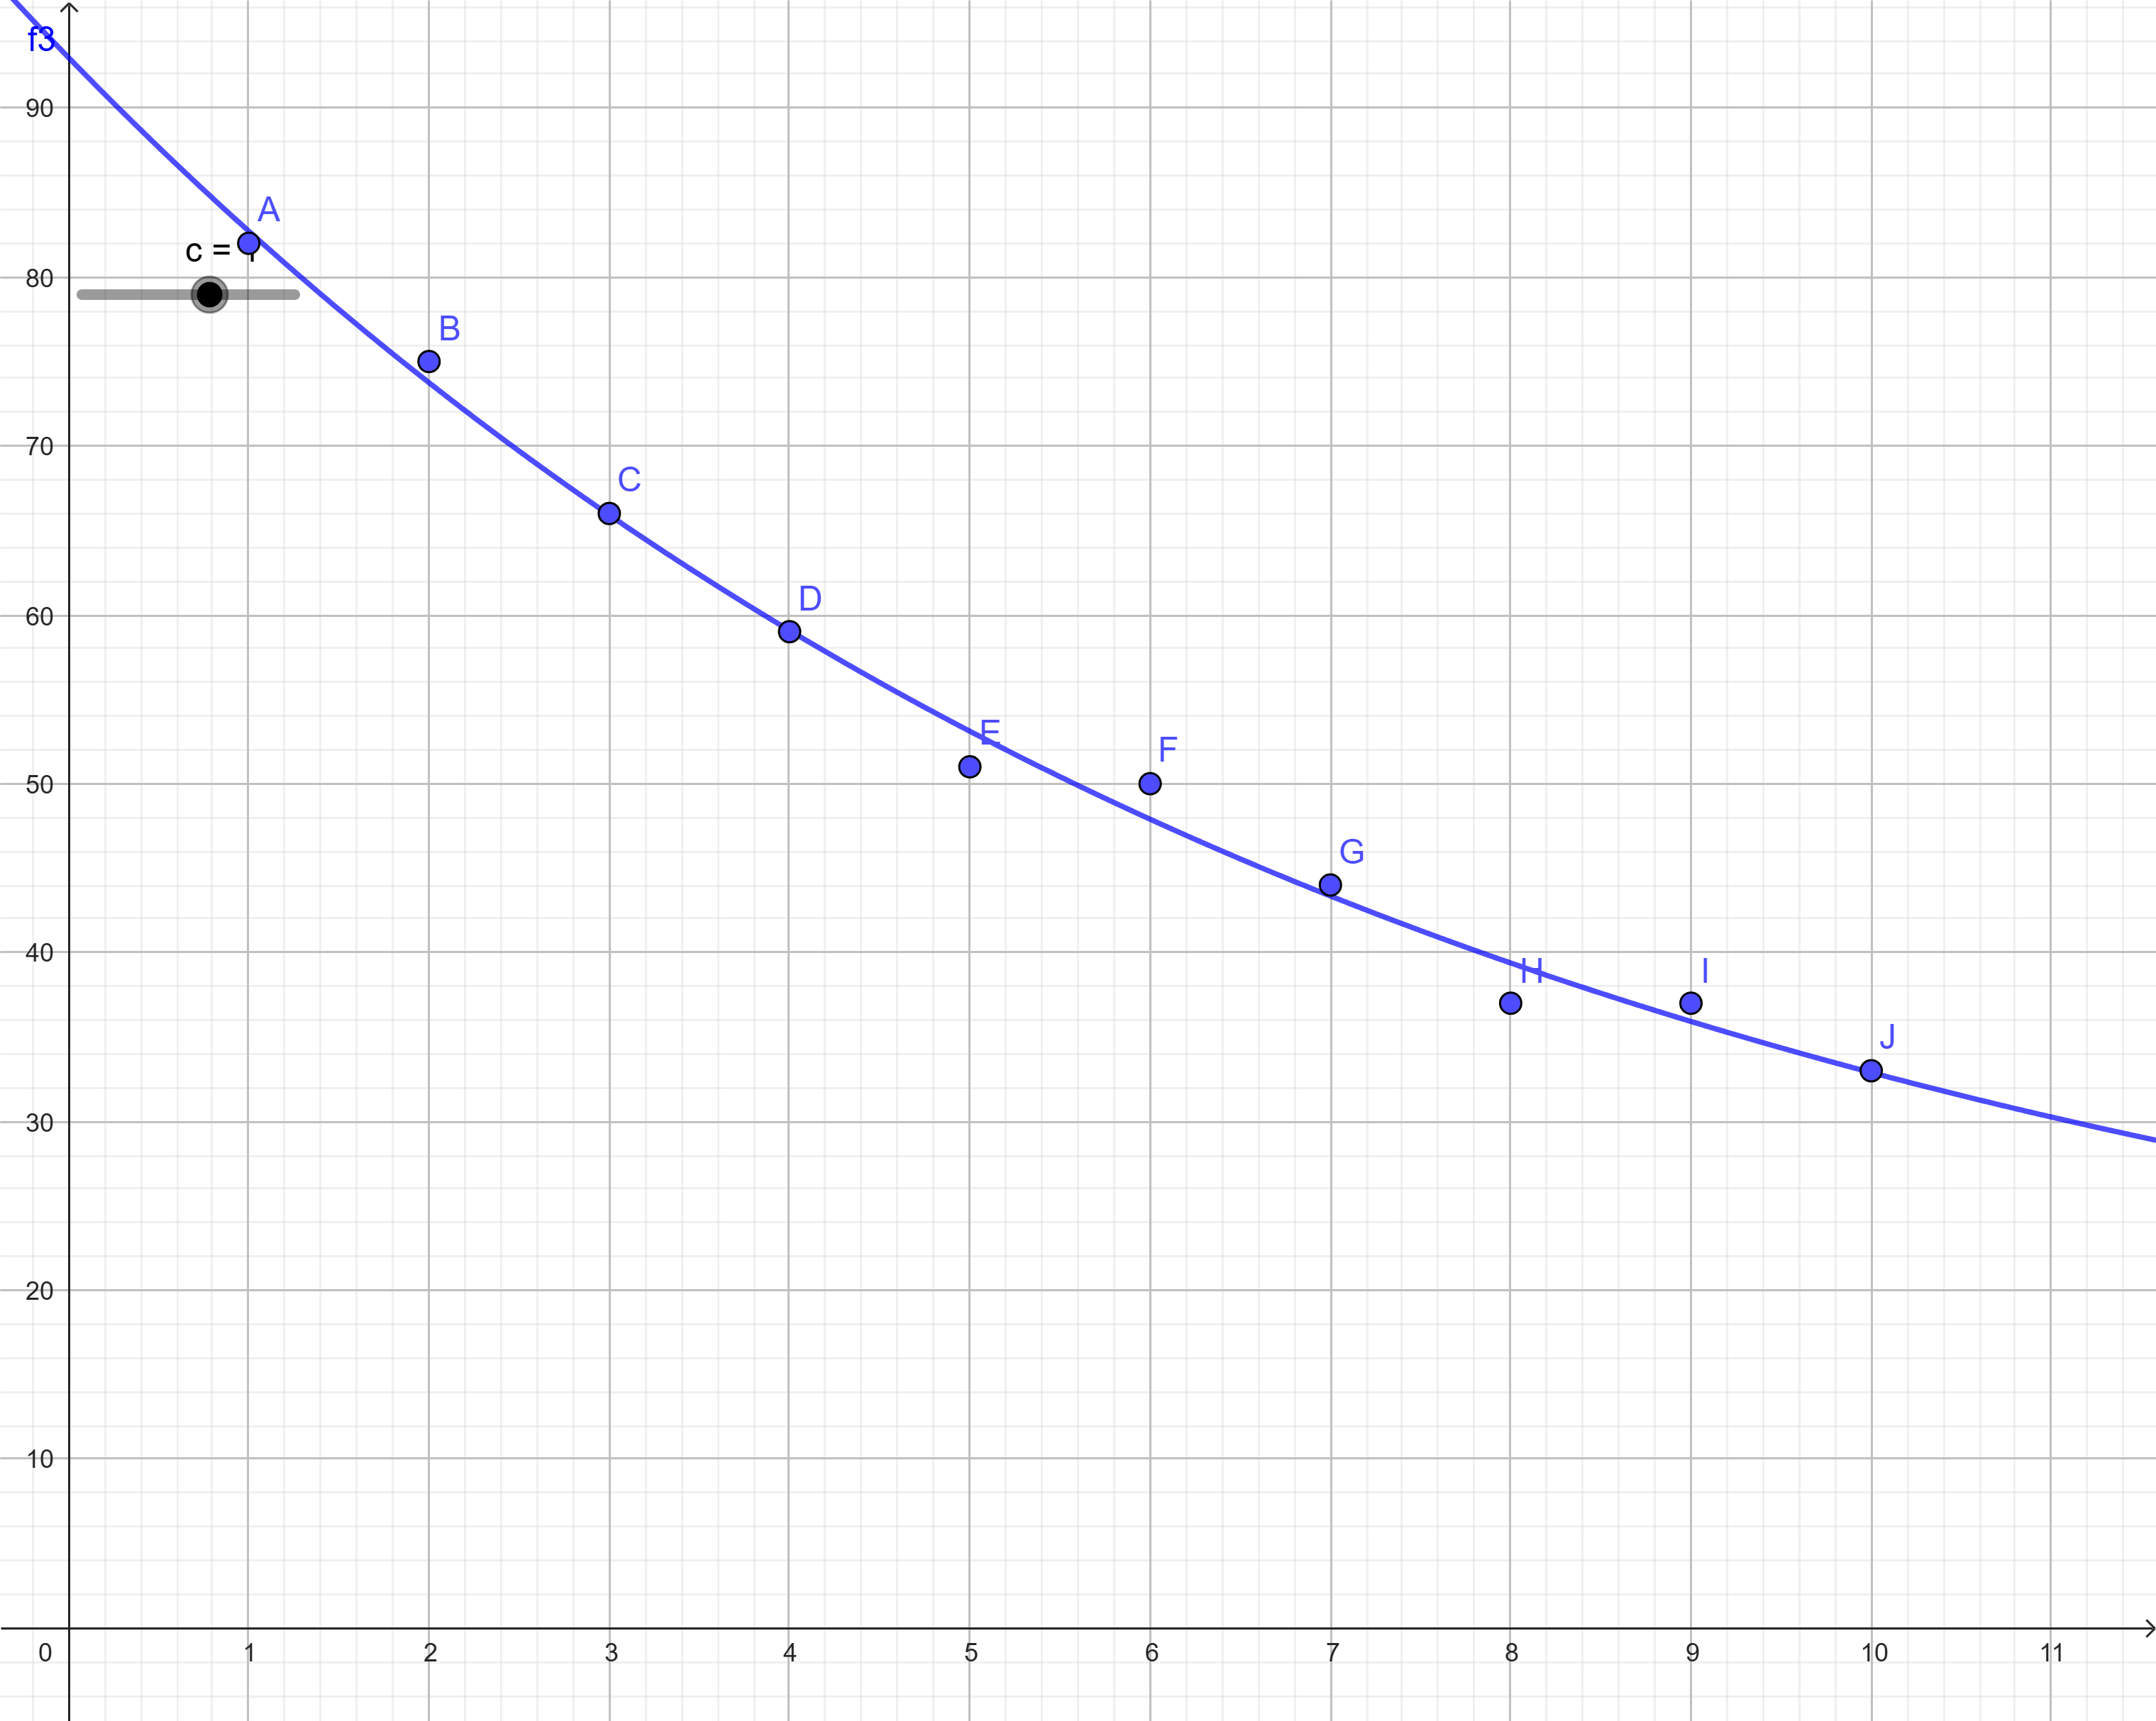
In the result, the three constants (a, b, c) are replaced with the numbers that make the function the best possible approximation to the points. You decide what you call the constants.
It is possible to specify the precision with which you want the constants. Very high precision can affect the calculation time, especially at many constants.
It is possible to enter starting guesses, for the individual constants, but not necessary. However, good initial guesses can be important.
It is important to note that this is a numerical method. There is no guarantee that there will not be functions that fit better than the one that is found. It can depend on the initial guesses, especially if there are many constants in the expression.

Probability
WordMath offers two ways to work with probability:
- Formula-based approach
CAS-based. The formulas are built into the formula collection.
(Formula collection is in Danish)
- Excel-based approach
View distributions and perform statistical tests via Excel sheets, which can be accessed from the menu under Distributions and Tests.

Combinatorics, binomial distribution and testing
In the formula collection you can find the definition of binomial coefficient, just search for 'bin' or click on probability calculus. Then you can find this overview of combinatorics formulas
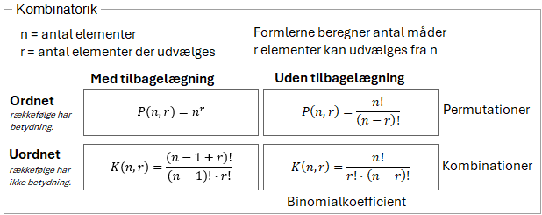
Or this one with formulas for binomial distribution, where the formula for binomial coefficient also appears
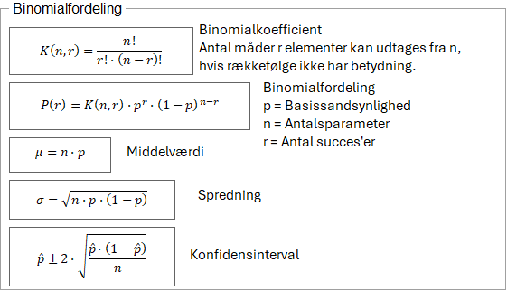
Once the formula for binomial coefficient is inserted, it will be as a definition.
$$K\left(n,r\right)≝\frac{n!}{r!·\left(n-r\right)!}$$
Note that this is not a formula where you insert numbers into the formula. It is a definition. Once defined, you can subsequently type
$$K\left(5, 2\right)=10$$
Note here that there must be a space on one side of the comma, or you must use a semicolon, otherwise 5.2 will be interpreted as the decimal number 5.2 and not two separate numbers (unless you have selected comma as a list separator in settings).
Maxima and GeoGebra also have a built-in binomial coefficient feature that you can use without having to define anything.
$$binomial\left(5, 2\right)=10$$
In the formula collection, you can also find the formula for binomial distribution. When inserted, it automatically defines n, p, and K(n, r).
$$Define:n=10, p=\frac{1}{2}$$
$$K\left(n,r\right)≝\frac{n!}{r!·\left(n-r\right)!}$$
$$P\left(r\right)≝K\left(n,r\right)·p^{r}·{\left(1-p\right)}^{n-r}$$
The idea is that you change n and p yourself, and then subsequently use P(r)
$$P\left(3\right)=0,1171875$$
$$Delete definitions:$$
Excel sheet for binomial distribution
Under Distributions > Binomial distribution, you will find the Excel sheet for the Binomial distribution.
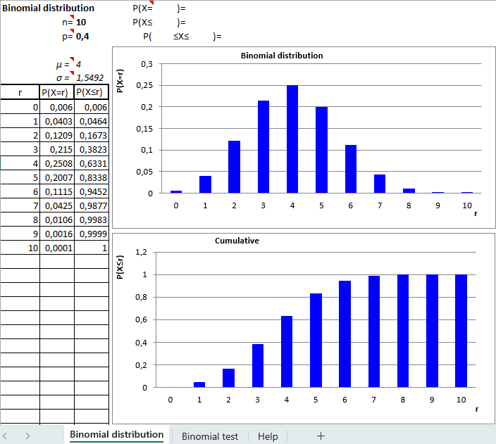 | At the top left, enter the number of trials n and the probability of success p. As a starting point, they are set: n=10 and p=0.4.  When n and p are changed, the tables for $P\left(X=r\right)$ and $P(X≤r)$ is automatically calculated, just as the distribution is illustrated on the two graphs for $P(X=r)$ and $P(X≤r)$.  The mean and standard deviation are calculated automatically.
For calculating $P\left(X=r\right)$ and $P\left(X≤r\right)$ you can look up the table, but there are also specific fields at the top for calculating $P\left(X=r\right)$, $P\left(X≤r\right)$ and $P\left(r≤X≤s\right).$
Note that at the bottom of the sheet there is a sub-sheet called Binomial Test. If you click on it, you will get a sheet that can do binomial tests on the same n and p.
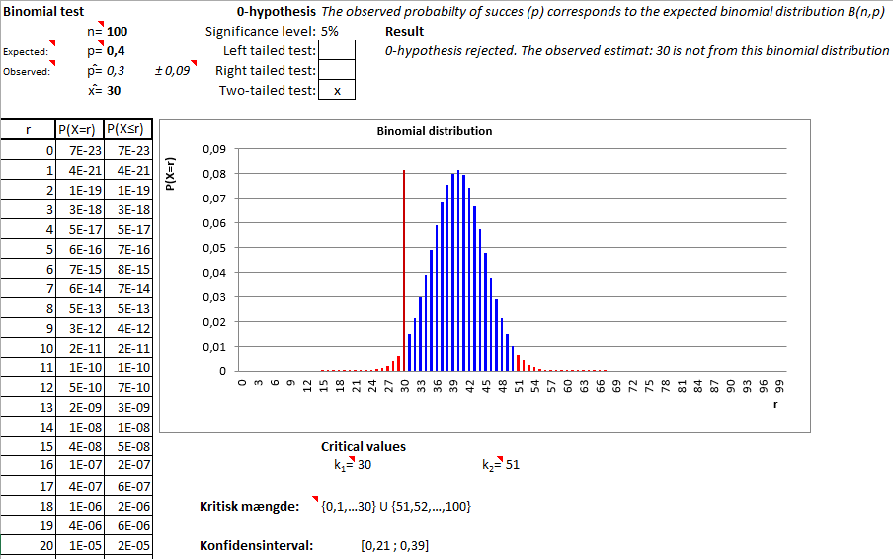
In the above example, n=100 and p=0.4
In order to perform the test, the sheet must also have an observed $\hat{p}$-value or an observed $\hat{x}$-value. If you fill in one of the two fields, the other is calculated automatically. In the above example $\hat{x}=30$ was entered.
As a starting point, a significance level of 5% and a double-sided test are assumed, but this can be changed.
On the chart, you can see the binomial distribution, and you can see the critical amount illustrated in red. The observed value is shown with a vertical line and it is colored according to whether it is inside the critical set. The specific critical values and critical quantity are listed below the diagram.
Also note that next to the observed $\hat{p}$-value, the uncertainty is indicated, which is also indicated as a confidence interval at the bottom of the page. The method for calculating the uncertainty is the approximate formula
$$Δ\hat{p}=1,96·\sqrt{\frac{\hat{p}·\left(1-\hat{p}\right)}{n}}$$
However, the constant 1.96 only applies to a significance level of 5%. If the significance level changes, WordMath calculates the correct constant.
$$Slet definitioner:$$

Normal distribution
As with binomial distribution, the normal distribution can be accessed via formulas or via an Excel sheet. Let's first look first at the formula approach.
In the formula collection, you can find the density function and the distribution function of the normal distribution
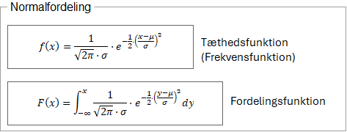
When you insert one of the formulas, the mean and standard deviation, as well as the function will be defined. You can then just change the mean and standard deviation.
Example: Both functions are defined from the formula collection
$$Define: μ=0 , σ=1$$
$$f\left(x\right)≝\frac{1}{\sqrt{2π}·σ}·e^{-\frac{1}{2}·{\left(\frac{x-μ}{σ}\right)}^{2}}$$
$$F\left(x\right)≝\int_{-∞}^{x}{\frac{1}{\sqrt{2π}·σ}}·e^{-\frac{1}{2}·{\left(\frac{y-μ}{σ}\right)}^{2}}dy$$
You can then calculate the probability that X is less than 1.4
$$P\left(X≤1,4\right)=F\left(1,4\right)≈0,9192433$$
Or we can solve the equation
$$P\left(X≤r\right)=0,3$$
Using.:
$$F\left(r\right)=0,3$$
$⇕$ The equation is solved by using WordMath.
$$r=-0,5244005$$
You can also draw the graph for the density function. Just click show graph if the density function is defined, and the function will be automatically transferred to GeoGebra.
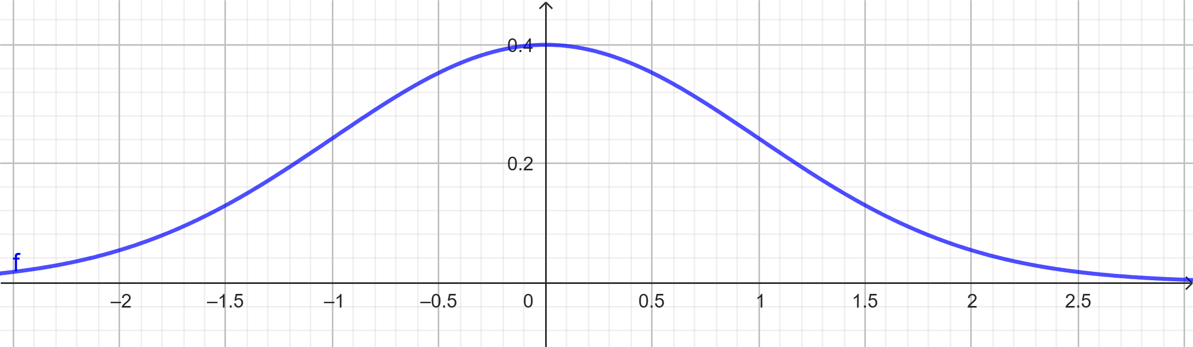

However, the display of the distribution function is not supported by GeoGebra, as it includes integral signs, but can be displayed with GnuPlot (Windows only)
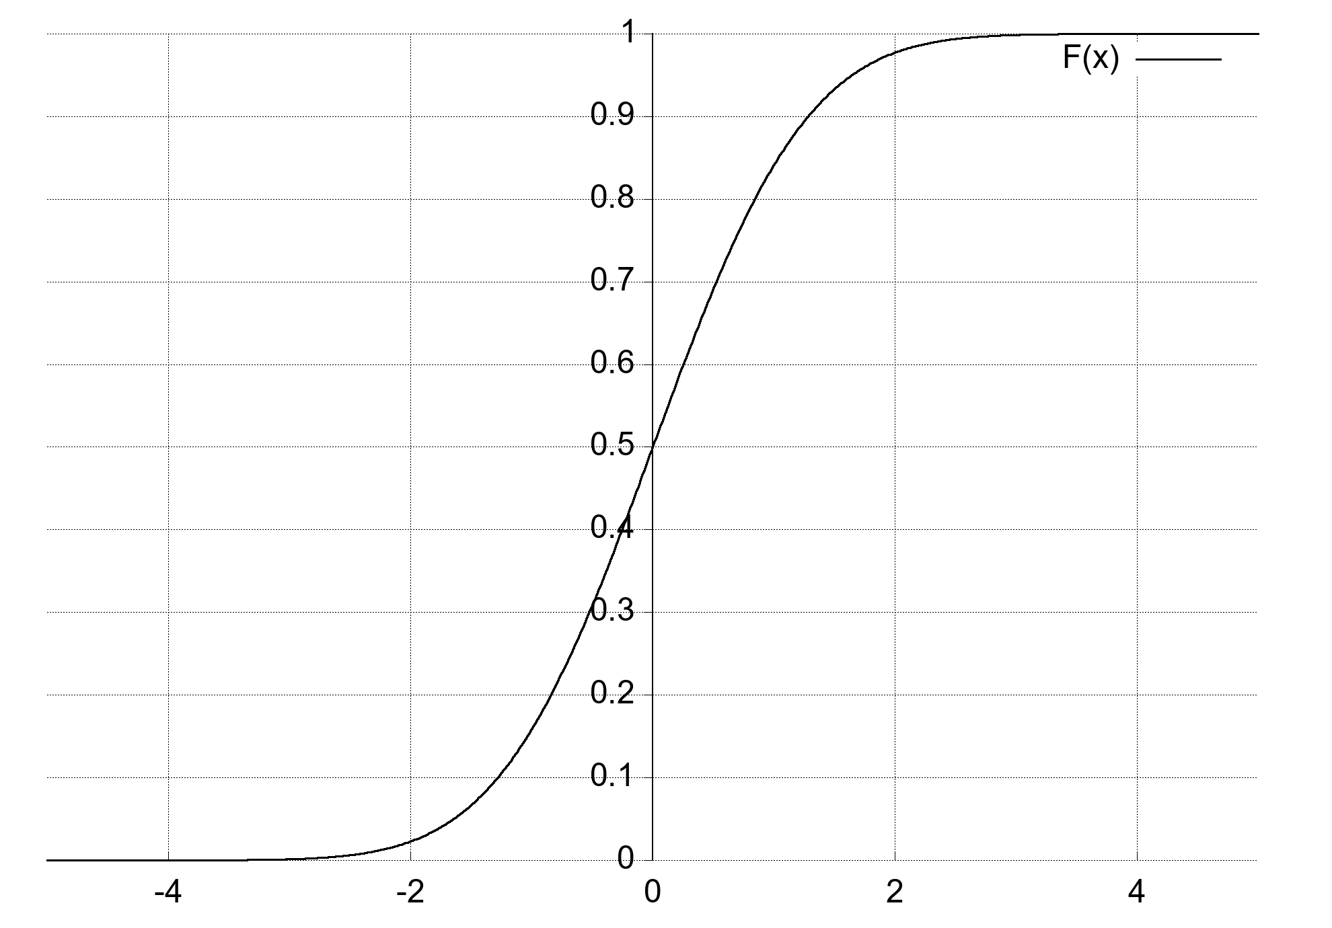
There are other ways to display the Distribution function that also work on Mac.
Click Distributions > Normal Distribution to open the Excel sheet for the Normal Distribution.
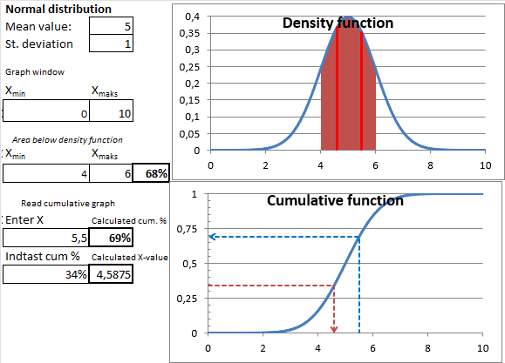 | As a starting point, the mean value is set to 5 and the standard deviation to 1. When it is changed, it automatically shows up on the graphs.  If the mean value changes, you typically also need to change the Graph window, by entering X_{min} and X_{max} just below.  The graph of the distribution function F(x) is called the cumulative graph.  By filling in the fields on the left side, you can calculate $P\left(r≤X≤s\right)$ and have it illustrated on the graph, as the area under the frequency function between r and s.
At the bottom there are two cells to calculate $F\left(x\right)$ and $F^{-1}(x)$ and at the same time have it illustrated with arrows on the graph for F(x).
$$Delete definitions:$$

ꭓ² distribution and testing
χ² - The frequency function can be found in the "old" collection of formulas. Click on the lower part of the Formulae button and select Prob. > χ² distribution > frequency function.
You will be asked to specify a number of degrees of freedom. If you just specify n (default), you get the general expression, and you can then define n yourself.
χ² - Frequency distribution with n degrees of freedom
$$f\left(x\right)≡\frac{1}{2^{\frac{n}{2}}·Γ\left(\frac{n}{2}\right)}·x^{\frac{n}{2}-1}·e^{-\frac{x}{2}}$$
$$Define: n=4$$

Note that the function is inserted as a definition.
$$f\left(6\right)≈0,0746806$$
The function can be viewed with GeoGebra. If you don't define n, you'll get a slider where you can adjust the number of degrees of freedom.
You can also get the frequency function with a certain number of degrees of freedom directly. When you click the button in the Formula-menu you are prompted to enter a degree of freedom.
χ² - Frequency distribution with 5 degrees of freedom
$$g\left(x\right)≝0.132980760370601·x^{1.5}·e^{-\frac{x}{2}}$$
Both of the above functions are shown here.
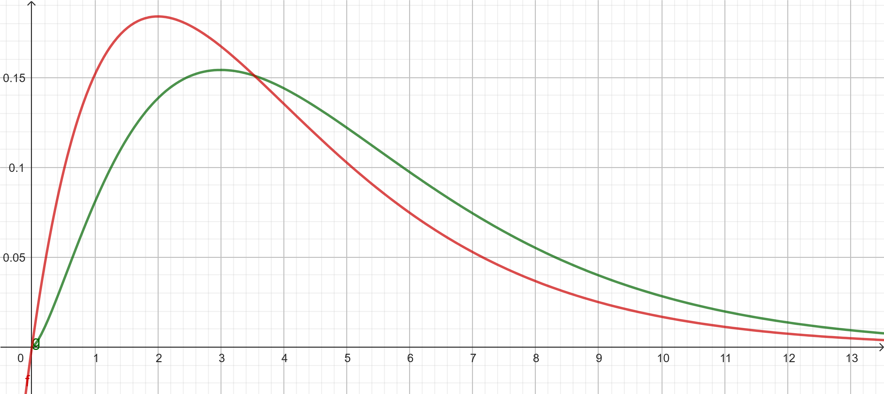
The Excel sheet is accessed via the menu Distributions > χ² distribution.
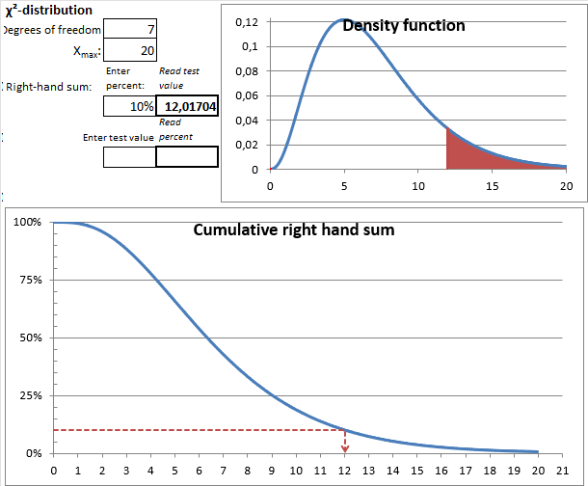 | At the top left, enter the number of degrees of freedom, and the graph to the right is automatically adjusted. It may then be necessary to adjust X_{max} just below to expand the coordinate system, so that you can see the entire graph.  In the "Right-hand sum" cell, you can enter a percentage. That percentage is then shown on the graph as a red area below the graph. The X-value for where the area stops is stated.  At the bottom is the graph for the Distribution function. Here you can see how to find the test value for the right-hand sum.

χ² - Test
WordMath makes it easy to perform a χ² test for the correlation between two variables:
- Click Test > χ² test for independence from the menu.
- You will be asked about the level of significance and the size of the cross-tabulation.
- An Excel sheet will open where you can enter your data.
If you already have the cross table in Word, you can simply place the cursor in the table and click Test > χ² test for independence. WordMath automatically transfers the numbers to Excel and determines the dimensions. This way of doing it also has the advantage of displaying the result directly in Word.
Example: Relationship between gender and height?
 | 100-160 | 160-180 | 180-300
M | 45 | 540 | 305
K | 213 | 824 | 120
χ² - test of indepence performed using WordMat
P-value: 4,734359E-48 = 4,734359E-46%
Using significance level of 5% the 0-hypothesis can be rejected. Hence there is dependence between the two variables.
In the Excel sheet, you can change the significance level, see the Q value, as well as the critical Q value.
You can also see how the Q-value is calculated using the expected values and the contributions to the Q-value.
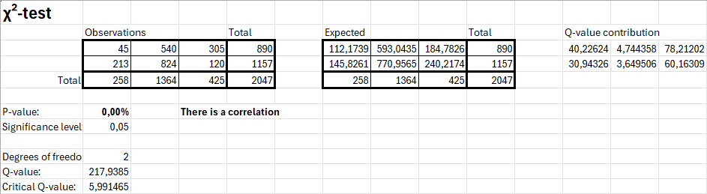

T-distribution
WordMath has an Excel sheet to show the t-distribution. It works similarly to the normal distribution sheet.
Unfortunately, the sheet cannot perform t-tests (Yet).
$$Delete definitions:$$

Calculus
Differential and integral calculus in WordMath generally works with the same notation as you would write math on paper.

Differential calculus
In differential calculus, it is generally a good idea to start by defining the function(s) to be worked with
$$Define:f\left(x\right)=x^{2}-3x+1$$
Now you can calculate the derivative, for example:
$$f^{'}\left(x\right)=2·x-3$$
Or find the differential quotient in a single point:
$$f^{'}\left(2\right)=1$$
The ' prime tags can be typed in several different ways on a keyboard. The different primes are all similar: ’ ´ `
WordMath supports all ways to enter prime tags, but it is recommended to use the one that is just to the left of the Enter button on the same button as *. It looks best and is the easiest to access.
You don't need to define a function to differentiate it. The following notation forms are also supported:
$${\left(x^{2}+2x-1\right)}^{'}\left(x\right)=2·x+2$$
$${\left(x^{2}+2x-1\right)}^{'}=2·x+2$$
The expression does not have to be a function, but then the variable must be x.
$$Define: y=x^{2}$$
$$y^{'}=2·x$$
In relation to the trigonometric functions, it is important that WordMath is set to calculate in radians
$${\left(\sin\left(x\right)\right)}^{'}=\cos\left(x\right)$$
If WordMath is not set to radians, it corresponds to the function $\sin\left(\frac{π}{180}·x\right)$ being differentiated, and then the result is:
$${\left(\sin\left(x\right)\right)}^{'}=\frac{π·\cos\left(x\right)}{180}$$
WordMath also supports 2nd and 3rd derivatives etc.
$$f^{''}\left(x\right)=2$$

Differential notation is also supported, but there is a problem. If you just type dy/dx it doesn't work:
$$\frac{dy}{dx}=\frac{dy}{dx}$$
This is because WordMath does not reserve the variables dy and dx. WordMath needs to know that you have not just entered an expression, where there are two variables called dy and dx.
This can be done in two different ways.
- Differential d
Word supports entering a special d, which can be used for dy/dx notation. This d is entered by typing '\dd' followed by a space. And then it works:
$$\frac{ⅆy}{ⅆx}=2·x$$
It looks exactly like a normal d, but there is a difference.

- The setting: "Use regular d as differential d"
It is also possible to get it to work by typing a regular d. This is done by opening Settings > Notation and ticking Use regular d as differential d
$$\frac{ⅆy}{ⅆx}=2·x$$
This setting can possibly cause problems in some contexts where d is part of a common equation. However, this is very unlikely.

Other examples of supported notation:
$\frac{ⅆf\left(x\right)}{ⅆx}$ , $\frac{ⅆ}{ⅆx}f\left(x\right)$ , $\frac{ⅆ}{ⅆx}\left(x^{2}+2x\right)$ , $\frac{ⅆ^{2}}{ⅆx^{2}}\left(x^{2}+2x\right)$

$$Delete definitions:$$
Partial derivatives
The differential symbol used for partial derivatives: ∂ - is entered with the shortcut "\partial"
Here are some examples of notation that can be used with the partial derivative symbol without defining a function:
$$\frac{∂}{∂x}\left(x^{2}·y\right)=2·y·x$$
$$\frac{∂^{2}}{∂x∂y}\left(x^{2}·y\right)=2·x$$
If you have defined a function of two variables, you can also use the subscript notation to determine partial derivatives:
$$Define: f\left(x,y\right)=x^{2}+3x·y-2y+1$$
$$f_{y}^{'}\left(x,y\right)=3·x-2$$
$$f_{yx}^{''}\left(x,y\right)=3$$
$${\left(3x^{2}+2y·x\right)}_{x}^{'}=6·x+2·y$$
$$\frac{∂^{2}}{∂x∂y}f\left(x,y\right)=3$$
$$\frac{∂^{2}f\left(x,y\right)}{∂x∂y}=3$$
$$Delete definitions:$$
Example exercise: Tangent determination
Determine the tangent of the function $f\left(x\right)=\frac{1}{2}x^{2}-2x+1$ in the point $(4, f\left(4\right))$
First define the function and the x-value of the point
$$Define: f\left(x\right)=\frac{1}{2}x^{2}-2x+1, x_{0}=4$$
Next, the formulae for the tangent's equation is retrieved by searching for 'tangent' in the formula booklet. (Alt+F)
$$y=f^{'}\left(x_{0}\right)·\left(x-x_{0}\right)+f\left(x_{0}\right)=2·x-7$$
The tangent is found by performing Calculate on the formula. Note that it has not been necessary to determine $f’(x)$, just define the components that are in the formula.
$$Delete definitions:$$
Nabla operator and functions of two variables
There is support for the nabla operator.
Enter it as follows:
\nabla → $∇$
Examples:
$$Define: f\left(x,y\right)=x^{2}·y$$
Calculation of the gradient as a vector function and in a specific point:
$$∇f\left(x,y\right)=\left(\begin{matrix}2·y·x \\ x^{2}\end{matrix}\right)$$
$$∇f\left(1, 2\right)=\left(\begin{matrix}4 \\ 1\end{matrix}\right)$$
Example of the Laplace operator:
$$∇^{2}f\left(x,y\right)=\left(\begin{matrix}2·y \\ 0\end{matrix}\right)$$

Integral calculus
The Integral sign is entered in Word like this:
\int space → $∫$
Two spaces after \int give a slightly larger integral sign:

An indefinite integral can be determined by entering the integral and performing calculate
$$\int{-x^{2}+2x+1dx}=-\frac{x^{3}}{3}+x^{2}+x$$
WordMath does not output an integration constant. It is not necessary to use the special differential d, when entering dx. Just enter a regular d.
As with differential calculus, it is important that WordMath is set to calculate in radians when using trigonometric functions:
$$\int{\sin{{\left(x\right)}^{2}}dx}=\frac{x}{2}-\frac{\sin\left(2·x\right)}{4}$$
Definite integrals are entered as follows:
\int_0^3 space → $\int_{0}^{3}{}$
Example:
$$\int_{0}^{3}{x^{2}dx}=9$$
You can have infinity signs in the boundaries
$$\int_{-∞}^{0}{e^{x}dx}=1$$
The shortcut to ∞ is \infty.
When calculating definite integrals, it is important to be aware that WordMath uses two different methods to calculate the integral, depending on whether WordMath is set to calculate exactly or numerically.
If WordMath is set to calculate exact, WordMath will first determine the antiderivative and from there determine the definite integral. When the setting is numerical, WordMath will use numerical methods to determine the integral. In the vast majority of cases, this will give the same result, and the two methods can also automatically switch to the other if one fails. However, problems can occur. If you experience problems with a particular integral, it may be a good idea to try change the setting. For example, there are integrals that WordMath will try to solve exactly for a very long time, leaving you stuck with the ‘Wait prompt’.
Double and triple integrals are supported. ex:
$$\int{\int{x·y}}dx dy=0,25·y^{2}·x^{2}$$
$$\int_{1}^{3}{\int_{2}^{5}{x·y}dx}dy=42$$
Note that there must be a space between dx and dy.
It is also possible to use the double and triple integral sign, but only for indefinite integrals.
$$\iint{x·y}dx dy=\frac{y^{2}·x^{2}}{4}$$
The shortcut to double integrals is \iint and to triple integrals \iiint
GeoGebra and Graph also both have functions for determining areas under graphs and thus definite integrals.
$$Delete definitions:$$

Limit values
WordMath can calculate limit values using the Lim notation.
Example: Calculation of the Differential Quotient for $x^{2}$ from the definition of the Differential Quotient
$$\lim_{h→0}\left(\frac{{\left(x+h\right)}^{2}-x^{2}}{h}\right)=2·x$$
Enter as follows: lim_(h->0) ((x+h)^2-x^2)/h.
Here is another example of using the definition of differential quotient, where the function is defined so that it is easy to change functions. For example, try switching to $\frac{1}{x}$
$$Define: f\left(x\right)=\sqrt{x}$$
$$\lim_{h→0}\left(\frac{f\left(x+h\right)-f\left(x\right)}{h}\right)=\frac{1}{2·\sqrt{x}}$$
It is not necessary to enter parentheses around the expression if you want to take a limit value of everything that is to the right of ‘lim’.
$$Delete definitions:$$

You can also determine thresholds from the right and left by adding a small + or - as superscript. This is illustrated here by an example.
We look at this slightly special function:
$$Define: f\left(x\right)=2+x+\sqrt{4x^{4}-8x^{2}+4}$$
Below you can see the graph of the function and its derivative.
f(x)  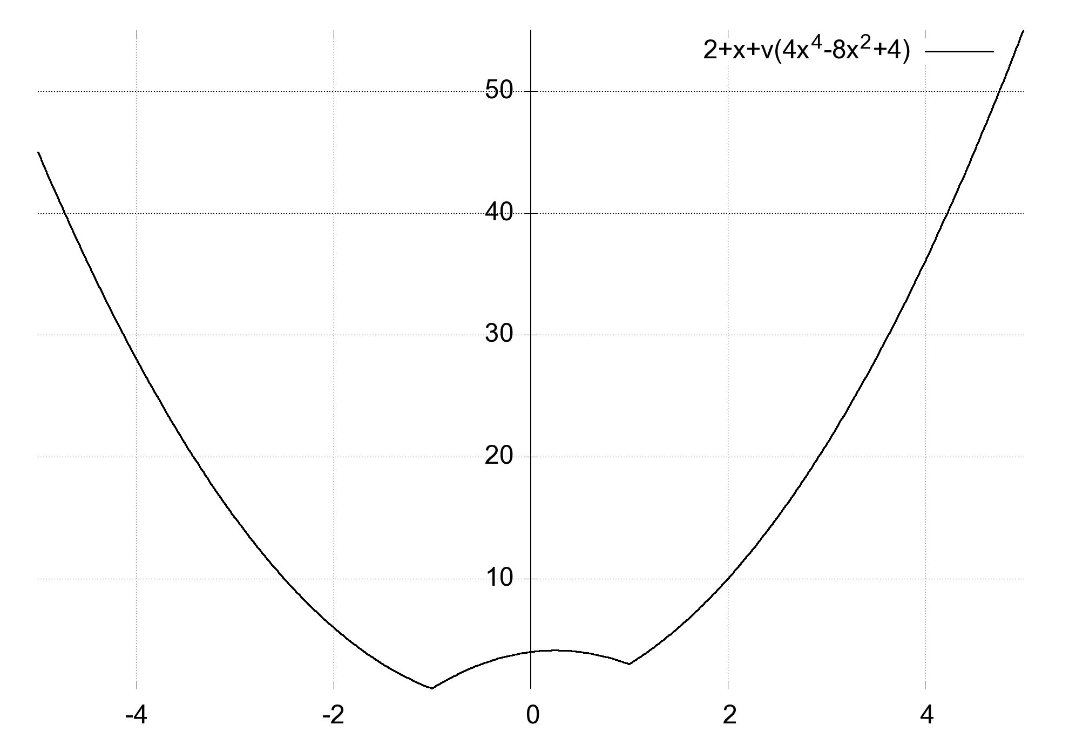 | f'(x)  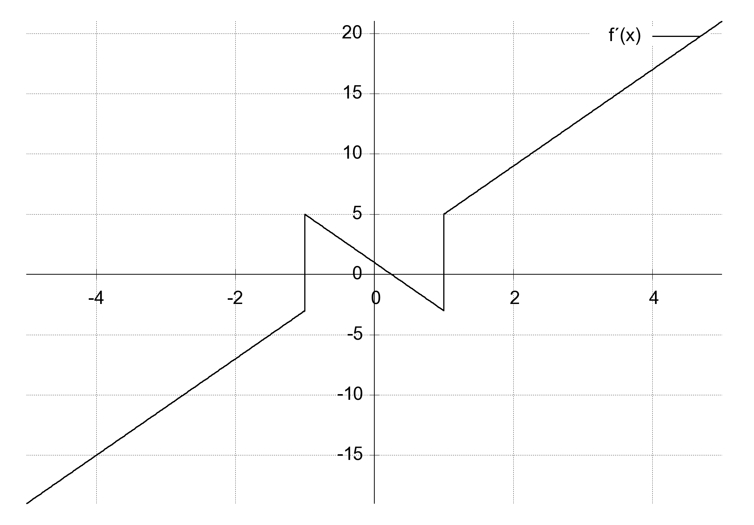

From the graph we can see that the function is not differentiable in $x=-1$ and $x=1$.
$$\lim_{x→1}{f^{'}\left(x\right)}≈not defined but limited$$
But we can find the right/left limit value
$$\lim_{x→1^{+}}{f^{'}\left(x\right)}=5$$
$$\lim_{x→1^{-}}{f^{'}\left(x\right)}=-3$$
Note the small + and -, which must be superscript.
$$Delete definitions:$$

Differential equations
WordMath can solve ordinary differential equations of the 1st and 2nd order. Enter the differential equation in a math field, and select Solve > Solve differential equation.
$$y^{'}=k·y$$
The differential equation is solved by WordMat's 'Solve differential equation' function
$$y=c·e^{k·x}$$
There are two other ways you can enter differential equations.
$$f^{'}\left(x\right)=k⋅f(x)$$
and
$$\frac{ⅆy}{ⅆx}=k·y$$
After you have clicked Solve differential equation, this window will appear:
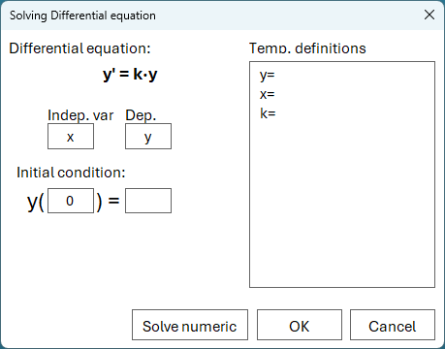 | WordMath tries to identify the independent and dependent variable. Check if it is correct.  If the differential equation includes a function such as f(x) instead of a variable such as y, then you should write the function as f(x) and not just f.  Insert any initial condition. If no initial condition is specified, you get the general solution with c as constant.
If you enter an initial condition, this will be indicated in the comment. Example:
$$y^{'}=k·y$$
The differential equation is solved by WordMat's 'Solve differential equation' function with start condition y(0)=1
$$y=e^{k·x}$$

NOTE: There is a special 'differential d' that can be used when using $\frac{dy}{ⅆx}$ notation. It is entered by typing "\dd" followed by space. It looks exactly like a normal d, but makes it easier for WordMath to identify it as a differential d and not a variable staring with d. In simple cases, however, it is not a problem to write $\frac{dy}{dx}$ with a normal d, but if y and x is not used, then d can be identified as a variable. Also note that in settings under notation there is a checkmark where you can force that regular d is always perceived as a differential d.
See section Differential calculus p. 78 for more info about the special differential d.

Example of differential equation of 2nd order.
$$y^{''}=y$$
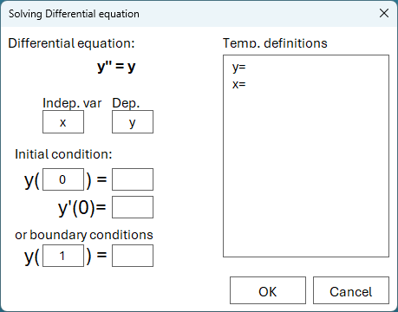 | Here you get additional options as you can choose between Initial conditions or boundary conditions.  If none is entered, you will get the complete solution with constants c1 and c2  Initial conditions  Fill in the first two y(..)= and y'(..)=  Boundary conditions:  Fill in the first y(..)= and the last y(..)=  The result of the above will be:
The differential equation is solved by WordMat's 'Solve differential equation' function with boundary conditions y(0)=1 og y(1)=2
$$y=0,6944005·e^{x}+0,3055995·e^{-x}$$

Examples of differential equations
Here is the complete solution for the logistic differential equation
$$y^{'}=a·y·(M-y)$$
The differential equation is solved by WordMat's 'Solve differential equation' function
$$y=0 ∨ y=M ∨ y=\frac{M}{c·e^{-\left(M·a·x\right)}+1}$$
Another logistical where a starting condition is specified:
$$N^{'}=\frac{1}{10500}·N·\left(1000-N\right)$$
The differential equation is solved by WordMat's 'Solve differential equation' function with start condition N(0)=100
$$N=\frac{1000}{9·e^{-\left(\frac{2·x}{21}\right)}+1}$$

Numerical solution of differential equations
If you solve a 1st order differential equation, there is a button that says 'Solve numerically'. This button activates Show graph > Direction field described in section 8 Graphing / Slope field (directional field) on p. 50
It can be used, for example, if WordMath is not able to solve the differential equation. In that case, the numerical solution can at least show the graph of the solution.
The next section describes the numerical solution of coupled differential equations.

Coupled differential equations
WordMath has a built-in function for numerical solving of one or more coupled differential equations. Simply enter the differential equations in the document, select the equations and click Solve > Solve system of differential equation(s) numerically.
You can also enter the functions directly into the window that opens. The variables must not be entered as functions. (i.e. N not N(t))
The differential equations are solved using Runge-Kutta's 4th order method.
Here is an example of a solution of 3 coupled differential equations (SIR disease spread model)
R is no of noninfected persons
S is the number og sick (infected) persons
I is the number of immune persons (previously infected)
$$R^{'}=-\frac{c}{N}·R·S$$
$$S^{'}=\frac{c}{N}·R·S-p·S$$
$$I^{'}=p·S$$
  - Select the 3 equations above
  - click Solve > Solve coupled differential equation(s) numerically
  - Set the constants in the definition textbox
  - Set the starting values for R, S & I next to each expression
  - Check the graph checkmark for R, S & I, to show graphs of each of the 3 functions
  - Set the independent variable to be t and go from 0 to 100
  - Finally, click Show Graph
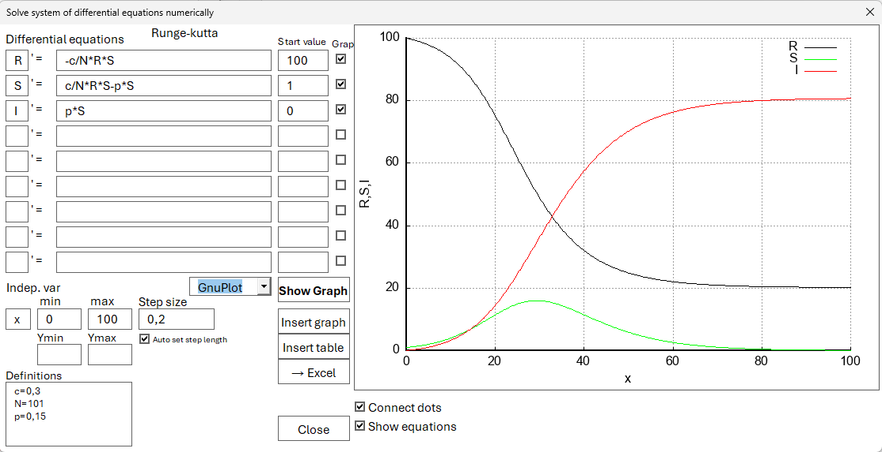
In the above example, GnuPlot is used to display the graphs. GnuPlot is not supported on Mac, but GeoGebra can also be used.
Note that you can send the calculated points to Excel if you want to continue working with them, possibly have them plotted using Excel or an other graph program.

Coupled differential equations with Excel and Euler's method
Another approach to coupled differential equations is Excel and Euler's method. It is less precise and requires more manual work, but can provide a better understanding of how numerical solving of coupled differential equations works.
Here is an example as an embedded Excel sheet.
You can set constants to be used in the calculations. Make a column for the independent variable (here t) and one for each of the dependent variables and their derivatives.
An appropriate number of values is inserted for the independent variable. (here from 0 to 100 days)
Starting values are inserted for the dependent variables (here R=100, S=1, I=0)
The derivatives are calculated using the differential equations, initial values and possibly constants.
In the next row, the new values for the independent variables can be calculated using linear extrapolation. E.g
$$R\left(t+∆t\right)=R\left(t\right)+R'(t)·∆t$$
Thus the whole row continues and now the formulas can be pulled down and a diagram can be constructed from the points.
Now you can try to change the constants to see how the graph changes.

Vectors
To work with vectors in WordMath, you need to be able to enter a vector in a math field. There are several ways to do this, but it's recommended to use the keyboard rather than the templates in the equation menu – it's both faster and easier once you've tried it a few times.
To enter a vector
Enter the starting bracket, ending bracket, and then press space to get the following

Then press the left arrow key and press Enter – then you get a vector with two components:

If you press Enter one more time, you get a 3D vector:

Examples of vector calculations
- Vector addition and multiplication with a constant
$$\left(\begin{aligned}1 \\ 3\end{aligned}\right)+2⋅\left(\begin{aligned}-1 \\ 2\end{aligned}\right)=\left(\begin{matrix}-1 \\ 7\end{matrix}\right)$$
- The length of a vector
$$\left|\left(\begin{aligned}2 \\ 3\end{aligned}\right)\right|=\sqrt{13}$$
The vertical lines are entered on Windows by holding Alt Gr + the button just to the left of the backspace. On Mac: Option + i.
- Scalar product
$$\left(\begin{aligned}1 \\ 4\end{aligned}\right)·\left(\begin{aligned}-3 \\ 2\end{aligned}\right)=5$$
- Ortogonal vector
$$\hat{\left(\begin{aligned}3 \\ 5\end{aligned}\right)}=\left(\begin{matrix}-5 \\ 3\end{matrix}\right)$$
The cross-vector hat is entered with \hat
- Determinant
$$\det\left(\left(\begin{aligned}1 \\ 3\end{aligned}\right),\left(\begin{aligned}2 \\ 3\end{aligned}\right)\right)=-3$$
- Cross-product (only for vectors in space(3D))
$$\left(\begin{aligned}2 \\ 3 \\ 4\end{aligned}\right)×\left(\begin{aligned}-1 \\ 6 \\ -2\end{aligned}\right)=\left(\begin{matrix}-30 \\ 0 \\ 15\end{matrix}\right)$$
The cross is entered with \times
Using vector arrows
It is recommended to define vectors with an arrow above the variable.
- To type a with arrow:
Type a\vec and press space twice: $\vec{a}$
- Alternatively, you can use \rhvec for a different vector arrow: $\overset{⃑}{a}$
If vectors are not defined with an arrow, you should be aware that WordMath may otherwise interpret the expression incorrectly – e.g. in the case of dot product.
Examples with defined vectors
$$Define: \vec{a}=\left(\begin{aligned}2 \\ 3\end{aligned}\right) , \vec{b}=\left(\begin{aligned}-1 \\ 2\end{aligned}\right)$$
- Orthogonal vector
$$\hat{\vec{a}}=\left(\begin{matrix}-3 \\ 2\end{matrix}\right)$$
Here the orthogonal vector is found using the hat operator. Typed a\vec\hat

- Angle between vectors
Use the formula collection and search for "vector". What is inserted in this case is a bit atypical, as the formula is inserted once and just before the formula the two vectors are defined. The idea is that you change the coordinates of the two vectors to the specific problem.
$$Define: \vec{a}=\left(\begin{aligned}2 \\ 3\end{aligned}\right), \vec{b}=\left(\begin{aligned}-1 \\ 2\end{aligned}\right)$$
$$\cos\left(v\right)=\frac{\vec{a}·\vec{b}}{\left|\vec{a}\right|·\left|\vec{b}\right|}$$
$⇕$ The equation is solved for v by WordMat.
$$v=60,25512$$

- Projection of a vector
$$\vec{b_{a}}=\frac{\vec{a}⋅\vec{b}}{{\left|\vec{a}\right|}^{2}}\vec{a}≈\left(\begin{matrix}0,6153846 \\ 0,9230769\end{matrix}\right)$$
$$\left|\vec{b_{a}}\right|=\frac{\left|\vec{a}⋅\vec{b}\right|}{\left|\vec{a}\right|}≈1,1094$$
Vector
Vector equations are actually systems of equation that WordMath can solve automatically.
- Example
$$\left(\begin{aligned}x+y \\ x-y\end{aligned}\right)=\left(\begin{aligned}1 \\ 2\end{aligned}\right)$$
$⇕$ The equation is solved for y by WordMath.
$$y=-\frac{1}{2} ∧ x=\frac{3}{2}$$
It can be a little sensitive to which variable is chosen. In this case, you have to choose y for it to work. If this does not succeed, it may be necessary to convert the vector equation to a system of equations, and then solve the system by selecting the equations.

- Intersection between line and plane.
Select the two math fields and press Solve.
$$\left(\begin{aligned}x \\ y \\ z\end{aligned}\right)=\left(\begin{aligned}1 \\ -1 \\ 6\end{aligned}\right)+t·\left(\begin{aligned}2 \\ -2 \\ 4\end{aligned}\right)$$
$$4x-6y+10z-26=0$$
$⇕$ The system of equations is solved for x,y using WordMath's 'Solve Equations' function,
$$t=-\frac{11}{15} ∧ z=\frac{46}{15} ∧ y=\frac{7}{15} ∧ x=-\frac{7}{15}$$
Square brackets
WordMath also supports vectors with square brackets. If the input uses square brackets, the output will also do so:
$$2·\left[\begin{aligned}2 \\ 3\end{aligned}\right]=\left[\begin{matrix}4 \\ 6\end{matrix}\right]$$
$$Delete definitions:$$
Referencing elements in vectors/matrices
You can refer to elements of a vector or matrix in several ways:
- $\vec{v}\left[r\right][k]$
- $\vec{v}\left[r,k\right]$
- ${\vec{v}}_{r ,k}$ (requires that "Subscript is list/matrix index" is turned on under "Settings > Notation". See Index / Subscript p. 13 )
where r is row number and k is column number (for vectors, k is always 1)
Example:
$$Define: \vec{v}=\left(\begin{aligned}1 \\ 2 \\ 3\end{aligned}\right)$$
$$\vec{v}\left[2\right]\left[1\right]=2$$
$$\vec{v}\left[2 , 1\right]=2$$
$${\vec{v}}_{2 ,1}=2$$

Matrices
In general, WordMath handles matrices as one would write it on paper. However, Maxima has a number of built-in commands for Matrices that can be very useful.
Entering matrices:
You can create a matrix by first typing the starting parenthesis, ending parenthesis, and then a space.

Place the cursor in the middle of the brackets, and then select the desired matrix from the equations menu → Matrix.

To expand the dimensions of the matrix (multiple rows/columns), right-click on the matrix and select Insert.

For advanced users, matrices can also be entered directly with shortcuts:
Type [\array (1&2@2&3)] and press space
$$\left[\begin{matrix}1 & 2 \\ 2 & 3\end{matrix}\right]$$
Matrices can be entered with both regular and square brackets. Output follows the same type as input.
Examples of matrix operations
- matrix addition, multiplication and power.
$$\left[\begin{matrix}1 & 2 \\ 3 & 4\end{matrix}\right]⋅\left[\begin{matrix}3 & 4 \\ 5 & 6\end{matrix}\right]+{\left[\begin{matrix}8 & 5 \\ 1 & 6\end{matrix}\right]}^{2}=\left[\begin{matrix}82 & 86 \\ 43 & 77\end{matrix}\right]$$
- Inverse matrix
$${\left[\begin{matrix}3 & 4 \\ 5 & 6\end{matrix}\right]}^{-1}=\left[\begin{matrix}-3 & 2 \\ \frac{5}{2} & -\left(\frac{3}{2}\right)\end{matrix}\right]$$
- Determinant of matrix
$$det\left(\left[\begin{matrix}1 & 2 \\ 3 & 4\end{matrix}\right]\right)=-2$$
Definition of matrices
It can be an advantage to use a line over the variable name to indicate that it is a matrix. Use the shortcut \overbar.
$$Definer: \overline{A}=\left[\begin{matrix}1 & -2 \\ 2 & 3\end{matrix}\right]$$
$${\overline{A}}^{2}=\left[\begin{matrix}-3 & -8 \\ 8 & 5\end{matrix}\right]$$
Maxima functions
To create large matrices, you can use the following built-in functions in Maxima:
$$zeromatrix\left(3, 4\right)=\left(\begin{matrix}0 & 0 & 0 & 0 \\ 0 & 0 & 0 & 0 \\ 0 & 0 & 0 & 0\end{matrix}\right)$$
$$zeromatrix\left(3, 4\right)+1=\left(\begin{matrix}1 & 1 & 1 & 1 \\ 1 & 1 & 1 & 1 \\ 1 & 1 & 1 & 1\end{matrix}\right)$$
$$ident\left(3\right)=\left(\begin{matrix}1 & 0 & 0 \\ 0 & 1 & 0 \\ 0 & 0 & 1\end{matrix}\right)$$
There are also a number of built-in functions in Maxima that may be relevant. Some of these are listed here:
$rref(M)$ Gaussian elimination (Reduced Row Echelon Form).
$eigenvalues\left(\left[\begin{matrix}1 & 2 \\ 3 & 4\end{matrix}\right]\right)$ Finds eigenvalues
$eigenvectors\left(\left[\begin{matrix}1 & 2 \\ 3 & 4\end{matrix}\right]\right)$ Finds eigenvectors, but in list form.
$transpose(M)$ transposes the Matrix M
$echelon\left(M\right)$ Returns matrix with 1s in diagonal and 0s below 1s

Here are a few very advanced examples
$ematrix\left(n;m;x;i,;j\right)$ Returns n×m matrix, with only zeros, except position i, j that will have x.
The following function inserts values based on a function that takes the column and column number as parameters.
$$genmatrix\left(lambda\left(\left[i, j\right], i·j\right), 3 , 3\right)=\left[\begin{matrix}1 & 2 & 3 \\ 2 & 4 & 6 \\ 3 & 6 & 9\end{matrix}\right]$$
Creates a 3x3 matrix where each element is the product of row and column number.

Complex numbers
Complex numbers are enabled in settings on the CAS tab. When enabled, the letter i is reserved for the imaginary unit $\sqrt{-1}$
Examples:
When complex numbers are turned on, you can calculate expressions with complex numbers
$${\left(1+2·i\right)}^{2}=4·i-3$$
solve equations with complex solutions:
$$x^{2}=-9$$
$⇕$ The equation is solved for x by WordMath.
$$x=-3·i ∨ x=3·i$$
If complex numbers are turned off, the same equation will not return any solutions:
$$x∈∅$$
The equation had no solutions within R for variable x
Maxima functions for complex numbers (with Maxima as the CAS engine):
- realpart(z) – Finds the real part of z
- imagpart(z) -- Finds the imaginary part of z
- rectform(z) – returns the complex number z in Rectangular form ($z=a+b·i$)
- polarform(z) – return the complex number in polar form ($z=r·e^{i·θ}$)
- abs(z) – Modulus (absolute value)
- arg(z) – Argument (angle)
Example:
$$\arg\left(1+i\right)=\frac{π}{4}≈0,7853982$$
Polar notation
WordMath can interpret polar notation written in the form
$$modulus ∠ argument$$
Example: (radians)
$$2∠\left(\frac{π}{4}\right)=\sqrt{2}·i+\sqrt{2}$$
When complex numbers are turned on, the ∠ symbol is reserved for this notation. It is entered: \angle → ∠
When complex numbers are turned on, you can choose to get output in polar notation. The option appears just below the checkmark, where complex numbers are turned on.
If polar-notation output is turned on. All numbers will be written in polar notation as output.
$$1+i=\sqrt{2}∠\left(\frac{π}{4}\right)$$
Note: Polar notation depends on whether you have selected degrees or radians in the settings.

Formula collection
WordMath has several formula collections. The newest and most comprehensive formula collection is opened by clicking the top of the formula collection button on the left side of the menu or with the keyboard shortcut Alt + F. (Only available in danish).
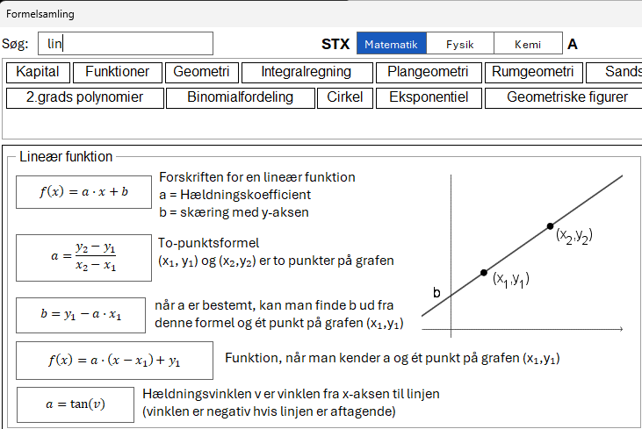 | When the formula collection is activated, the cursor is automatically placed in the search box, ready to type. You can also click on one of the keywords just below the search box.  All of the formulas have a number of different keywords associated with them.  You can switch between subjects with the tab key and scroll with the arrow keys if there are many results.

The formula collection will be closed automatically when a formula is inserted, otherwise you can use the Alt + F shortcut to close the formula collection. If you hold down Ctrl (Mac: Option) while clicking a formula, the formula collection does not close, enabling you to insert multiple formulas.
As a rule, the formula is inserted twice in the document: one for documentation and one where you can insert numbers.
$$a^{2}+b^{2}=c^{2}$$
$$3^{2}+4^{2}=c^{2}$$
Some formulas (e.g. the binomial coefficient and the binomial distribution) are inserted as a definition. Then you are not supposed to insert numbers into the equation, but rather use the definition in your calculations.
WordMath will sometimes define standard values, which you are supposed to change. Here is what is inserted if binomial distribution is selected:
$$Define:n=10, p=\frac{1}{2}$$
$$K\left(n,r\right)≝\frac{n!}{r!·\left(n-r\right)!}$$
$$P\left(r\right)≝K\left(n,r\right)·p^{r}·{\left(1-p\right)}^{n-r}$$
Then you can change the n and p in the definition yourself and use the definitions of the functions for calculations:
$$P\left(4\right)≈0,2050781$$
In the physics and chemistry formulas, physical constants are automatically inserted into the second formula that is inserted.
Here is an example where the speed of light is automatically inserted into Einstein's formula for mass equivalence.
$$E=m·c^{2}$$
$$E=m·{\left(3·{10}^{8} \frac{m}{s}\right)}^{2}$$
There is an option to choose whether or not to insert constants with units at the top of the formula collection.
A suggestion for a keyboard shortcut you can create is to assign double tap of Alt + M to formulae.
Click Shortcuts in the menu and find this line and select Formulae:
The new formula collection requires WordMath+ to be able to insert the formulas, but there are also older alternatives.
Old formula collection
If you click on the lower part of the formula button in the left side of the WordMath menu, a number of items will open where you can click your way to a formula that will then be inserted into the document.
The formulas are not updated for any particular syllabus but are very broad.
At the very bottom of the formula menu, you can select M, F, or K. These buttons open Word documents with full formula collections for math, physics, and chemistry. These Word documents are editable. Just be aware that they are overwritten when updating WordMath. These formulas are older and not targeted at a specific education.

Lists
A list is an ordered array of mathematical objects - typically numbers. Lists are useful when you need to do many of the same type of calculations.
To enter a list
- Lists are written with square brackets around the elements
- Each item is separated by a list separator (depending on your setting under notation). The default is semicolon, but you can also use a comma if you make a space next to the comma so that it is not perceived as a decimal separator.
Examples of 2 lists with 3 numbers:
$$[1 ;2,5 ;6]$$
$$[1, 2,5 , 6]$$
Using lists
- You can perform arithmetic operations directly in lists.
- Lists can be defined and used in functions.
- Lists can easily be converted to and from tables via the menu.

Examples of lists and arithmetic operations

- Arithmetic operations performed on list
$$\left[3;4;6\right]+2·\left[1;-3;6,4\right]=\left[5;-2;18,8\right]$$
- Definition of list and use of function on list
$$Define: list=\left[1;2;3\right] ; f\left(x\right)=x^{2}$$
$$f\left(list\right)=\left[1;4;9\right]$$
See also the section on "Index / Subscript" p. 13 for how to access the individual items in a list.
Conversion between table and list
You can convert a table to a list and vice versa via the menu:
- Table > Table→List: Converts a table column to a list.
- Table > List→Table: Converts a list to a one-column table.
It can be used to manipulate a table or parts of a table.
Example: From table to list and back
We have the following table
x | y
1 | 34,5
2 | 45,3
3 | 51,1
4 | 60,3
5 | 67,7

We would like to subtract 30 from the numbers in the 2nd column and take the logarithm of the result.
- First, select the numbers in the right column and select Table > Table→List.
- You now get the numbers in the column in list form, and define the list by writing L≔ in front of it

$$L≔\left[ \left[34,5\right],\left[45,3\right],\left[51,1\right],\left[60,3\right],\left[67,7\right]\right]$$
- The calculation is now performed on the defined list
$$\log\left(L-30\right)≈\left[\left[0,6532125\right];\left[1,184691\right];\left[1,324282\right];\left[1,481443\right];\left[1,576341\right]\right]$$
- Select the list and click Table > List→Table to turn the list back into a table.
0,6532125
1,184691
1,324282
1,481443
1,576341

- The column can now be copied into the table we started with
x | y
1 | 0,6532125
2 | 1,184691
3 | 1,324282
4 | 1,481443
5 | 1,576341

Note: Often such tasks can be solved more easily in Excel, but WordMath provides extra options if you need more advanced math tools.

$$Delete definitions:$$

Sum signs and product signs
Sum signs (Σ) and product signs (∏) are used to sum or multiply a series of numbers or expressions – often in conjunction with lists or formulas.
Sum characters are either entered with a template from the menu, but can also be written directly in a mathematics field. The sum character is written with the shortcut \sum. The Product sign is written with the shortcut \prod.
The lower and upper limits are typed using _ and ^
Example:
The sum of $n^{2}-n$ from $n=1$ to $n=5$:
$$\sum_{n=1}^{5}{\left(n^{2}-n\right)}=40$$
You can enter this expression directly into a math field like so:
\sum_{n=1}^5 (n^2-n) followed by space
Here's an example with the product sign:
$$\prod_{i=1}^{5}{i+1}=720$$
This is equivalent to $\left(1+1\right)·\left(2+1\right)·\left(3+1\right)·\left(4+1\right)·(5+1)$
Combination with lists
Sum and product signs can also be used with lists to make calculations on multiple elements in one expression.
If you have a defined list
$$Define: L=[2;4;6]$$
you can type:
$$\sum_{k=1}^{3}{L\left[k\right]}=12$$
Which sums up all the items in the list.
If you have set the setting Settings > Notation > Subscript is list/matrix index, you can use this notation:
$$\sum_{k=1}^{3}{L_{k}}=12$$
See also the section on "Index / Subscript" p. 13 for how to access the individual items in a list.
In the formula collection, there are formulas where lists and sum characters are used. Find the formula for mean under stochastic variable, then insert this:
$$x≔\left[1;2;3\right]$$
$$p≔\left[0,3;0,3;0,4\right]$$
$$n≔length\left(x\right)$$
$$μ=\sum_{i=1}^{n}{x\left[i\right]·p\left[i\right]}=2,1$$
List x contains the observations, while list p contains the frequencies. n will have the number of observations. At the bottom is the actual formula for the mean value, which sums up all the elements in the two lists and multiplies the observation by frequency. The idea is that you change the list x and the list p to match your specific problem/exercise. If you have the numbers in a table, you can use Table > Table → list to transform into a list.

Triangle solver
The triangle solver can, based on input of known sides and angles, calculate the remaining sides and angles in arbitrary triangles, as well as draw the triangle in the correct dimensions and show intermediate calculations that form the basis for the result.
The triangle solver is activated by clicking ∆Triangle in the menu, which opens this menu:
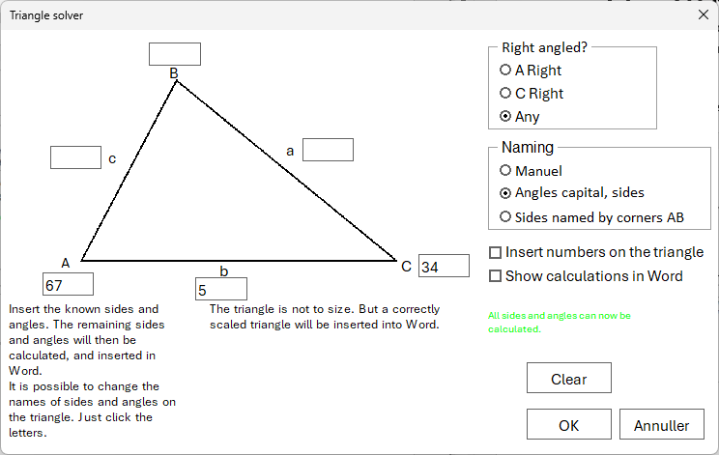 | If you know that the triangle is right-angled, start by marking it in the top right corner.  Now enter the known sides and angles directly into the figure.  When there is enough information to calculate the remaining sides and angles, it will be indicated in green on the right side.  Note that you have the option to choose how the sides are named.

Here you can see the result of the above. For this output the option ‘Show calculations in Word’ was chosen.

WordMat's trianglesolver is used with input: A = 67° , C = 34° , b = 5

A  B  C  a  b  c | A = 67°  B = 79°  C = 34°  a = 4,688668  b = 5  c = 2,848296

Angle B found using sum of angles = 180 ° in a triangle
$$B=180°-A-C=180°-67°-34°=79°$$
The length of the sides a og c found using law of sine
$$a=b·\frac{\sin\left(A\right)}{\sin\left(B\right)}=5·\frac{\sin\left(67°\right)}{\sin\left(79°\right)}=4,688668$$
$$c=b·\frac{\sin\left(C\right)}{\sin\left(B\right)}=5·\frac{\sin\left(34°\right)}{\sin\left(79°\right)}=2,848296$$

Note that the calculated results are marked in bold.
The triangle solver can be used for an experimental approach to triangles.
Here are some examples of how you might take advantage of the triangle solver:
- What do you need to know to be able to calculate all sides/angles?
(it is written immediately next to the OK button if a solution can be found).
- Under what circumstances can there be two solutions?
(This is also indicated by the OK button).
- The triangle solver can be used to compare your own solution method with WordMath's
- The triangle solver can also just be used to draw a triangle in the right dimensions, which can then be used in Word.

Units
You can use units in any calculation. E.g:
$$\frac{120 km}{1,5 s}=\frac{80·km}{s}$$
In this case units are perceived as variables. This means that the unit is not automatically converted to other units.
However, if you turn on units, WordMath will automatically handle and convert units. The above calculation will give this result with units turned on:
$$v=\frac{120km}{1,5 s}=80000 \frac{m}{s}$$
The result is now indicated by a unit at the end of the expression. A multiplication sign is not written and km/hour is converted to the SI unit m/s.
NOTE: Units only work with Maxima as a CAS engine.
How to turn units on and off
There are three ways to turn units on or off:
- From the menu: There's a shortcut to turn devices on and off in the menu:
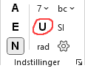 | Click the U to turn units on and off.
- Via Settings: Open Settings (Alt + J) and tick units on/off (on the CAS tab)
- Via keyboard shortcut: You can also choose to assign a keyboard shortcut that can toggle units on and off. For example, you can use the shortcut Alt + E. Click on Shortcuts in the menu and set
Important precautions
Only use units when you need to. Remember to turn units off again when you're done.
The following are problematic when units are turned on:
- The speed of calculations is slower
- WordMath has a little more difficulty solving equations and performing other operations
- Many letters are reserved for units and cannot be used as variables.
m, g, V, K, etc. can not be used as ordinary variables. Especially in physics formulas, this can cause problems as m often stands for mass. You can then use a capital M or m₁ with subscript. Likewise, g means both the acceleration of gravity at the earth's surface and grams. For example, use $g_{earth}$ instead of g. You also have to be careful with variables of two or three letters length, as it can be a unit with a prefix. E.g. aM, mm, ...
You can always see in the menu if units are turned on by looking for the U in settings. When you solve an equation and units are turned on, a red warning will be shown, as a reminder to turn off units if you don't need it.

Which units and prefixes are supported?
All SI units with all SI prefixes are supported as listed in the tables below. Both the 7 SI base units and derived SI units are supported. See the table below for a complete list. Some units can also be written both with their abbreviation or spelled out For example, meter or the abbreviation ‘m’.
A distinction is made between uppercase and lowercase letters. The units must be written correctly. For example, Joules should be written with a capital J and not a lowercase j. The prefix kilo should be written with a small k.
Note that WordMath returns all results as decimal numbers when units are turned on.

Prefix name value Prefix name value
Y Yotta 10²⁴ y yocto 10⁻²⁴
Z Zetta 10²¹ z Zepto 10⁻²¹
E Exa 10¹⁸ a atto 10⁻¹⁸
P Peta 10¹⁵ f femto 10⁻¹⁵
T Tera 10¹² p pico 10⁻¹²
G Giga 10⁹ n nano 10⁻⁹
M Mega 10⁶ μ micro 10⁻⁶
K kilo 10³ m milli 10⁻³
h hecto 10² c centi 10⁻²
da deka 10¹ d deci 10⁻¹

SI Base Units
Size unit name
Length m meter
Mass kg kilogram
Time s second
Temperature K Kelvin
Electricity A Ampere
Number mol mol
Light intensity cd Candela

SI-Derived Units
N, J, W, Pa, C, V, F, Ω (or Ohm), T, H
Other units that can be used
Length: AU, ly, pc
Volume: L, liter
Mass: u, ton
Frequency: Hz, Bq
Energy: eV, kWh, cal, kcal
Pressure: bar, dry, mmHg, atm
Temperature: $℃$ (special character \degc) but works like Kelvin

Many units also have a longer version. For example, you can write "10 meter" instead of "10 m". If a prefix is to be used in combination with the long version, the prefix must also be written in the long version. For example, you can write "10 kilometer".
Outputunits
By default, all units are converted to SI units without a prefix. Both the SI base units and the derived SI units can be converted.
However, you can choose other output units, and it can be done in 2 different places:
- In the menu just to the right of the U, there is a button labelled SI.
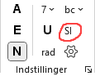 | SI means that you convert to SI units. Pressing the button will give you the option to specify other output units. You can specify multiple units separated by commas. Note that the button-label changes from SI to the first unit you have specified in the list, so you can always see the output unit in the menu.

- Open Settings (Alt + J) and select the units tab. Enter the output units in the textbox. You can specify multiple units separated by commas. This page also has a small guide.
You is not allowed to enter two units for the same physical quantity. For example, both eV and aJ are both units of energy. It is then the last one on the list that applies.
Combined units such as "km/s" must be specified as "km, s". You can't write "cm^3", just type "cm".
Examples:
Calculation of heat energy to be used to heat 500g of water 15 degrees
$$Q=m∙c∙∆T$$
$$Q=500g·4,2·\frac{kJ}{kg·K}·15K=31500 J$$
Calculation of time for bike to drive 50km. The speed is 10 m/s.
$$Define:l=50km, v=10\frac{m}{s}$$
$$v=\frac{l}{t}$$
$⇕$ The equation is solved by WordMath.
$$t=5000 s$$
Calculation of voltage from resistance and current
$$U=I·R=150mA·5Ω=0,75 V$$
Calculation of deflection angle in diffraction lattice
$$Define:n=1;λ=632,8nm ;d=\frac{1mm}{300}$$
$$\sin\left(θ\right)=\frac{n⋅λ}{d}$$
$⇕$ The equation is solved for θ by WordMath.
$$θ=\sin^{-1}\left(0,18984\right)≈10,94345$$
In the above example, it was necessary to press calculate after the result to get a decimal number. It can happen.
$$Delete definitions:$$

Special Functions
This section is only for the more ambitious user.
Via WordMath, you get access to Maxima's entire library of functions and programming languages.
An overview and explanation of all the features of Maxima can be found here:
https://maxima.sourceforge.io/docs/manual (There is also a link in the Menu under Help)
The functions can be used in expressions just as any other functions you define yourself. In the menu here is a button, "Maxima command", to send an expression directly to Maxima. It can be used if you do not want WordMath to change Maxima's output. When calculating, WordMath also makes a simplification and converts from radians to degrees etc." Maxima command" can be associated with a keyboard shortcut, but is not set by default.
Below are some examples of useful functions
Examples:
$mod\left(5, 4\right)=1$ 5 mod 4
$\gcd\left(24, 18\right)=6$ Largest common divisor
$primep\left(457\right)=true$ Determine if a given number is prime
$random\left(25\right)=12$ Returns random integer 0-24
$random\left(25,5\right)≈3,155938$ Returns random rational number x, 0<x<25.5
$taylor\left(f\left(x\right),x,0, 3\right)$ Taylor polynomial of f(x) around development point 0 to 3rd order

If you use GeoGebra as a CAS engine, these functions will not work. However, GeoGebra also has its own functions.

$$Slet definitioner:$$

Lambert W Function
The Lambert W function is the inverse function of
$$f\left(x\right)=x·e^{x}$$
The function is not injective and therefore comes in two 'branches': $W_{0}\left(x\right)$ and $W_{-1}(x)$
These two functions are therefore reserved in WordMath.
They will only appear if WordMath is set to specifically calculate exactly, otherwise they will be rounded numerically.
The Lambert W function is used by WordMath to solve equations such as
Example 1:
$$x·e^{x}=4$$
$⇕$ The equation is solved for x using WordMath.
$$x=W_{0}\left(4\right)≈1,202168$$
Example 2:
$$3^{x}=5x+1$$
$⇕$ The equation is solved for x using WordMath.
$$x=2,298454 ∨ x=0$$

Programming / Code Fields
You can use programming to define your own functions, and in this way make very advanced functions or expand WordMath's possibilities.
Here's an example that shows the possibilities:
$$AnswerMe(name,age)≔block([var1,var2] ,var1:30,var2:70,if age<var1 then return(sconcat(name," is young" )),if age>var2 then return(sconcat(name," is old" )),sconcat(name," is in his prime" ))$$
Here, the function is used, which takes two parameters:
$$AnswerMe\left(peter,17\right)≈peterisyoung$$
As seen above, spaces have been removed in the output. This is due to WordMath's formatting of output. This can be avoided by using 'Maxima command' instead of calculate (See previous section).
$$AnswerMe\left(peter,17\right)$$
$$\text{peter}\text{ is }\text{young}$$
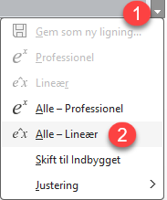 | Programming in math fields is not optimal, as they are not intended for long text. However, it can be made a little easier by working with linear mathematics fields.
If you want to program longer functions, it is recommended to use code fields instead of math fields. To insert a code field, click on Def. > Insert code field
Enter Maxima code here

When you insert a code field, you may be greeted with a warning that code fields are not turned on. They are activated in Settings > Code > Allow Code Fields. If code fields are not allowed, the code fields will be ignored. Code fields are not enabled by default, as code fields will slow down WordMath a bit. You should also be aware that the code in code fields applies to the rest of the document, from the place where the code field is inserted, but not before. 'Delete Definitions' has no effect on code fields.
Here, the above function is written in a code field, so it is a little more readable.
AnswerMe(name,age)≔block([var1,var2] ,var1:30, var2:70,
if age<var1 then return(sconcat(name," is young")), if age>var2 then return(sconcat(name," is old")), sconcat(name," is in his prime" ))
$$AnswerMe\left(hans,32\right)$$
With code fields, you can prepare functions that are available when you open the word document.
It is possible to create your own functions, which are always available in WordMath, without them being written in a Word document. This is done under Settings > Code.
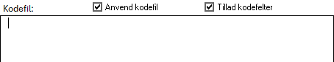
Tick Apply code file. Then enter your code/function in the text field, and the functions will always be available. However, using code file will affect the speed of WordMath slightly.
Warning: If there are errors in the code that is in the code file, then all calculations in WordMath will fail.

Programming language
The programming language used is Maxima's own language, which is similar to Lisp. It can only be used if Maxima is set as the CAS engine. GeoGebra does not support programming.
See https://maxima.sourceforge.io/docs/manual/ for documentation.
Here's some help to get you started:
- Maxima is case-sensitive. It can cause problems when Word is set to automatically start with uppercase letters, as Maxima's functions will not be recognized
- Lines should end with ; or $ (commands can also be separated by commas in block() functions)
- Variables are defined by colons.
a:3;
- Functions are defined by ≔
f(x)≔x^2;
block()
This function can be used to frame a longer expression, and is typically used as follows:
f(x)≔block([lokvar1, lokvar2], ...);
The first argument in the function can be a list of local variables used in the function. These variables will then not be affected outside of the function. Each subsequent argument is a command to be executed. The output of the function is the last argument to the function. You can use return(x)
in the function to exit and return x. The example of the AnswerMe function above exemplifies the use of block.
If then else
Works like most programming languages
if x=0 then 5
elseif x=1 then 6
else 7

Example definition of piecewise function:
f(x):=if x<0 then x^2
elseif (x=0 and x<5) then x
else (-x+10)
See also the AnswerMe function above, where if is used in conjunction with block().

Latex
WordMath has several different ways to generate LaTeX.
- WordMath can convert math fields to LaTeX syntax
- WordMath has a template that imitates a document created in LaTeX
- WordMath can act as an editor for MikTeX
Word also has a built-in LaTeX feature.
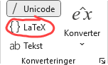 | It is strongly recommended that you do not change this setting to LaTeX  Place the cursor in a math field and click the equations menu. On the left side, you will have the option to change the input format from Unicode to LaTeX. The change applies generally to all mathematics fields.  This cannot convert the expression in the math field to LaTeX, but allows you to enter a math expression using LaTeX and then choose professional layout, Word will then interpret the LaTeX code correctly.
Note: It is a slower way to write math than with UniCode, and most of WordMath's other functions will not work correctly with this setting.

Converting Math Fields to LaTeX
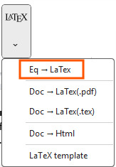 | Place the cursor in a math field and click on LaTex > Eq→LaTex in the menu. The math field will then be replaced by LaTex code, which is not written in a math field.  By default, the keyboard shortcut is Alt + T.
Example:
$$\frac{a+b}{x^{2+c}}$$
$\frac{a+b}{x^{2+c}} $
Clicking Alt+T again turns the LaTeX code into a math field again. However, this back-conversion is only rudimentarily implemented, so the translation will only work well for simple expressions.
If you click on the top part of the LaTeX button in the menu, you will get a window with several options.
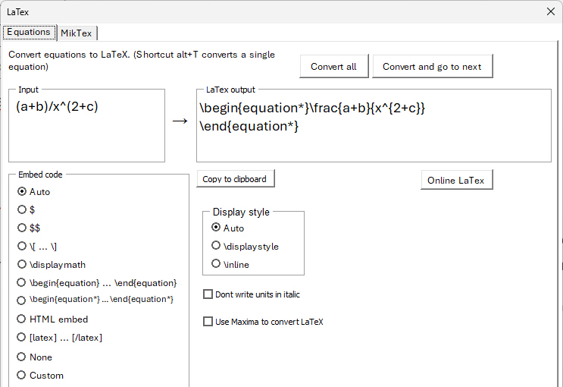 | Here you can see a preview of how the equation will be converted. You can choose between different enclosing characters, or specify your own. WordMath remembers this setting, and this setting is also applied with the keyboard shortcut.  Note the embed code HTML embed. It inserts html code that automatically converts LaTeX into an image if used in an html file on the Internet. It can be used, for example, if you need to insert mathematics on a website or in a blog post. See also section 25 ‘Word to HTML’

In LaTeX documents, math is displayed in either displaystyle or inlinestyle format. In Word this corresponds to View and Built-in, respectively.
Displaystyle is when an equation is displayed on a line by itself, where it is displayed in large format.
$$\int{\frac{x^{2}}{2}} dx$$
Inlinestyle is when an equation appears on the same line as text: $\int{\frac{x^{2}}{2}} dx$
In the window under “Display style”, you can choose whether WordMath should convert the math fields according to this context, or whether you want to force the conversion into one of the two types.
Note that at the top there is a button to convert all math fields in the document to LaTeX.
Maxima has a built-in feature to convert expressions to LaTeX. You can choose to use it instead of WordMath's. In most cases, WordMath's function will be best.
The button don’t write units in italics can be used if you want more precise output, for example if you are making textbook material. The default in textbooks is that you write variables in italics, but not units. This feature tries to recognize units in the expression and inserts LaTeX code that ensures that the units do not appear in italics. However, the feature is not 100% reliable, check for yourself.

Latex template
WordMath has a document template that can make Word documents look similar to LaTeX documents.
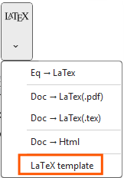 | Click on LaTeX > LaTeX template to open a new “LaTeX” document.  When the document opens, it is not blank, but contains a sample of a LaTeX document with examples and information about how it imitates a LaTeX document. You can just delete all the content to start a new document.

The template is designed to look like a LaTeX document in the following way:
- The same font is used as in LaTeX, both in text and in math fields.
This is possible because WordMath installs these fonts. The font is called LM Roman 12 for text and Latin Modern Math for math fields.
- Heading styles are set to match LaTeX style, with numbering of headings.
- The margins are set to the same values as in a standard A4 LaTeX document.
- Hyphens are turned on.
- The cover page in the sample document looks like a LaTeX cover page. When you need to create a new document with a cover page, reuse it.
- BibWord is installed. In Word's menu under References > Citations and Bibliography > Typography, you can choose "A BibWord Bitation and Bibliography Style" which is similar to the standard in LaTeX.
WordMath also has the ability to insert numbered equations and references to equations, just like in a LaTeX document. See the following section about numbered equations.

Word as MikTex editor
If you want a LaTeX document that is 100% LaTeX, WordMath can act as an editor for MikTeX, which can then generate the LaTeX code and a pdf. It all works from Word.
This feature only works on Windows, and is in Beta. It is not recommended to use it for larger documents yet.
The advantage of this method over other LaTeX editors is that you will be able to apply Word's math fields and let WordMath convert to LaTeX. Word also allows multiple people to write in the same document via OneDrive.
WordMath will convert the following to LaTeX:
- Title → Chapter
Heading 1 → Section
Heading 2 → Subsection ...
- Bold, italic, underline
- Pagination
- Math fields
- Lists (numbered and bullets)
- Tables
- Pictures & shapes
- Bibliography
You can choose whether you want to write the LaTeX code directly in Word or use Word's functions and let WordMath convert.
In order for WordMath to create a LaTeX pdf document, you must have MikTeX installed.
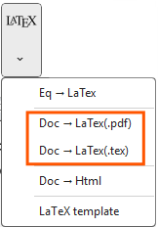 | In the LaTeX menu in WordMath, you can use these two buttons to convert the document directly to a pdf or to a tex file that opens in TexWorks.  However, it is recommended to initially click on the upper part of the LaTeX button and on the MikTeX tab, where you can set settings for the conversion.

On the right side, you can set some general settings, and when they change, you can see the preamble on the left side changes accordingly. At the bottom, you can add your own input to the preamble.
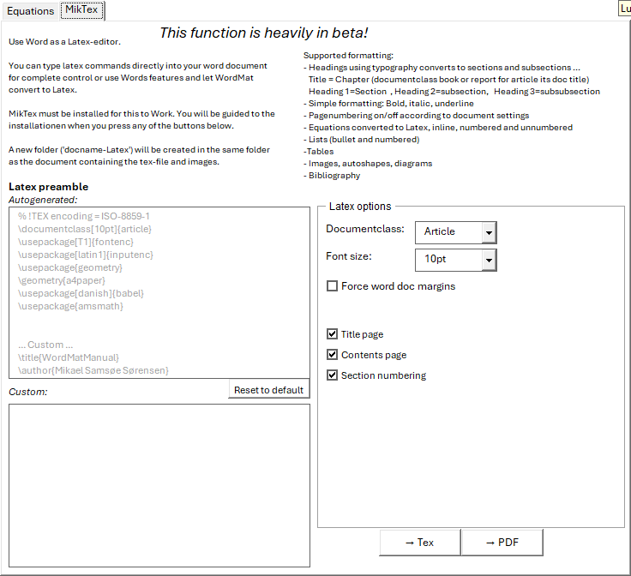
Again, it is emphasized that the function is in Beta, and should only be used in simple documents, where no complicated formatting has been used beyond the one mentioned above, or special characters that can be included in LaTeX code such as & and {}.

Numbered equations
Word has a built-in function to number equations, but WordMath has it own implementation of numbered equations with more feature.
Word's built-in numbered equations feature
You can add a number on the right side of a math field by typing #(1) after the expression in the math field. When you press Enter, it will be changed to a number on the right side. (It doesn't work with space. It must be Enter)
Example:
$$\begin{aligned}a^{2}+b^{2}=c^{2}\#\left(1\right)\end{aligned}$$
You can edit the number as you want, and actually write anything on the right side. The number is not automatically updated and references cannot be made to the field that automatically updates.
WordMath cannot perform calculations on math fields that are numbered in this way.

WordMath's Numbered Equations Feature
Click New Equation > Insert numbered equation
$$Skriv ligningen her.$$

Via settings, you can choose whether the number is written on the right or left side.
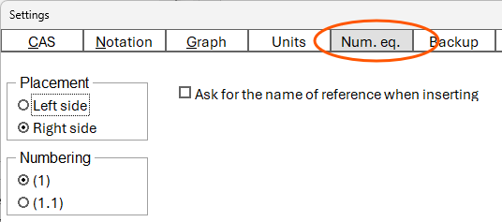 | Every time a new numbered equation is inserted, the number is automatically increased.

$$Skriv ligningen her.$$

You can create a keyboard shortcut to insert a numbered equation. Click Shortcuts in the right side of the menu. For example, you can use the keyboard shortcut Alt+M2 ( Double tap Alt + M) for numbered equations.
A math field can be toggled to a numbered/unnumbered by clicking Insert numbered equation or using the keyboard shortcut.

If you insert a numbered equation between two existing numbered equations, then all the numbers in the document are updated to accommodate the new numbered equations.
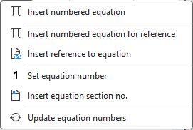 | If a numbered equation is deleted, then an automatic update does not occur. To update the numbers, select New Equation > Update equation numbers

If you need to reset or set the equation number to a specific value, you can select the equation number and click Set equation number. Note that subsequent numbered equations will then be numbered from the new value.
Since equation numbers are dynamic, it can be difficult to refer to them. For this purpose, you can Insert numbered equation for reference. When this type of number equation is inserted, you will be asked to enter a name for the equation when it is inserted. To reference the equation, use click Insert reference to equation. Then you get the opportunity to choose between the names you have previously given for the equations.
Under settings it is possible to get the number equations with two numbers separated by .
 | $$Skriv ligningen her.$$ | (0.1)
The next time an equation is inserted, the last number is increased by one.
 | $$Skriv ligningen her.$$ | (0.2)

The first number can be changed using Set equation number, or using Insert equation section no. function. This inserts a number in the document that increases the first number by 1 and resets the second number to 1. Typically, this section number is placed in a heading as numbering of chapters or sections. (It is also possible to insert the number hidden if it is not to be used).
Note: With numbered equations, a hidden table is inserted. Be careful not to write anything else in the table than the equation. i.e. make sure to put the cursor after the table when continuing to write.

Word to HTML
WordMath can convert a Word document or parts of a Word document to Html. This is a feature that Word already has, but WordMath is better at handling math fields, images and creates simpler html. HTML code is created that is not dependent on external files, meaning the code can be inserted anywhere where it is possible to insert custom html. It could be a WordPress post, for example.
The function is used to convert this manual into a website.
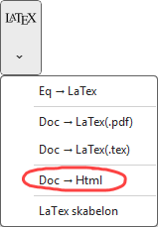 | Click LaTeX > Doc → Html to turn the Word document into html.
You will now get a text box where the generated html can be seen and where you can choose some options. Click Update to regenerate with new options.
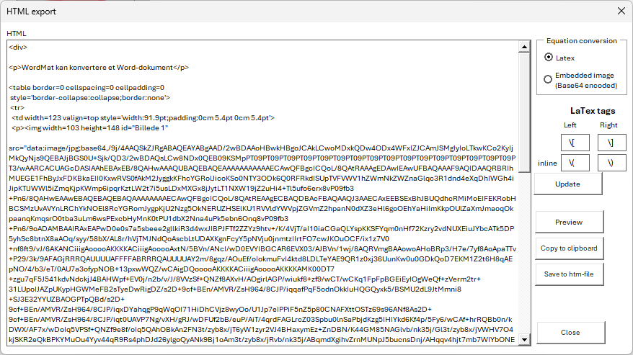
The PreView button displays the Html code in a browser, so you can see how it will look on a website (depending on css).
The top option 'Equation conversion' determines whether math fields are inserted as images or as LaTeX code. Images take up a lot of space in the code, but will work everywhere, while the LaTeX code requires the website to run with a LaTeX filter for them to be displayed correctly. It can vary which LaTeX tags different LaTeX filters use, so it is possible to manually specify LaTeX tags for both inline and display style.
The following elements can be converted to Html:
- Headlines
- Formatting: bold, italic, underline
- Tables
- Images
- Equations

Speed Tips
Here are a few helpful tips to improve the speed of Word when working with equations.
Slow Equation Menu
The equation menu in Word that displays equation templates can be very slow. Word uses the default printer to generate these templates. You can increase the speed by switching to a faster driver. "Microsoft print to pdf" is faster than a driver for a physical printer. "Cute pdf" is very fast.
To set a default printer

- Press the Windows key and type printers.
- Select Printers & Scanners in the search results.
- scroll down and uncheck "Let Windows manage my default printer."
- Find the printer you want to use by default (for example, Microsoft Print to PDF).
- Click on the → select Set as default.

Draft view
If you have an older computer, or are working in a large document, you may want to switch to draft view in Word. Draft view shows the document in a slightly simpler form, with no margins, indents, columns, header, and pagination. The normal view is called Print Layout and shows exactly how the document will look when it is printed or converted to PDF, but it is often not necessary when working with WordMath.
Draft view still shows normal formatting, fonts, font size, and formulas. Working in Draft view is much less demanding for Word, so Word will feel much faster - especially in large documents.
There are two ways to switch to draft view:
- Open the 'View' menu and click 'draft'.
To switch back to normal view, click 'Print Layout'
- Keyboard shortcuts:
Alt + Ctrl + N: Draft view
Alt + Ctrl + P: Print layout

WordMath Mac and Windows
In general, WordMath on Windows and Mac works similarly, but there are some differences. It is mainly about some additional features that are only available in the Windows version.
The following is only available in the Windows version
- Plotting Graphs with GnuPlot
- Plotting Graphs with Graph
- Generating LaTeX files to pdf with MikTex
The reason for these differences is that WordMath depends on some external programs that are not available for Mac.
If you want to use GeoGebra as a CAS engine on Mac, it requires some manual settings that are not necessary on Windows. See the section CAS engine p. 11.
In relation to Maxima, the two versions should work the same, but it cannot be 100% guaranteed that there will be a difference in special cases.

External programs
WordMath does some calculations itself, but works to a large extent in the way that it translates the mathematical expressions that are typed in Word, and sends them to other programs, and some send results back to Word.
The other programs used are:
- Excel
- Maxima - http://maxima.sourceforge.net
- GeoGebra - www.geogebra.org
- GnuPlot - http://www.gnuplot.info
- Graph - http://www.padowan.dk
Maxima, GeoGebra, GnuPlot and Graph are open-source, free-to-use programs that can be downloaded from the web. They are installed with the WordMath installer.
Maxima is an advanced CAS program originally developed at MIT in 1968. The later life of the program is a longer story, but the program has for a long time been a commercially leading product in its field (under the name MacSyma). In 1998, the program was made free under the GNU public license, and its further development is now handled by an independent group.

Graph is a free graph program that can be inserted directly into Word via WordMath. It is very user-friendly, but only works on Windows.

Debugging

It is possible for schools to purchase a partnership that provides access to support, WordMath+ and a number of additional services that make the work of getting WordMath running on many computers much easier.
It is the partnership schools that help to ensure that WordMath is continuously updated.
Read more about partnership here

You have the following options for resolving problems on your own:

1. On WordMath's website there is a FAQ where the most common problems are described.
WordMath FAQ
2. On WordMath's YouTube site, there are videos that can help. There are, among other things. videos that describe many of the problems described in the FAQ in more detail.
https://www.youtube.com/playlist?list=PLBE92A91925446259
3. On WordMath's GitHub page under discussions, you can create a post and ask for help from other users. It may also be that you can find a post that is about your problem.
https://github.com/Eduap-com/WordMath/discussions
4. On WordMath's GitHub page under issues, you can report bugs and see which bugs have already been reported. It is important to first search points 1-3 before errors are reported here.
https://github.com/Eduap-com/WordMath/issues
5. On WordMath's Facebook page, problems are also regularly mentioned and in some cases there may be help to get
https://www.facebook.com/WordMath

Tips for the technician

Installation
There are several different installation files for WordMath. The installation files that are made available free of charge are intended for installation on private computers with administrative privileges only.
With WordMath partnership, you get additional access to the following installation files:
- MSI files for installation with MDM systems such as InTune.
- Installation file that can install WordMath on Windows computers where the user does not have administrative privileges. It is a good solution for schools where teachers do not have administrative rights.
- Installation files for Mac computers that have been validated by Apple so that WordMath can be installed without having to go into System Preferences and exempt the file.
Access to the installation files is granted via IP address
Parameters for the installation files
The installation files made available to partnership schools can be run with the following parameters:
/Silent Installs WordMath without user input. Required for installation on many computers. it may be necessary to use the /verysilent and /SUPPRESSMSGBOXES and /nocancel parameters
/TASKS="installeralle" If there is to be installed for everyone. Here, WordMath.dotm is placed in the
C:\Program Files\Microsoft Office\root\Office16\STARTUP
/TASKS="installeruser" If to install for the user. Here, WordMath.dotm is placed in %appdata%/Microsoft/Word/STARTUP or %appdata%/Microsoft/Word/STARTThis is the default
/COMPONENTS="! Graph! GeoGebra"
Graph and GeoGebra 5 will not be installed. Can be used if Graph and GeoGebra 5 are installed by other means. Note, however, that there may be version problems if other versions of GeoGebra 5 are used.

Antivirus issues
Some antivirus programs may falsely flag WordMath as Malware or a virus. This is a false-positive detection. The problem is rooted in the way WordMath behaves. It communication between programs, accesses the internet etc. Behaviour that virus programs also exhibits.
A blog post has been written about the problem, where it is explained in more detail:
https://WordMath.blogspot.com/2025/02/WordMath-and-antivirus-problems.html

Where is WordMath installed?
Most files are installed in
"C:\program files(x86)\WordMat"
Or if installed without administrative privileges:
"%appdata%\WordMat"
WordMath is installed in Word as a Global Template, by placing WordMath.dotm in a folder from which templates are automatically loaded
If WordMath is installed for all users, then WordMat.dotm is placed in the folder
C:\Program Files\Microsoft Office\root\Office16\STARTUP
(depending on Word version)
If WordMath is installed 'only for this user', then the template is placed in the profile in the folder: %appdata%\Microsoft\Word\STARTUP
WordMath uses the registry to store settings under HKEY_CURRENT_USER\Software\WordMat
A dll file (MathMenu.dll) is registered that the program in the template draws on. This dll file requires .Net framework 4.0.

